

eProcurement
Requester Guide
LSUNO Only

Version Date: June 22, 2026

Table of Contents
eProcurement_Requester_Guide_LSUNO Only 1
eProcurement Basic Navigation & information 1
Create a Requisition 5
Enter Requisition Defaults for a Punchout Requisition 5
Create a Punchout Requisitions 21
Create a Special Request Requisition 31
Checkout Page: Header, Justification, and Line Comments, and Attachments 53
Checkout Page: Distributions, Schedule and Line Details, and Save 65
Find, Submit, and Print a Saved Requisition 71
View Requisition Details and Lifeline 81
Using the Requisition Actions Menu 87
Budget Check a ePro Requisition 91

eProcurement Requester Guide - LSUNO Only

eProcurement Basic Navigation & information
Procedure

In this topic you will learn eProcurement Basic Navigation and Information.

Step | Action
*****NOTICE*****

For training purposes only, the screen shots used in this topic were taken in the FIN PAT database. Users will enter eProcurement information into the FIN PRD (Production) database.

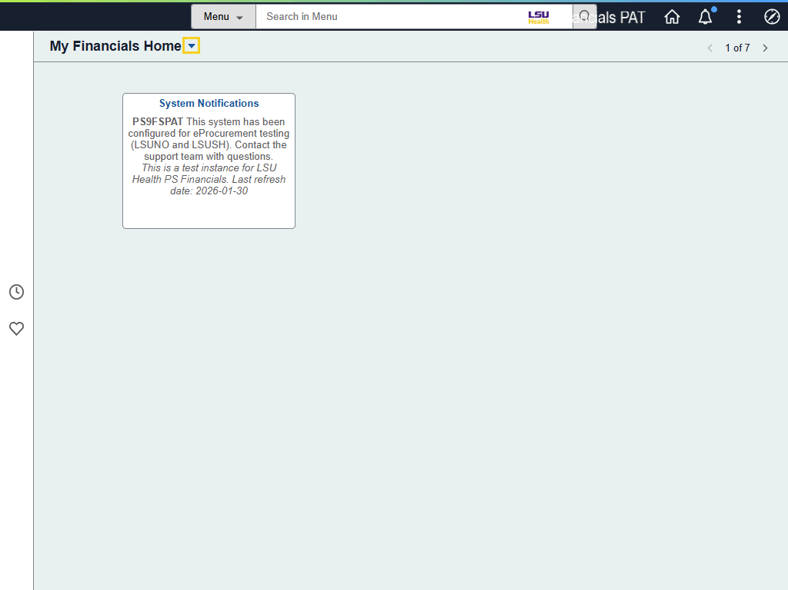

Step | Action
Navigation to eProcurement

The eProcurement tile is located on the LSU Health Financials homepage.

Click the My Financials Home dropdown button to activate the menu.
Navigation to eProcurement (continued)
Click the LSU Health Financials menu.
Create Requisition and eProcurement Tiles

Users can access the Create Requisition tile directly from the LSU Health Financials homepage. However, the same tile can also be accessed by selecting the eProcurement tile.

NOTE: The Create Requisition tile is for creating new requisitions only. No other actions (e.g., edit, approve, etc.) will be performed using this tile.

For training purposes only, click the eProcurement tile.
My Requisitions and Change Requests Tiles

The My Requisitions tile is used for performing new tasks on an existing requisition. Actions such as edit, approve, cancel and print will be performed using My Requisitions.

The Change Requests tile allows users to view, monitor, and check the approval status of requested changes on existing Purchase Orders (POs) or requisitions. Change Requests can be created by the user if specific field(s) need to be adjusted - such as unit price, quantity, or shipping status.
Navigating on PeopleSoft Pages

The Tab key on your keyboard is used to move from field to field within PeopleSoft. The Enter key acts as a Save button, so it cannot be used to move from field to field on a page.

NOTE: Use only the buttons and links provided on the PeopleSoft pages. Do not use the Back and Forward arrows on your browser.
What is an eProcurement Requisition?

An eProcurement requisition is a request for items to be ordered from a supplier. This creates a pre-encumbrance in the PeopleSoft system which is an intent to buy a product or service. It is a commitment to a department's budget, but it is not final and binding with the supplier. eProcurement allows users to create, review, edit, approve or cancel a requisition.
Approve & Budget Check

Once the requisition is entered into the PeopleSoft system, two (2) things must occur for Purchasing to be able to generate a Purchase Order to the supplier in the PeopleSoft system:

1. The requisition must be approved.

2. The requisition must pass the budget check process.

Budget Checking ensures that financial obligations and expenditures do not exceed budget limits. Controls are created to permit only those transactions that are applied to correct calendar periods, as well as to the correct account types and ChartString combinations. Budget Checking a requisition also verifies that the allocated funds are still available before a liability is created. In short, the Budget Check process verifies the ChartString entered in the requisition is valid and that the funds are available for the ChartString.
Elements of a Requisition

There are four (4) basic elements that comprise a requisition:
1. Headers
2. Lines
3. Schedules
4. Distributions

Each requisition has one header but can have multiple lines. Each line can have multiple schedules, and each schedule can have multiple distributions.
Request for Quote

Louisiana State Law requires that every purchase above $10,000 - including freight and handling - must go out for bid. Purchases made under the Governor's Executive Order for Small Purchases are the exception to this rule.

NOTE: See your Buyer for detailed information about the bid process (i.e., the price thresholds, required quotes from Suppliers and items that require and do not require bids, etc.) Users may also review the Executive Order for Small Purchases on the Louisiana Office of State Purchasing web site for information about the bid process.
This completes eProcurement Basic Navigation and Information.
End of Procedure.

Create a Requisition

Enter Requisition Defaults for a Punchout Requisition
Procedure

In this topic you will learn how to use Enter Requisition Defaults for a Punchout Requisition.

Step | Action
*****NOTICE*****

The Buyer names, Suppliers, and other values being shown in this exercise are for demonstration purposes only. When working in Production, users must enter their requisition information specifically for their department.

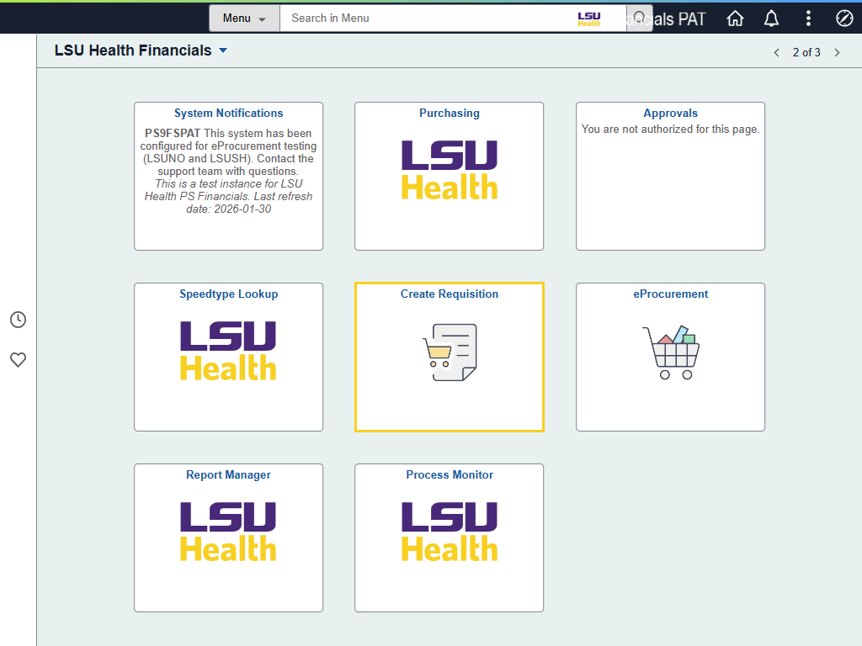

Step | Action
Create Requisition

Begin by selecting the Create Requisition tile from the LSU Health Financials homepage.

Click the Create Requisition tile.
Requisition Defaults for Punchout and Special Request Requisitions

The Requisition Defaults page is displayed. The Requisition Defaults page is where initial values for the requisition can be set. Whichever values are entered on this page will be present in the requisition going forward.
Requisition Defaults for Punchout and Special Request Requisitions (continued)

NOTE: There are specified fields that are considered required for
completing a Punchout requisition. These fields are:

• Acctg Date - will only be changed if items will be charged in new Fiscal
Year - located in Header Defaults section
• Supplier ID - located in Line Defaults section
• Buyer - located in Line Defaults section
• Ship To - located in Shipping Defaults section
• Due Date - located in Shipping Defaults section
• Accounting tag / chartfields - located in Distribution Defaults section
• Account - located in Distribution Defaults section
Requisition Defaults for Punchout and Special Request Requisitions (continued)

NOTE: There are other fields that are considered optional - but highly recommended - for entering information. These fields are:

• Requisition Name - located in the Header Defaults section
• Attention - located in the Shipping Defaults section
Requisition Defaults for Punchout and Special Request Requisitions (continued)

NOTE: Category and Unit of Measure (UOM) are in the Line Defaults section. These fields will not be populated by the user for Punchout requisitions. The Category and UOM will default onto the punchout requisition based on the item(s) selected from the supplier's ePro catalog.
Header Defaults

The Header Defaults section of the Requisition Defaults page contains information that will be found in the Header (top) section of the requisition when printed. Default setting can be changed by the user if needed.

The user's Requester ID will default into the Requester field. If it does not default, do not continue with the requisition; contact Purchasing for assistance.
Header Defaults (continued)

It is highly recommended that a Requisition Name be entered for each Punchout and Special Request requisition created. If the Requisition Name field is left blank, the system will auto-populate the requisition's id number when it is saved / submitted.

Enter the desired information into the Requisition Name field. Enter "Gen dept supplies".
Header Defaults (continued)

The Acctg (Accounting) Date defaults to the current date. However, it may need to be adjusted depending on the time of year you are creating the requisition. For example, if you are entering a requisition for the next Fiscal Year, the Acctg Date must be adjusted to 07/01/XX or after to ensure the requisition is charged to the correct budget period.

For this exercise, the user will enter 07/01/26 as the Acctg Date.

Enter the desired information into the Acctg Date field. Enter "070126".
Line Defaults, Shipping Defaults, and Distribution Defaults

The sections for Line Defaults, Shipping Defaults, and Distribution Defaults are set by PeopleSoft to be collapsed. Select the arrow to the left of each section name to expand the section.

NOTE: This step serves as an example for expanding a collapsed section. No other expand / collapse steps will be included in this topic or in all remaining topics.

Click the Line Defaults arrow.
Line Defaults (continued)

The Supplier ID and Buyer must be entered by the user. The Supplier Location will default into the field when the Supplier ID is entered / selected.

Click the Look up Supplier ID button.

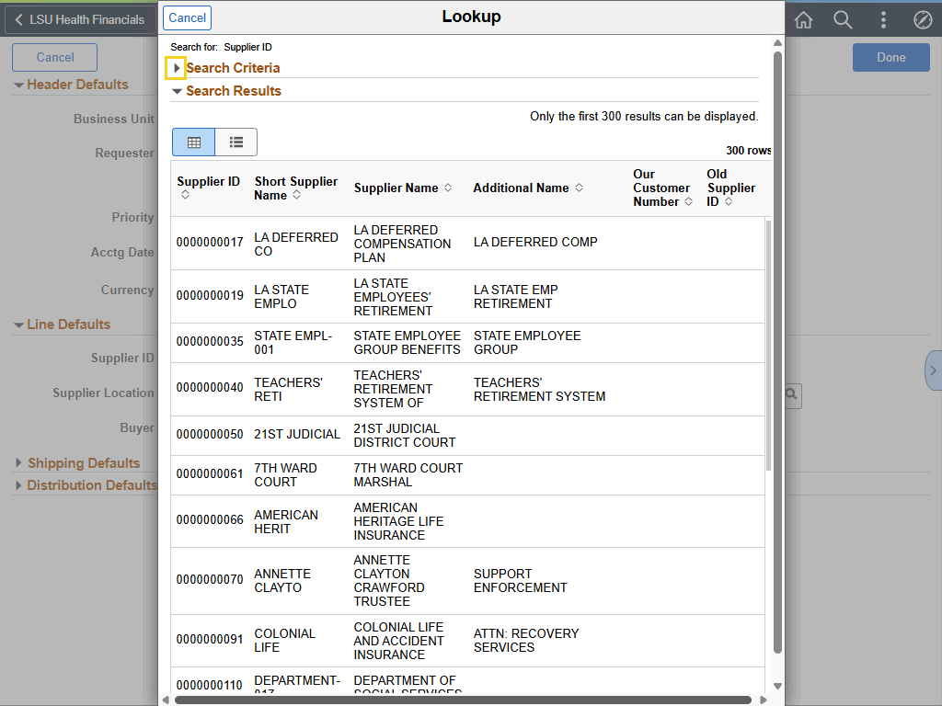

Step | Action
Search Criteria Section

NOTE: The Search Criteria section is set by PeopleSoft to be collapsed. Users must expand the section on all Lookup pages to utilize search options. Search options will vary based on the Lookup page being accessed.

NOTE: This step serves as an example for expanding / collapsing sections. No other expand / collapse steps will be included in this topic or in all remaining topics.

Click the Search Criteria arrow.

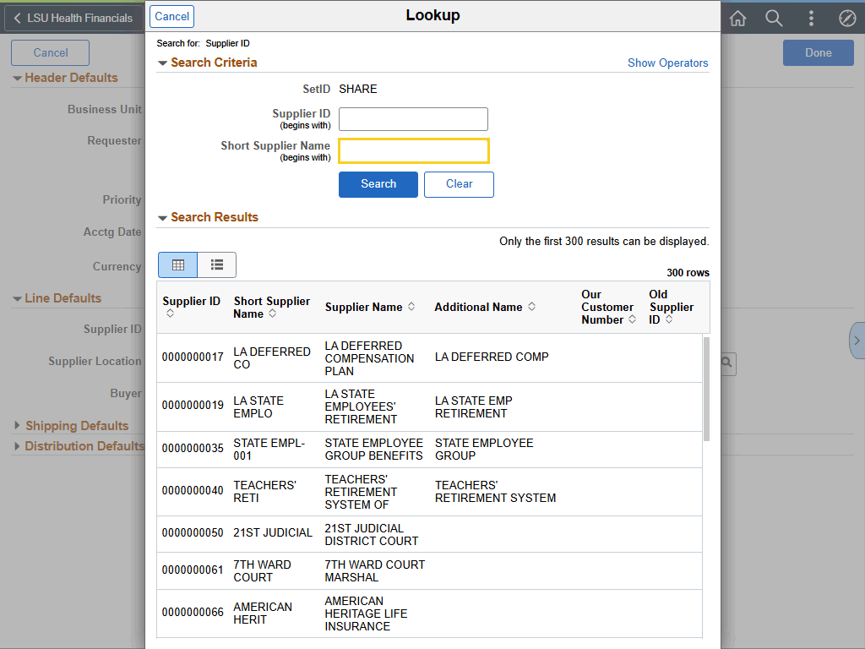

Step | Action
Search Criteria Section (continued)

In this exercise, Staples will be used as the Supplier.

Enter the desired information into the Short Supplier Name field. Enter "STAPLES".

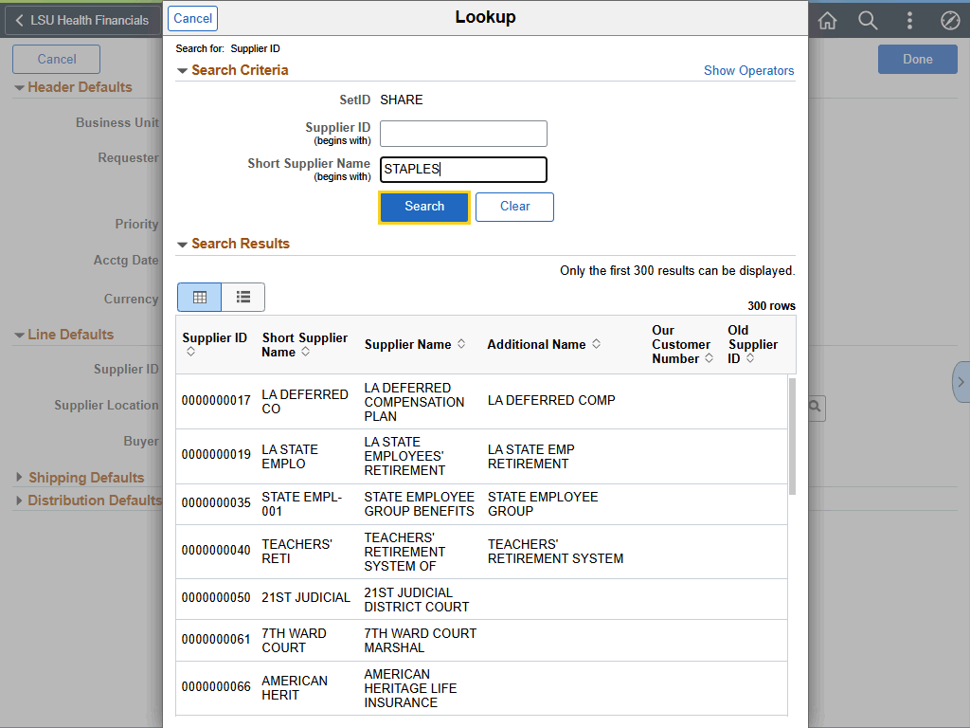

Step | Action
Search Criteria Section (continued)

Click the Search button.
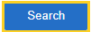
Search Criteria Section (continued)

NOTE: The 0000002106, STAPLES CO-002, STAPLES CONTRACT & COMMERCIAL LLC will be used by LSUNO when ordering items using ePro.

Click the 0000002106 - STAPLES CO - 002 button.
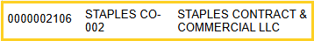

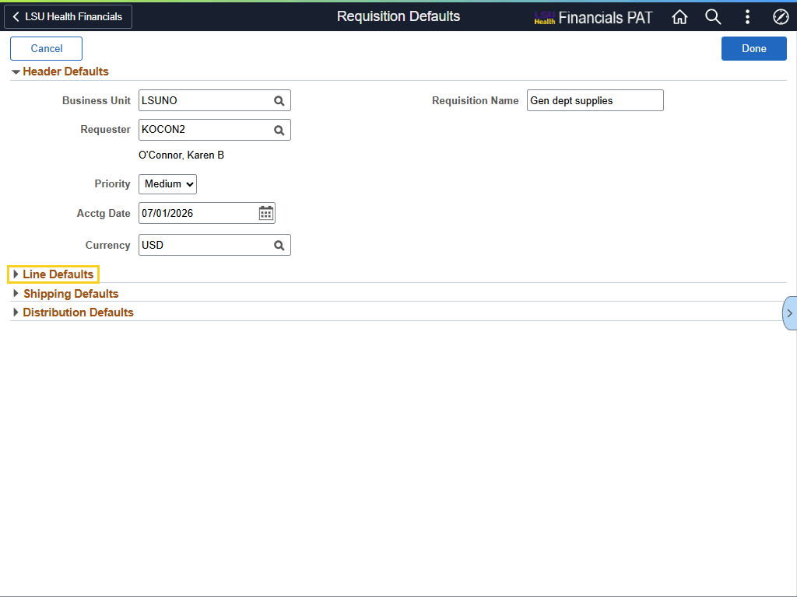

Step | Action
Line Defaults (continued)

NOTE: The Line Defaults section is set by PeopleSoft to be collapsed. Users will be required to re-open the Line Defaults section each time the Lookup feature is used.

NOTE: This step serves as an example for expanding collapsed section. No other expand / collapse steps will be included in this topic or in all remaining topics.

Click the Line Defaults arrow.

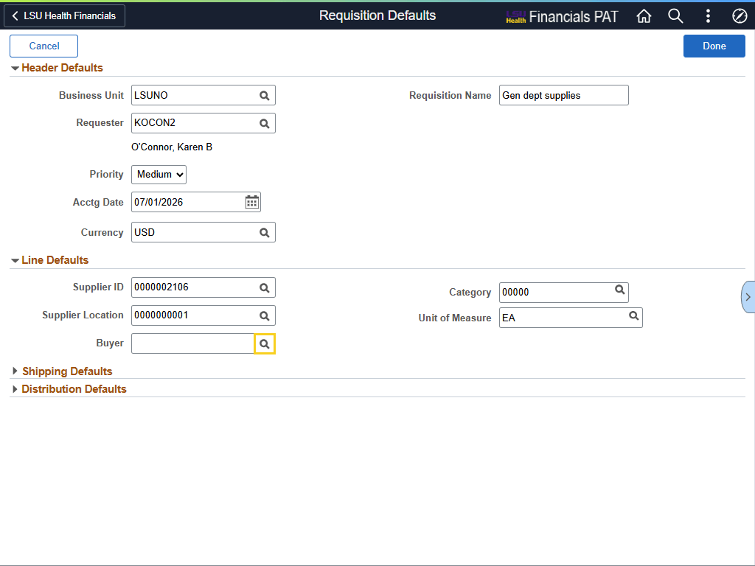

Step | Action
Line Defaults (continued)

The Buyer is a required field for LSUNO. If you do not know who your buyer is, you can search for the Buyers By Department page using the Search option on the LSU Health New Orleans web page. The URL is provided below. The user can copy and paste the URL into his/her browser.

https://www.lsuhsc.edu/administration/SupplyChain/buyers_by_department.aspx

Click the Lookup Buyer button to search for the Buyer's user id.

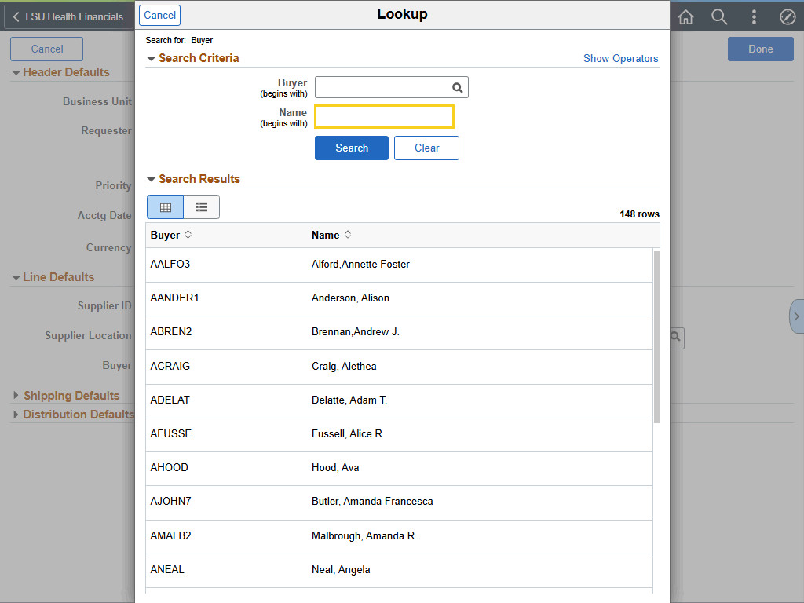

Step | Action
Search Criteria

In this exercise, the user will search for Deborah Holmes as the Buyer.

Enter the desired information into the Name (begins with) field. Enter "HOLMES".

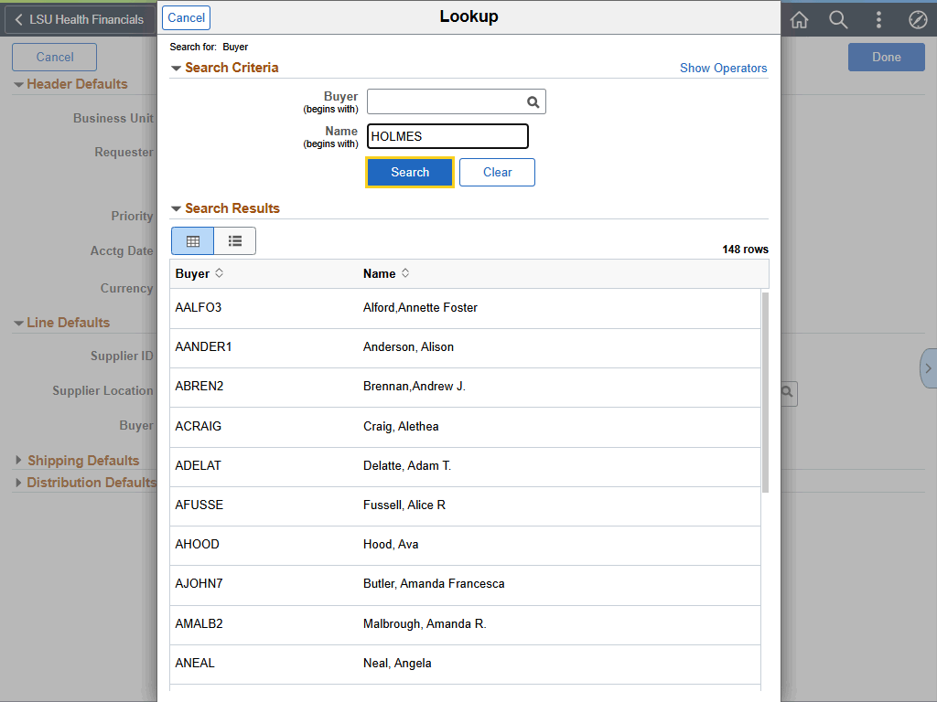

Step | Action
Search Criteria (continued)

Click the Search button.

Search Criteria (continued)

Click anywhere on the line containing the Buyer's name to select the Buyer.

Click the DHOLME2 - Holmes, Deborah button.
Category and Unit of Measure (UOM)

Category and UOM will be left as defaulted on the Punchout Requisition Defaults page.
Line Defaults (continued)

Once all relevant fields are populated, the user may collapse the Line Defaults section.

Click the Line Defaults arrow.
Shipping Defaults

Expand the Shipping Defaults section.

Click the Shipping Defaults arrow.

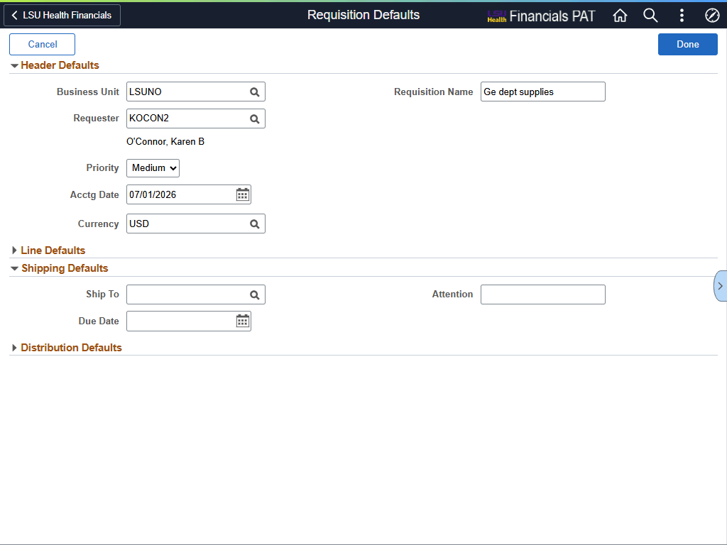

Step | Action
Shipping Defaults (continued)

Your department number serves as the Ship To location.

Enter the desired information into the Ship To field. Enter "1491500".
Shipping Defaults (continued)

The Due Date is the date you expect to receive the item(s) or service(s).

For this exercise, the user will enter the Due Date of 7/08/26.

Enter the desired information into the Due Date field. Enter "070826".

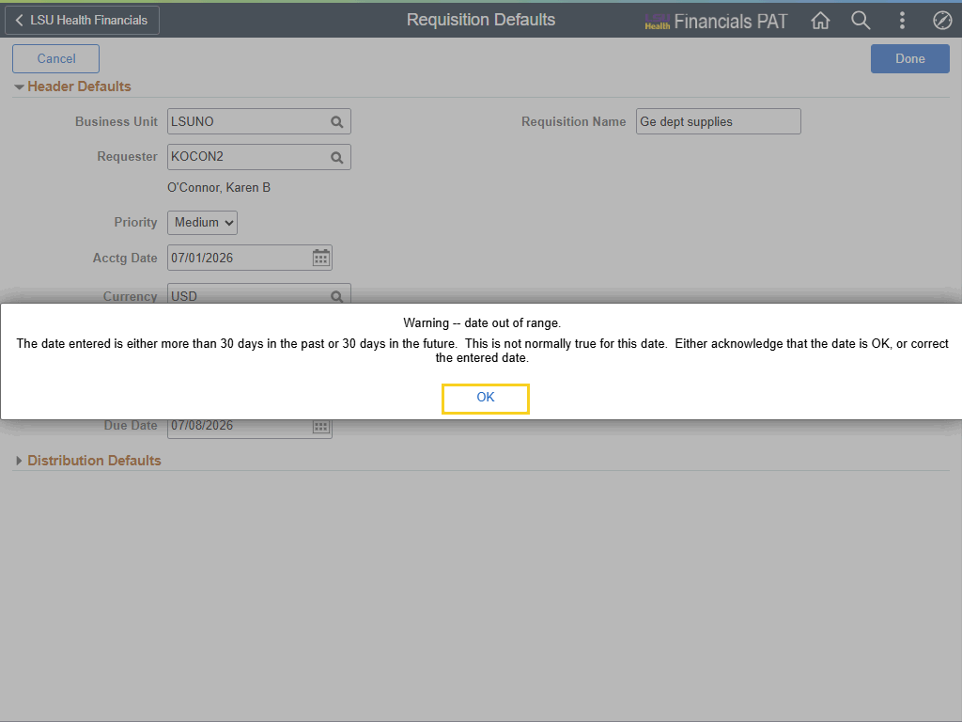

Step | Action
Shipping Defaults (continued)

When creating a requisition for the new Fiscal Year, as is being demonstrated in this exercise, it is usual for the user to receive a Warning message for the date being more than 30 days in the future. This message will be displayed when the user attempts to navigate away from the Due Date field.

Select OK to clear the message.

Click the OK button.

Shipping Defaults (continued)

The Attention field is an optional field for entering data. It is highly recommended that an appropriate name be entered into the Attention field for each requisition created.

For this exercise, Karen O'Connor will be the person to whom the item(s) will be delivered, so her name will be entered into the Attention field.

Enter the desired information into the Attention field. Enter "KAREN O'CONNOR".
Shipping Defaults (continued)

Once all relevant fields are populated, the user may collapse the Line Defaults section.

Click the Shipping Defaults arrow.
Distribution Defaults

Expand the Distribution Defaults section.

Click the Distribution Defaults arrow.
Distribution Defaults (continued)

In the Requisition Defaults page and in the Distribution section of the Requisition Line Details - Schedule page, Accounting Tags can be used to efficiently enter chartfield information.

An Accounting Tag is a predefined shortcut that automatically populates individual chartfield values (e.g., Account, Dept, Fund, etc.) on the Distribution Line located on the Requisitions Defaults page.

Chartfields provide the basic structure to identify and categorize transactional and budget data. When entered on a requisition, the chartfield values are telling the system to what accounts and budget the item(s) on the requisition will be charged.
Distribution Defaults (continued)

Chartfield and budget information can be updated in the Distributions section across several tabs. Below are the noteworthy fields and the tabs where they can be found:

• Chartfields1 Tab: Percent, Location, GL Business Unit, and Account
• Chartfields2 Tab: Fund, Depart, Program, and Class
• Chartfields3Tab: PC Business Unit, Project, and Activity

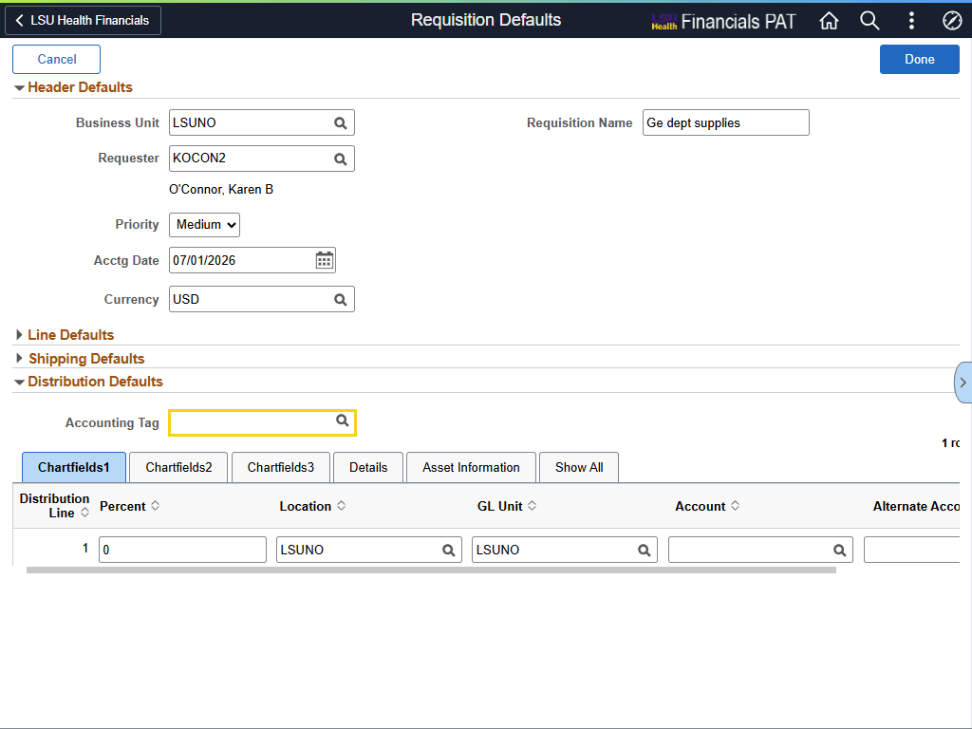

Step | Action
Distribution Defaults (continued)

The user will enter the Accounting Tag to which item(s) will be charged.

Enter the desired information into the Accounting Tag field. Enter "0491500014".
Distribution Defaults (continued)

Press [Tab] key on your keyboard to exit the Accounting Tag field. The system will automatically populate the chartstring information onto the Distribution Line.
Distribution Defaults (continued)

Account is a required field. It does not, however, default onto the Distribution Line via the Accounting Tag. Account is not one of the chartfields that make up an Accounting Tag.

NOTE: To view Accounting Tag chartfield values, select the Chartfields2 tab.

Enter the desired information into the Account field. Enter "546700".

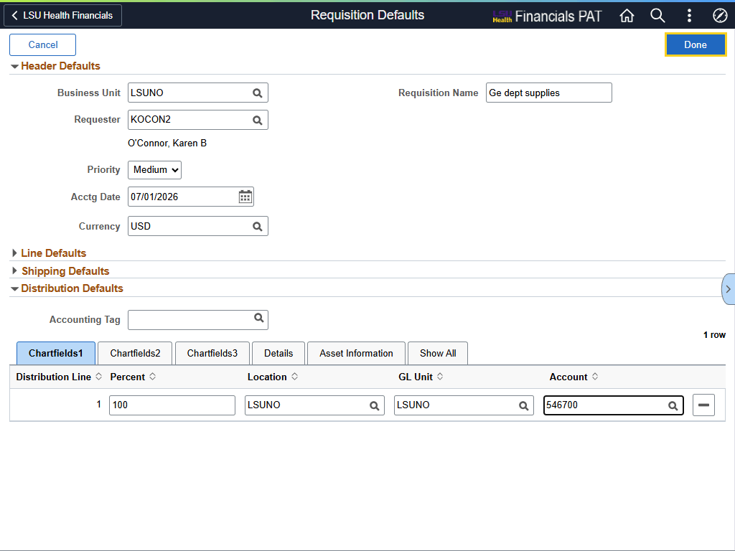

Step | Action
Requisition Defaults for Punchout Requisitions (continued)

After all information has been entered on the Requisition Defaults page, select the Done button to navigate to Punchouts supplier catalog list.

Click the Done button.
This completes Enter Requisition Defaults for a Punchout Requisition.
End of Procedure.

Create a Punchout Requisitions
Procedure

In this topic you will learn how to Create a Punchout Requisition.

Step | Action
*****NOTICE*****

The Supplier names, ordered items, and other values being shown in this exercise are for demonstration purposes only. When working in Production, users must enter their requisition information.
Create Requisition

The eProcurement main page for creating requisitions has three (3) sections:

• Navigation frame – menu options for Special Requests, Punchouts, Favorites, Templates, Item History, and Express Entry
• Main frame – where the page chosen from the Navigation frame is displayed – by default, the Punchout page is displayed
• Cart frame – shows what is currently in the requester’s cart
Create Requisition (continued)

Navigation Frame

• Special Requests page – are created for requesting all other items that are not available from, or user has chosen not to order from, punchout suppliers
• Punchouts page – shows a list of punchout suppliers – supplier’s external ordering catalog allows the requester to view and order items from the supplier catalog
• Favorites page - allows requesters to order items that have been saved as Favorites, which can be special request and punchout items
• Templates page – allows requesters to submit full requisitions that were saved as a template
• Item History page – allows the requester to re-order items that have previously been requested
• Express Entry page – is not used by LSUNO
Create Requisition (continued)

The requester can close/open the Create Requisition menu by selecting the Side 1 page - Requisitions button (black button on left side menu).
Create Requisition (continued)

The requester can open/close his/her shopping cart by selecting the Open/Close Shopping Cart button (grey button) on the right side of the punchout page.

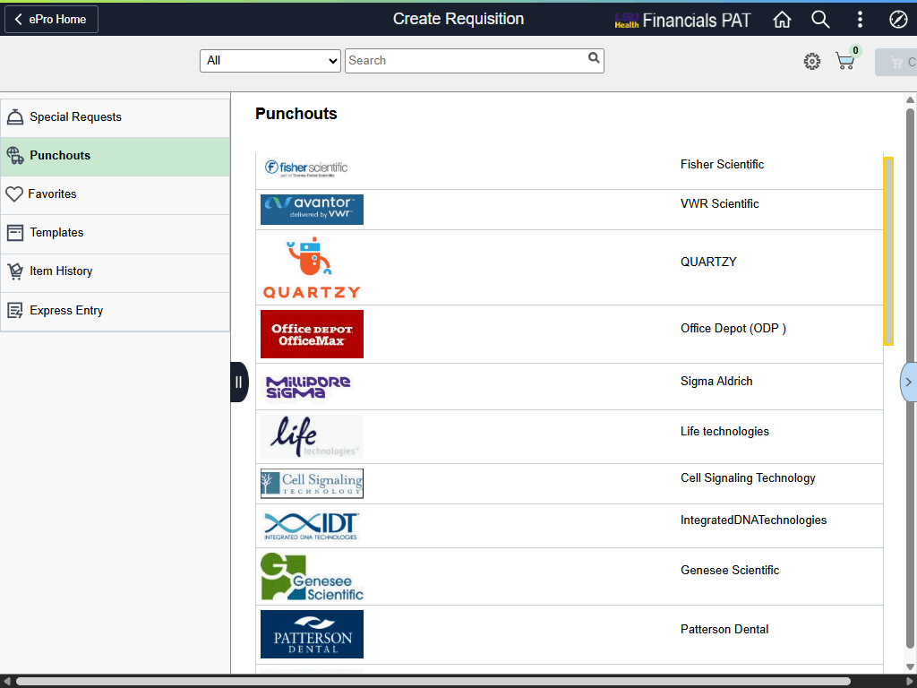

Step | Action
Punchout Requisitions

The system defaults you into the Punchouts option in the Navigation frame.

A list of available supplier external catalogs is displayed in the Main frame. You will scroll to find the desired supplier.

In this exercise, Staples will be the supplier used.

Click the Down button of the scrollbar.
Punchout Requisitions (continued)

Click the Staples list item.

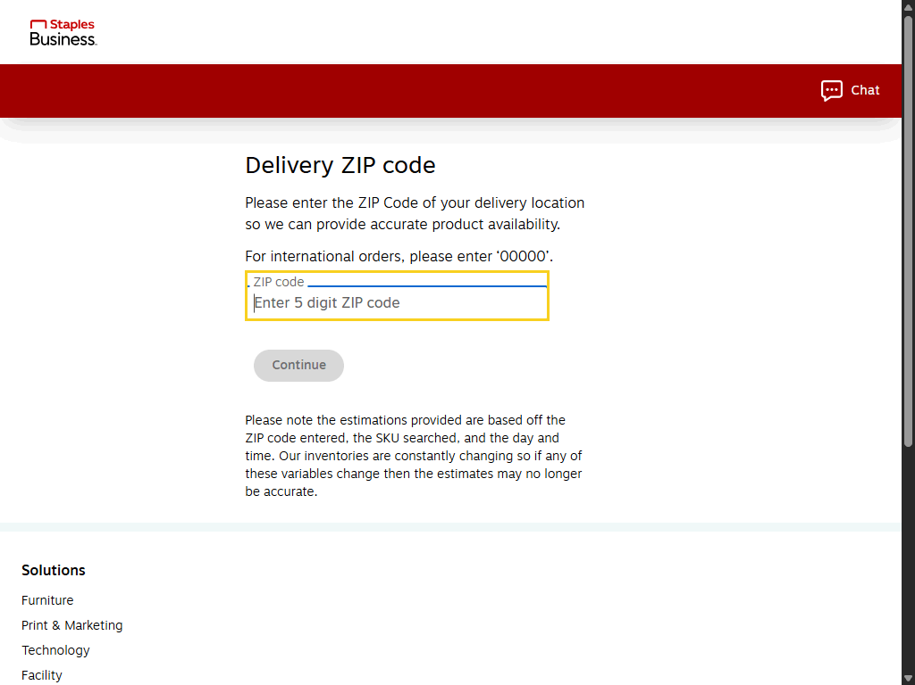

Step | Action
Punchout Requisitions (continued)

Enter the Zip Code for where the items will be delivered.

Enter the desired information into the Zip Code field. Enter "70112".

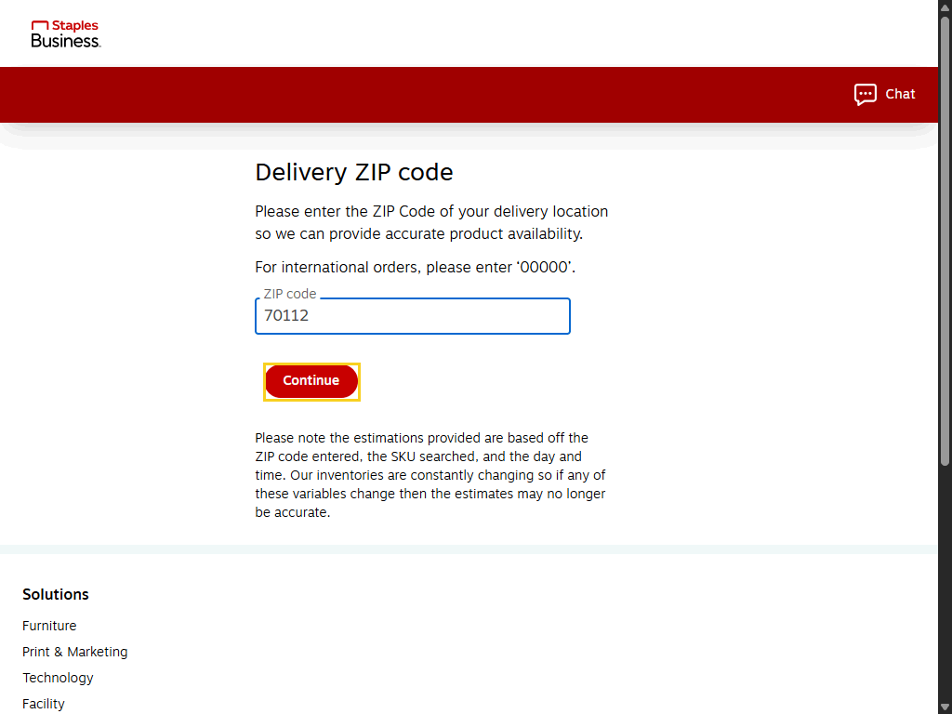

Step | Action
Punchout Requisitions (continued)

Click the Continue button.
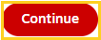
Punchout Requisitions (continued)

The first time you enter Staple's catalog, you will receive this message. Please read the entire message before proceeding with your requisition.

Click the Close Message button.

Punchout Requisitions (continued)

There are three (3) options you can use to search for items to purchase:

• Shop – select Shop to view a menu of available options (e.g., Office Supplies, Paper, etc.)
• Pictorial Menu – select from the picture icons the desired option you wish to view (e.g., Furniture, Office Supplies, etc.) – select the right arrow to view more picture options
• Search – click into the Search box for a list of options (e.g., pens, copy paper, sticky notes, etc.) – you can also enter the name of the item you wish to view and click the magnifying glass to view options
Punchout Requisitions (continued)

In this exercise, you will use the Search option to find items to purchase.

Click in the Search field.

Punchout Requisitions (continued)

In this example, you will select the pens list option.

Click the pens list item.
Punchout Requisitions (continued)

A menu of picture icons is displayed at the top of the page. By selecting a picture icon, you can narrow the focus by type of pen you wish to purchase.

In this example, you will select Black Pens.

Click the Black Pens button.
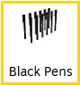
Punchout Requisitions (continued)

Notice all three (3) items are listed as "State Contract Approved" items. The State of Louisiana contracts with suppliers to purchase specified items for a specified price during a specified time period. State Contract items do not require specifications or RFQ's (Request for Quote) which means orders are received faster. Users are not required to purchase items on State Contract but are encouraged to do so.
Punchout Requisitions (continued)

Select the BIC Round Stic Xtra-Life Ballpoint pen, Medium Point, Back Ink, 60/pack (GSM609-BLK). Order 1 box.

Click the Add button.

Punchout Requisitions (continued)

A panel displays showing you have added 1 item (BIC Black Pens) to your cart. The delivery date is also noted.

For this example, select the Continue Shopping option.

Click the Continue Shopping button.
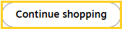
Punchout Requisitions (continued)

Click the "X" inside the Search field to remove "pens".

Click in the X in the Search field.
Punchout Requisitions (continued)

Select the Clear History link to view the entire list of items.

Click the Clear History link.
Punchout Requisitions (continued)

In this example, select the sticky notes option.

NOTE: If "sticky notes" are not in your search list, enter it in the Search field and click the magnifying glass.

Click the sticky notes list item.
Punchout Requisitions (continued)

In this example, you will select the 3 x 3 option.

Click the 3 x 3 button.

Punchout Requisitions (continued

In this example, you will select Staples Recycled Sticky Notes, 3 x 3, Sunshine Collection, 36 Pads/Pack (S-33YR36). Order 1 pack.

Click the Add button.

Punchout Requisitions (continued)

A panel is displayed showing you have added 1 item (Staples Recycled Sticky Notes) to your cart. The delivery date is also noted.

After entering all items, select the Review & Checkout option.

Click the Review & Checkout button.


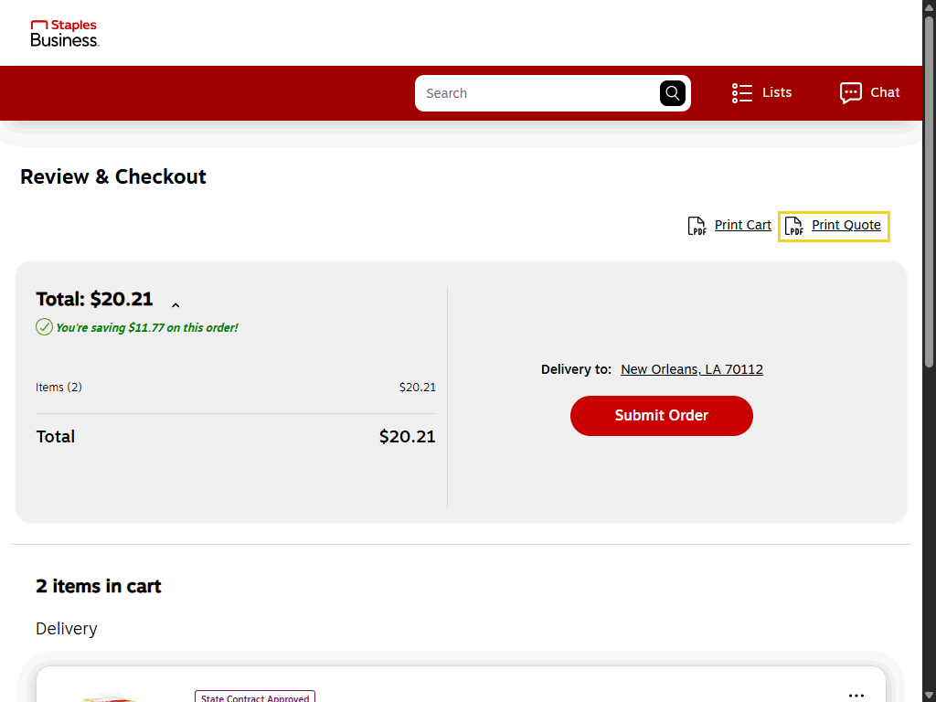

Step | Action
Punchout Requisitions (continued)

The user can print a copy of the cart or a quote (cost of each item).

In this example, the user will Print Quote.

Click the Print Quote link.

Punchout Requisitions (continued)

A message will be displayed stating a PDF will display the information in your cart. Select whether you wish for images of the items to be included.

In this example, the With Images option is selected and will remain as defaulted.

Click the Create PDF button.


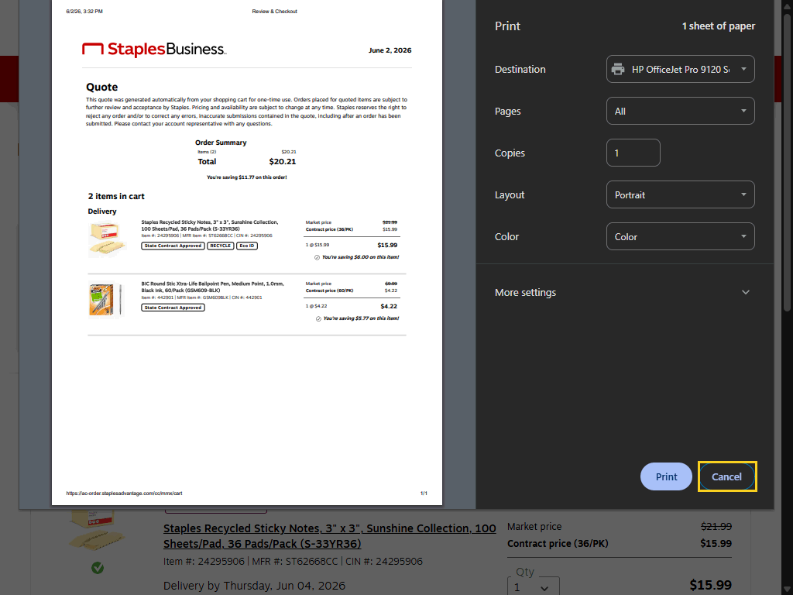

Step | Action
Punchout Requisitions (continued)

Select your printer parameters to print the document.

For training purposes only, click the Cancel button.


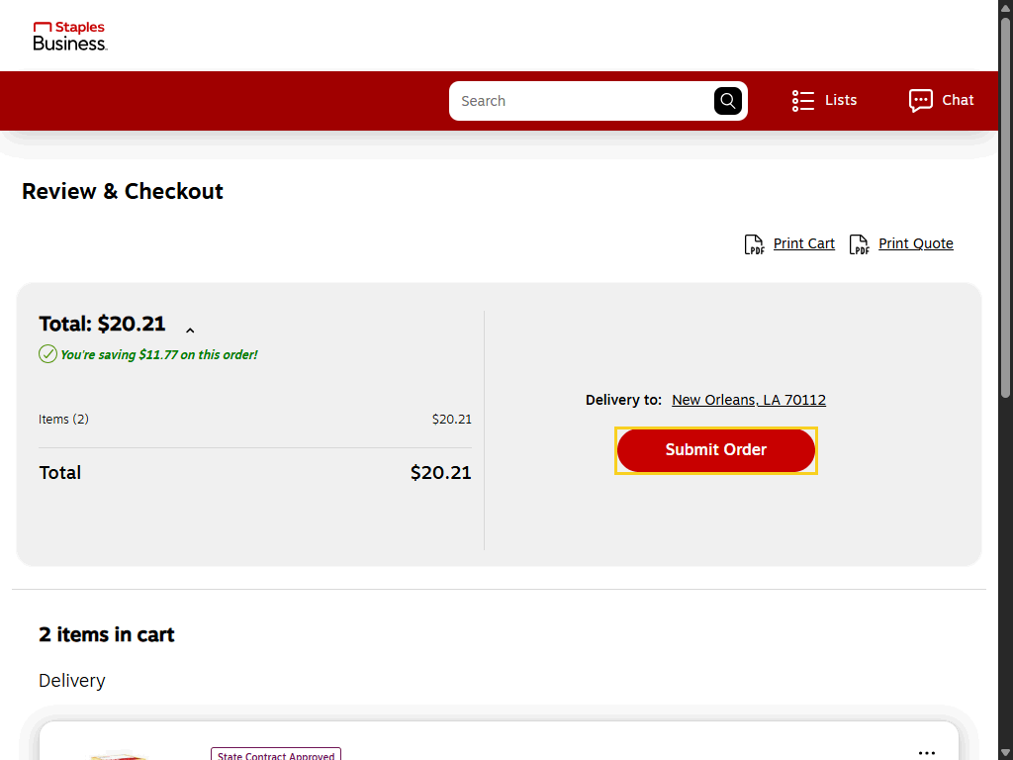

Step | Action
Punchout Requisitions (continued)

Select the Submit button to return to PeopleSoft so that comments, attachments, and chartfield information can be added or adjusted before submitting the requisition for approval.

Click the Submit Order button.

This completes Create a Punchout Requisition.
End of Procedure.

Create a Special Request Requisition
Procedure

In this topic you will learn how to Create a Special Request Requisition.

Step | Action
Create a Special Request Requisition

A Special Request Requisition is used to manually create requisitions for goods and services (e.g., blanket requisitions) that are not available through Punchout requisitions. It serves as a custom order form and allows users to define items by entering their own descriptions, prices, and quantities. (Oracle Help Center)

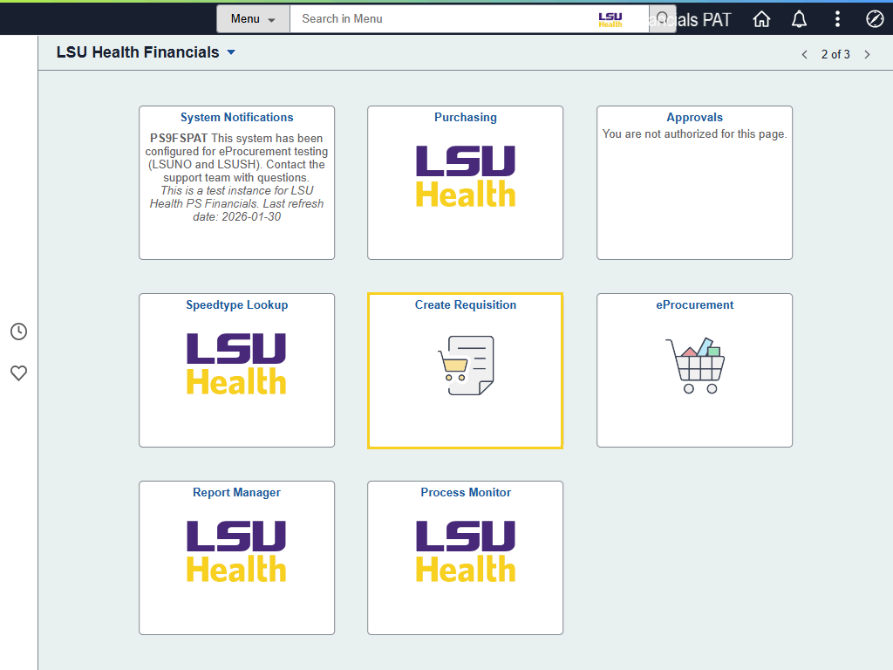

Step | Action
Create a Special Request Requisition

From the LSU Health Financials homepage, click the Create a Requisition tile.
Header Defaults

The user will follow the same steps for entering Requisition Defaults for a Special Request requisition as s/he did when entering Punchout Requisition Defaults.

NOTE: In this exercise, only the steps will be demonstrated for Requisition Defaults. Please refer to the Requisition Defaults topic for explanation information.

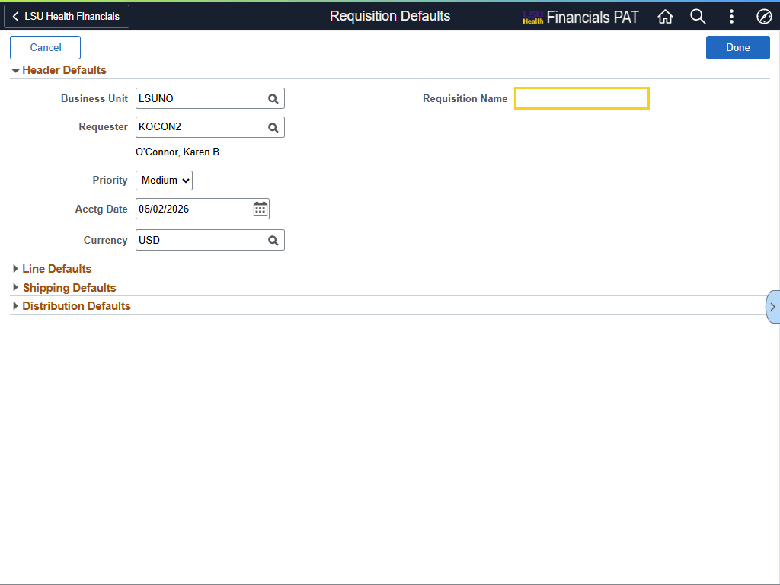

Step | Action
Header Defaults (continued)

It is highly recommended that a Requisition Name be entered. If the Requisition Name field is left blank, the system will auto-populate the requisition's id number when it saved / submitted.

Enter the desired information into the Requisition Name field. Enter "KENTWOOD BLANKET".
Header Defaults (continued)

For this exercise, the user will enter 07/01/26 as the Acctg Date.

Enter the desired information into the Acctg Date field. Enter "070126".

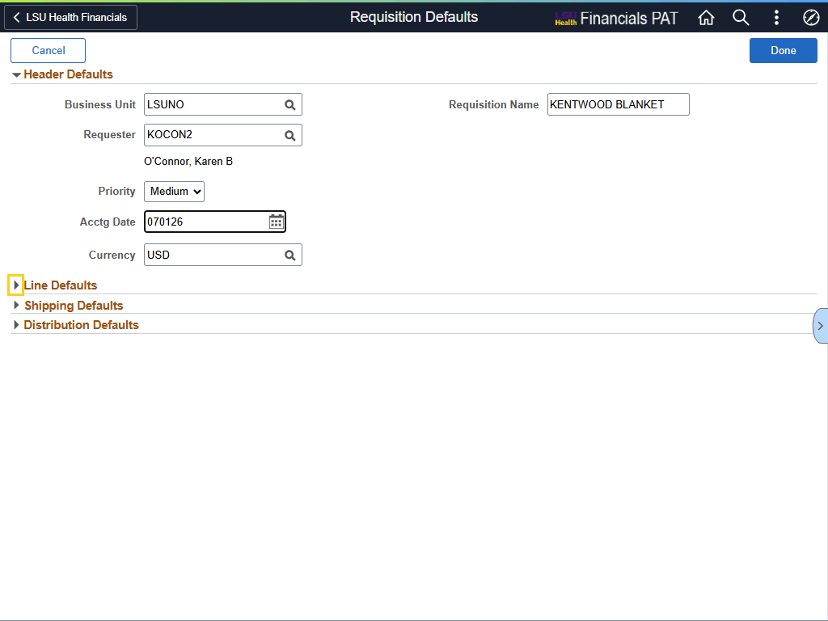

Step | Action
Line Defaults

Click the Line Defaults arrow.
Line Defaults (continued)

Click the Lookup Supplier ID button.
Lookup / Search

Click the Search Criteria arrow.

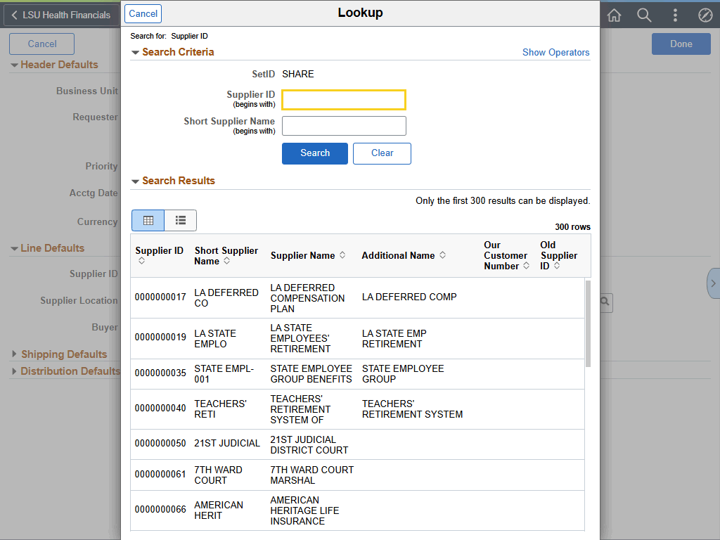

Step | Action
Lookup / Search (continued)

Enter the desired information into the Supplier ID field. Enter "KENTWOOD".

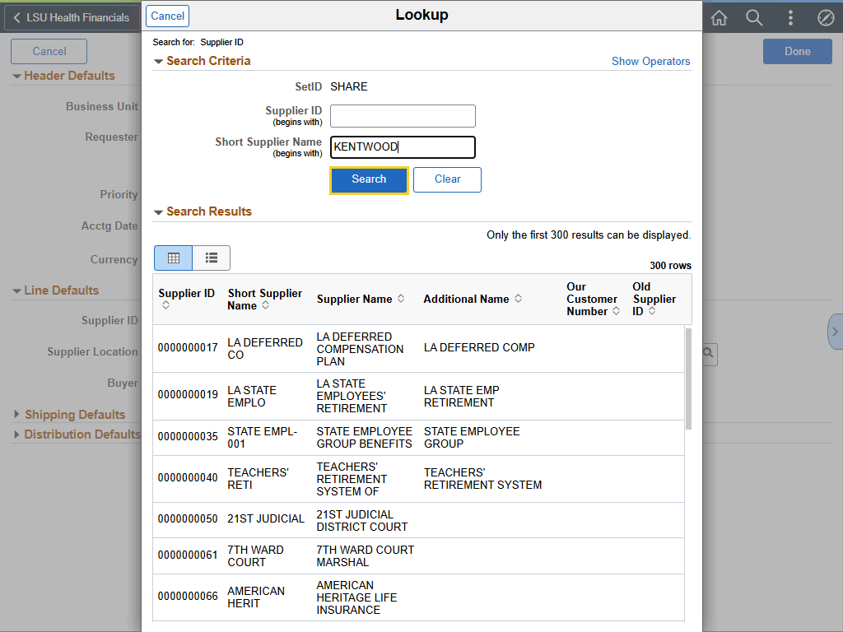

Step | Action
Lookup / Search (continued)

Click the Search button.

Lookup / Search (continued)

Click the KENTWOOD SPRINGS button.
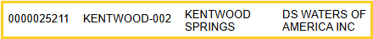
Line Defaults (continued)

Click the Line Defaults arrow.

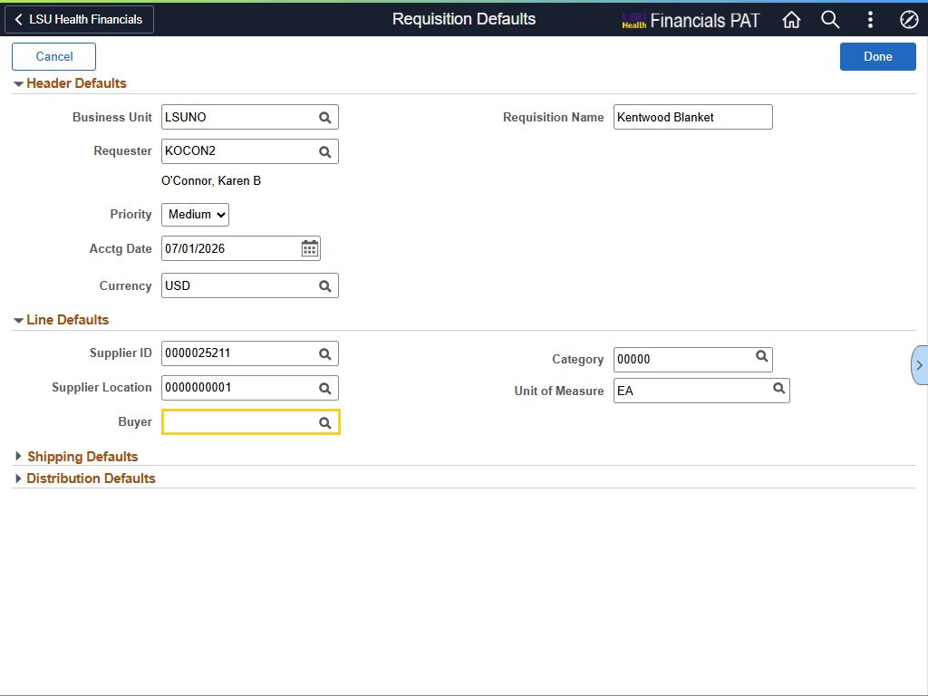

Step | Action
Line Defaults (continued)

Enter the desired information into the Buyer field. Enter "DHOLME2".

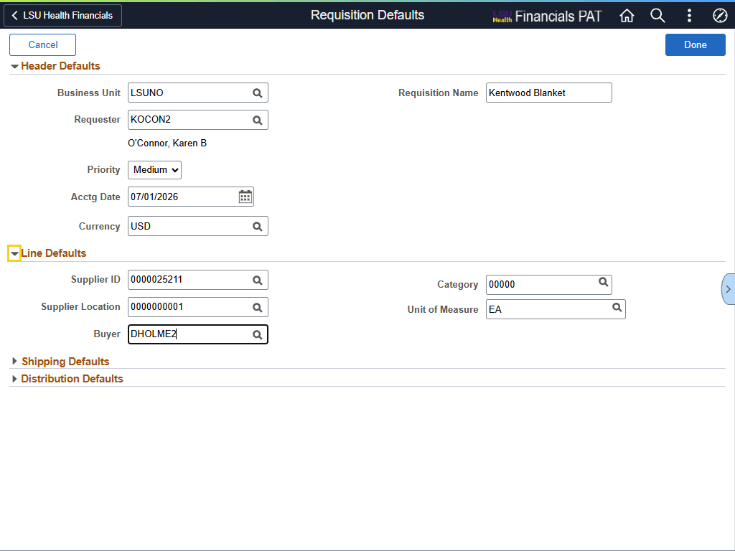

Step | Action
Line Defaults (continued)

Click the Line Defaults arrow.
Shipping Defaults

Click the Shipping Defaults arrow.

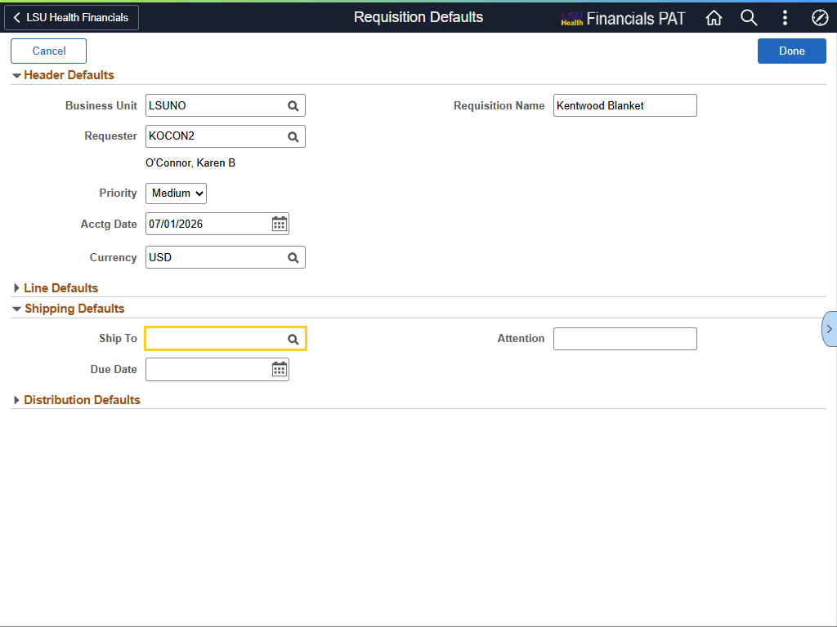

Step | Action
Shipping Defaults (continued)

Enter the desired information into the Ship To field. Enter "1491500".
Shipping Defaults (continued)

Enter the desired information into the Due Date field. Enter "063027".

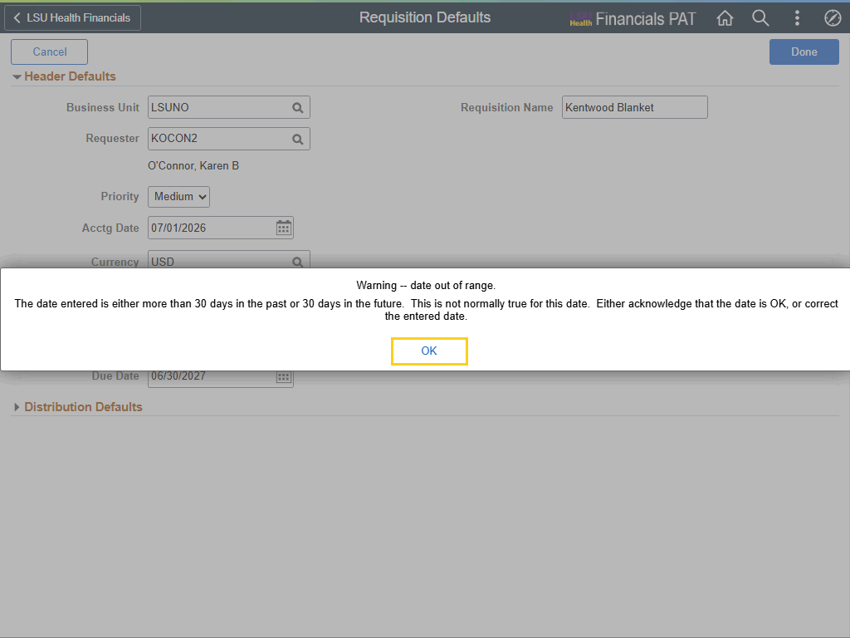

Step | Action
Shipping Defaults (continued)

Click the OK button.


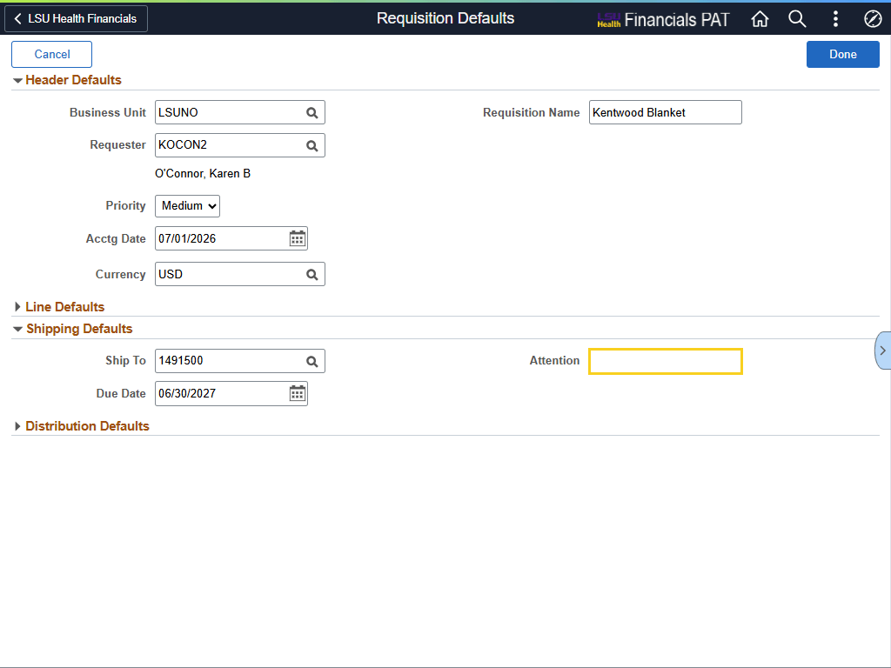

Step | Action
Shipping Defaults (continued)

Enter the desired information into the Attention field. Enter "KAREN O'CONNOR".

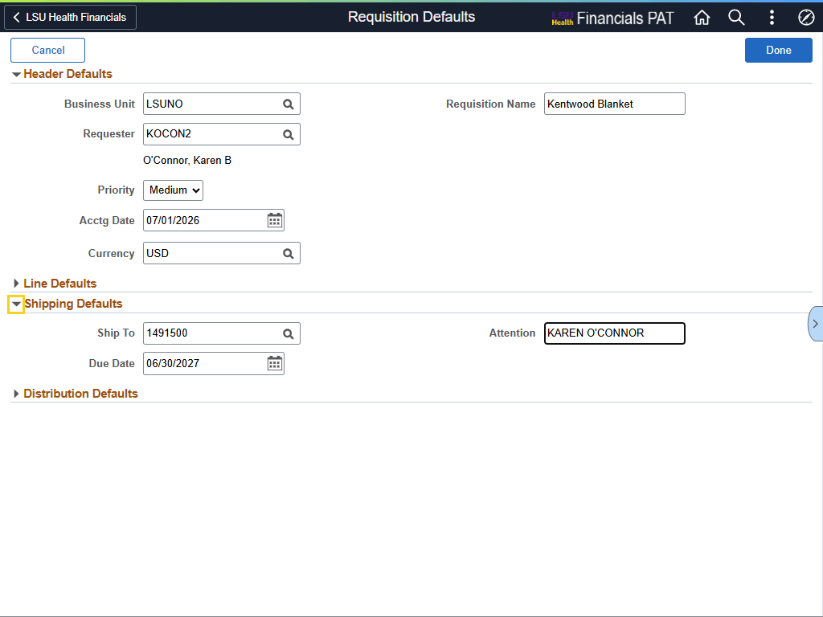

Step | Action
Shipping Defaults (continued)

Click the Shipping Defaults arrow.
Distribution Default

Click the Distribution Defaults arrow.

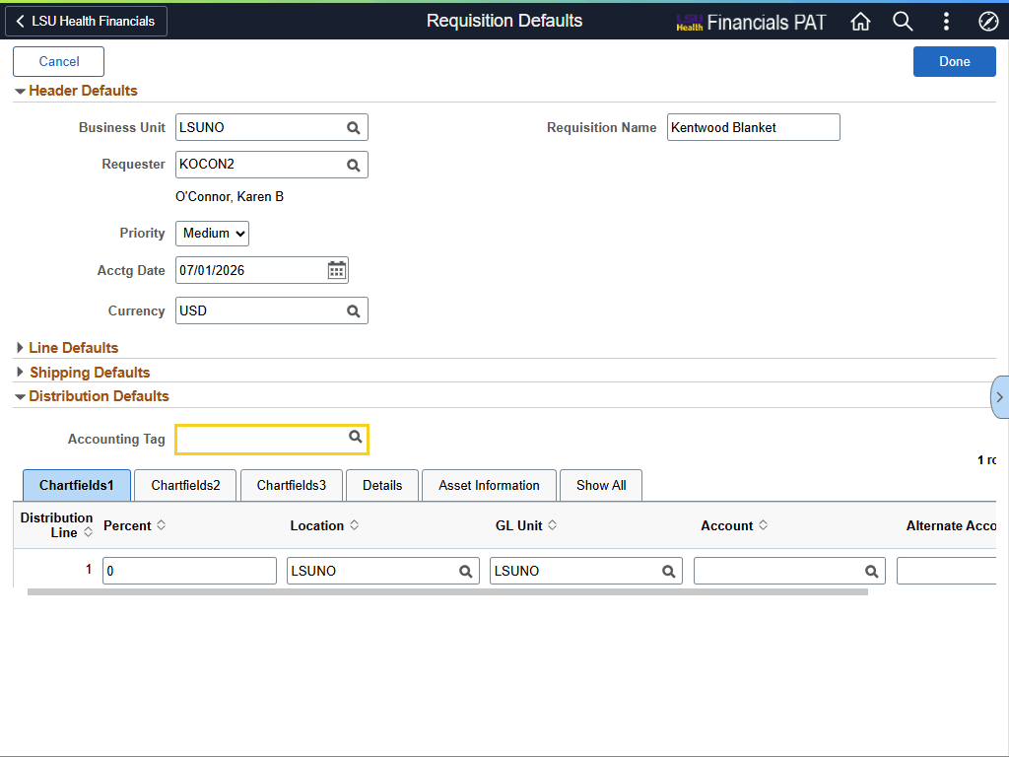

Step | Action
Distribution Default (continued)

Enter the desired information into the Accounting Tag field. Enter "0491500014".
Distribution Default (continued)

Press [Tab] button on your keyboard.

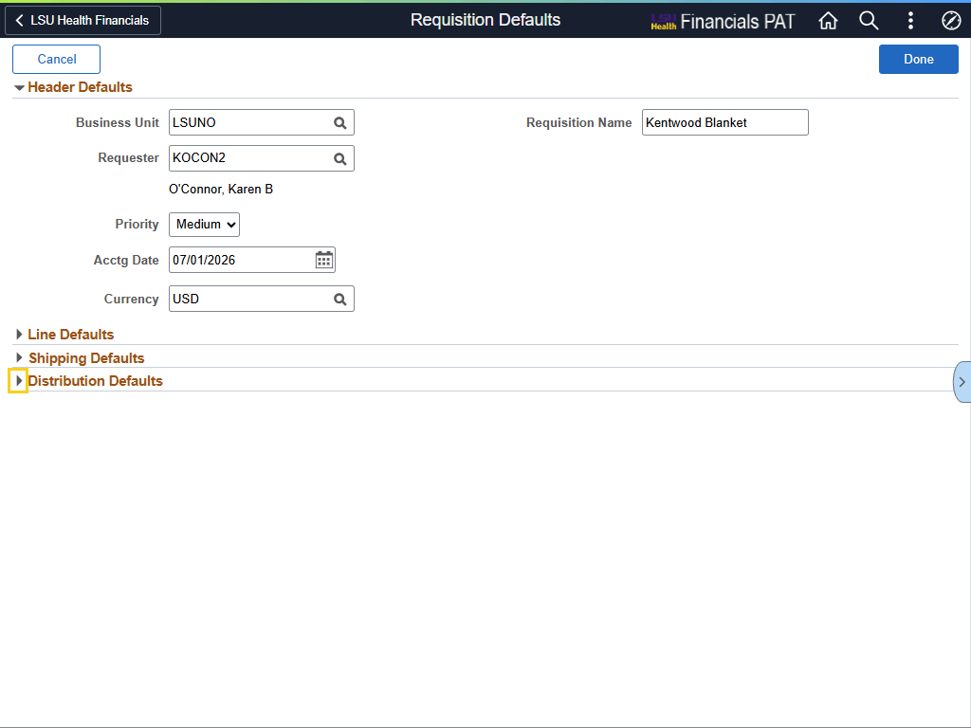

Step | Action
Distribution Default (continued)

Click the Distribution Defaults arrow.

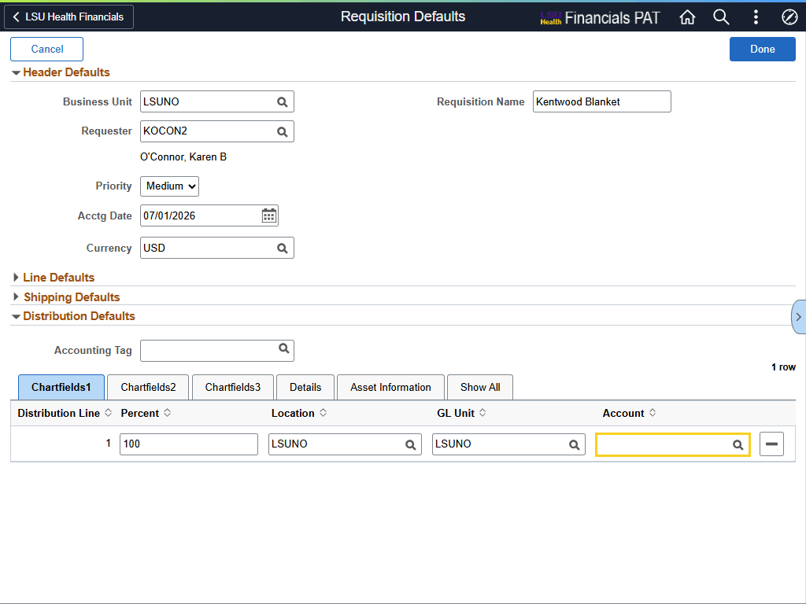

Step | Action
Distribution Default (continued)

Enter the desired information into the Account field. Enter "543700".

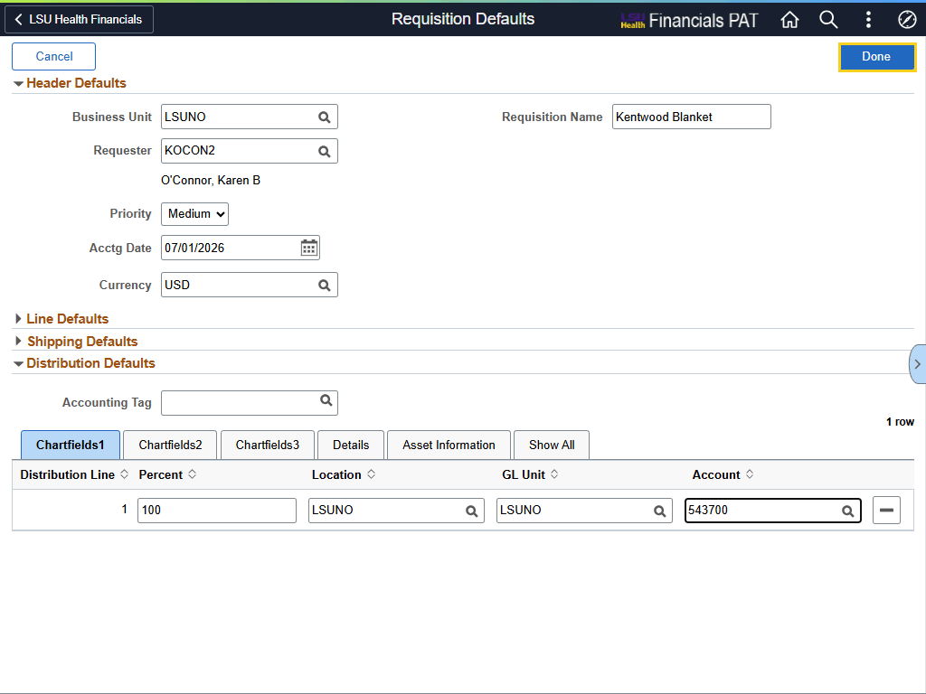

Step | Action
Requisition Defaults

Click the Done button.

Create a Special Request Requisition

Click the Special Requests menu.
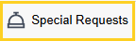
Create a Special Request Requisition (continued)

Click the Close Menu button.
Create a Special Request Requisition - PeopleSoft Required Fields

All fields that have an asterisk (*) before the field name are PeopleSoft required fields. This means you must enter a value into the field; it cannot be left blank.
Create a Special Request Requisition - LSUNO Required Fields

LSUNO has designated specific fields as required as well. These fields do not have an asterisk before the field name. However, you are required to enter a value into the fields listed below for LSUNO purposes:
1. Due Date - this value will default over from Requisition Defaults
2. Supplier ID - this value will default over from Requisition Defaults
3. Supplier Location - this value will default over from Requisition Defaults
4. Comment Text -
Item Information

The Item Information section allows the user to include specific details regarding the requested item to ensure the exact goods or services are being ordered. Some field information is automatically displayed based on information entered by the user in the Requisition Defaults page.
*Item Description

The Item Description field is a required PeopleSoft field, so a description must be entered in ALL CAPS for each line item. The field is a free-text edit field. This means any type of character can be entered into the field (e.g., letters, numbers, special characters, etc.).

The box is limited to 254 characters, which includes spaces. The system will allow you to enter more than 254 characters, but the system will truncate the number of characters entered down to 254.

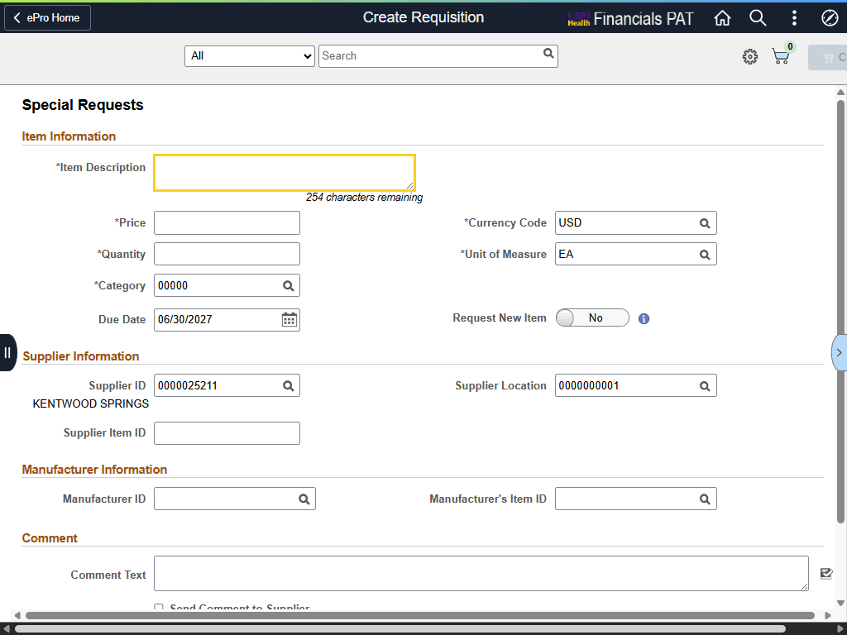

Step | Action
*Item Description (continued)

NOTE: Please ensure the description provides Purchasing with the needed detail without being overly verbose.

Enter the desired information into the *Item Description field. Enter "WATER SERVICE FY27".
*Price

The Price will be the unit price, contracted price, and / or yearly cost of the item or service being requested. When entering the cost of an item into the Price field, users must enter the decimal point to indicate cents (e.g., 12.95).

Enter the desired information into the *Price field. Enter "1500".
*Quantity

The Quantity must be entered in whole numbers (e.g., 10 or 11 rather than 10.5). This is the physical number of items being requested. When entering a fiscal year blanket requisition, the Quantity will be "1".

Enter the desired information into the *Quantity field. Enter "1".
*Unit of Measure

The Unit of Measure (UOM) defaults to "EA" (Each). The UOM can be changed as needed based on the item or service being requested. The user may enter the UOM directly into the field, or search for it by clicking the Look up UOM button to the right of the field.
Category

The Category is a value from the Inventory Tables of the State Commodity Code. The Category code will vary by business unit.

LSUNO users will enter or search for the appropriate Category code. If the appropriate code cannot be found, contact Purchasing for assistance.

Enter the desired information into the *Category field. Enter "39091".

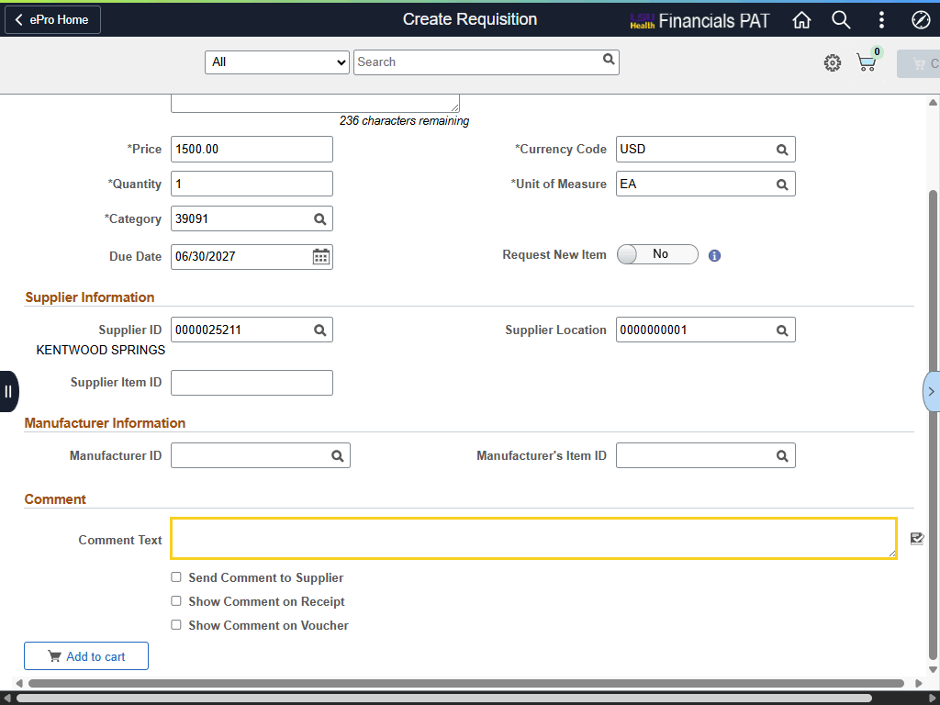

Step | Action
Comment Text

Use the Comment Text field to enter any additional information Purchasing may need regarding the item / service being requested.

Enter the desired information into the Comment Text field. Enter "WATER SERVICE FY27 BLANKET".
Add to Cart

Click the Add to cart button.

Cart

The user can view the items in his / her cart, by selecting the blue Open Cart button on the right side of the page.

Click the Open Cart button.
Checkout

The item(s) in the cart are displayed in the Cart column.

If all items have been added to the cart, select the Checkout button.

Click the Checkout button.

Checkout (continued)

On the Checkout page, the user can enter Header, Justification, and Line Comments, adjust Quantity or UOM, and access the Schedule and Line Details pages.
Header and Line Comments

The same method is used for entering Header and Line Comments. Comments can be added in Header Comments, or in Line Comments located in the Requisition Lines Overview section. The method used is the same for entering both Header and Line Comments.

Comments that will apply to all lines of the requisition will be entered into Header Comments, such as specific shipping instructions, supplier information if the supplier is not listed in the database, etc. Comments pertaining to a specific line item will be entered at the Line Comments.

File attachments can also be added in Header and Line Comments.
Header and Line Comments

NOTE: Entering Header and Line Comments will not be demonstrated in this example.

See the Checkout Page: Header, Justification, and Line Comments, and Attachments topic for instructions on entering Header and Line Comments.
Justification Comments

Justification Comments are used to explain why a specific purchase is needed - the purpose of the request - and the urgency of the request.

NOTE: Entering Justification Comments will not be demonstrated in this example.

See the Checkout Page: Header, Justification, and Line Comments, and Attachments topic for instructions on entering Header and Line Comments.
Schedule Details

Click the Schedule Details button.
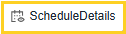
Schedule and Line Details

NOTE: Reviewing, adding, or adjusting Ship To, Due Date, Quantity, chartstrings, Buyer and / or Supplier will not be demonstrated in this example.

See the Checkout Page: Distributions, Schedule and Line Details, and Save topic for instructions on using Schedule and Line Details.

Checkout (continued)

After all comments, attachments, and adjustments have been made, you can Submit the requisition for approval.

Click the Submit button.

Checkout Confirmation

The Checkout Confirmation page is displayed, and the Requisition ID number is assigned. Budget Check cannot be completed until the requisition is approved.

Select the View Approval Chain to view the approval sequence. Select the Print Preview to print the requisition.

Notice the Next Steps section where you can Edit the Requisition, find existing requisitions, and begin a new requisition.
This completes Create a Special Request Requisition.
End of Procedure.

Checkout Page: Header, Justification, and Line Comments, and Attachments
Procedure

In this topic you will learn about the Checkout Page: Header, Justification and Line Comments, and Attachments.

NOTE: Information presented in this topic is relevant to both Punchout and Special Request requisitions. In this exercise, the Punchout requisition is used as the example.

Step | Action
Checkout

Use the Checkout page to review the contents of the requisition. Final adjustments can be made to quantity and UOM if the requisition is a Special Request requisition. The user can also add last-minute items to the requisition, as well as edit chartfield distribution. Selecting the Submit button transmits the requisition for approval.
Checkout (continued)

A level of priority can be assigned to the requisition. By default, all requisitions are set to "Medium" priority.

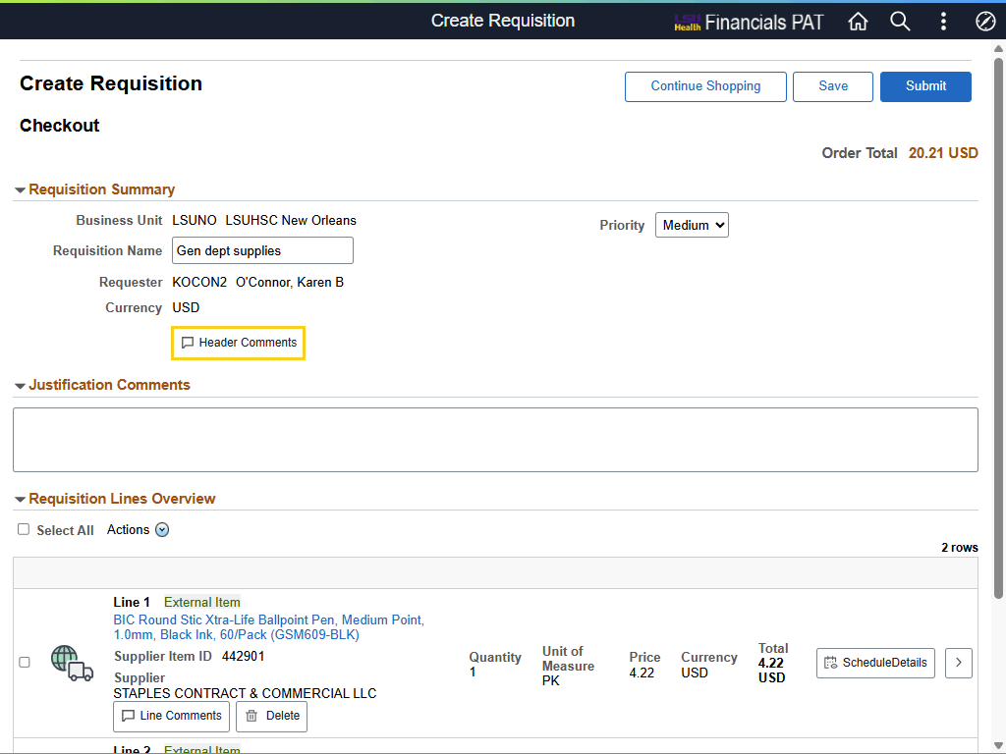

Step | Action
Header Comments

Comments can be added at the Header level by selecting the "Header Comments" button.

NOTE: Comments entered at the Header level will display and print on the requisition. Please do not include any comments you do not wish to be seen or shared.

Click the Header Comments button.
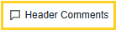
Requisition Header Comments and Attachments

The "Use Standard Comments" option is not used by LSUNO.
Requisition Header Comments and Attachments (continued)

Users will only enter information in Header Comments that applies to the entire requisition (e.g., specific shipping or delivery instructions applicable to all line items, etc.). A name for the requisition can be entered into the Comment Text field. If the Comment Text field is left blank, the system will auto-populate the requisition id number into the field when the requisition is saved or submitted.

Comment Text field is a free-text field, and your Enter key on your keyboard can be used to move between lines. PeopleSoft is a web-based application, so data (e.g., item specifications) from the web, or other Microsoft sources, can be copied and pasted into the comment boxes.

NOTE: It is recommended that users limit comments in each box to half a page.
Requisition Header Comments and Attachments (continued)

The user can select if the Header Comments be shown at various levels through the process. Select the radio button to the left of each option to change from "No" to "Yes" to indicate that Header Comments be shown.
Requisition Header Comments and Attachments (continued)

If comments are lengthy, documents can be attached rather than typing or copying and pasting information.

NOTE: Adding an attachment will be demonstrated later in this exercise.
Header Comments (continued)

Click the Done button when you have completed entering comments and adding attachments.

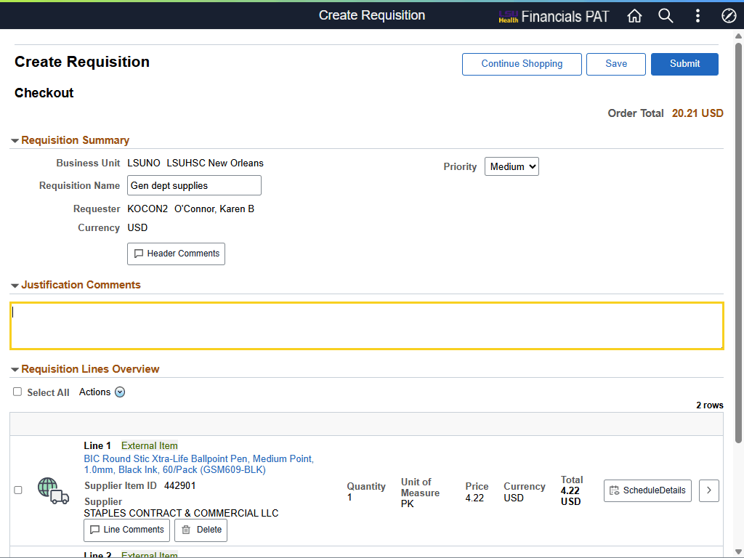

Step | Action
Justification Comments

Justification Comments for a purchase will be added by the user. The Justification Comments will be displayed on the Requisition Approval page for approver review.

Enter the desired information into the Justification Comments field. Enter "BUDGET FOR FY26 HAS BEEN SPENT".
Requisition Lines Overview

Each item in the cart is shown as a line item in the requisition. Users can access Line Comments, Schedule Details, and Line Details for each line item.

NOTE: Punchout items are marked as an "External Item" on the requisition line.

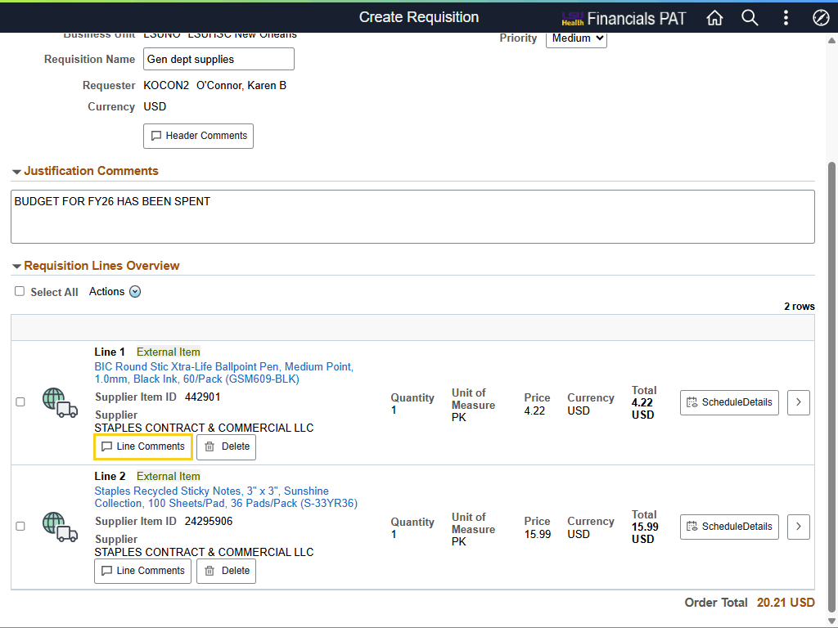

Step | Action
Line Comments

NOTE: Comments added to Line Comments will be displayed and printed below the corresponding line-item information on the requisition. Please do not include any comments you do not wish to be seen or shared.

Click the Line 1 Line Comments button.
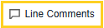
Line Comments (continued)

Line Comments will only be entered if they pertain to the specific line (e.g., item specifications). Line Comments have the same properties and characteristics as Header Comments, so follow the same instructions used to enter Header Comments.

For training purposes only, click the Cancel button.
Schedule vs Distribution

The schedule defines when and where you want the item(s) delivered. The distribution defines how accounts and departments are charged for the item(s), as well as how much of the total price the department will pay.

NOTE: To update more details of the item, as well as the shipping and chartfield information, select the Schedule Details button.
Schedule Details

If the user did not enter the required information on the Requisition Default page, the information can be added on the Schedule Details page. Users can also update item information, as well as shipping and chartfield information on the Schedule Details page.

Click the Schedule Details button.
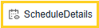
Ship To Comments

Ship To Comments can be added in Header Comments or Line Comments. Ship To Comments define when and where the user wants the specified item delivered.

In this example, the user will add a Ship To Comment, select Send to Supplier, and attach a document.

Click the Ship To Comments button.


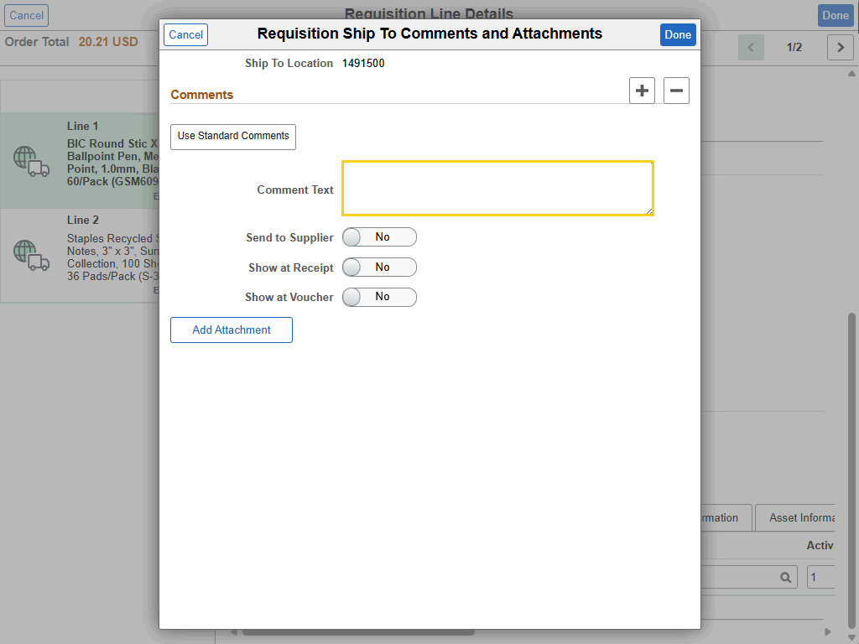

Step | Action
Ship To Comments (continued)

Enter the desired information into the Comment Text field. Enter "DELIVER TO MEB 4TH FLOOR, SUITE 4303".

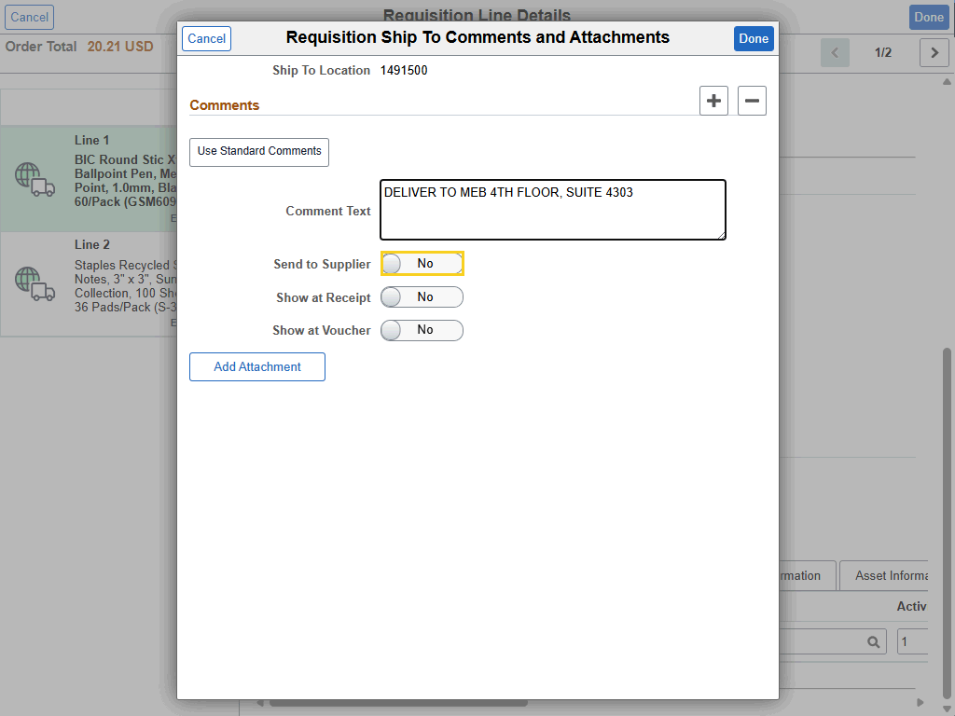

Step | Action
Ship To Comments (continued)

Click the Send to Supplier toggle button.
Add Attachments

If comments are lengthy, documents can be attached rather than typing or copying and pasting information.

Click the Add Attachment button.
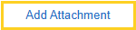
Drag and Drop to Add Attachments (continued)

Attachments can be "dragged-and-dropped" from a separate window into the blank space below the My Device button. Up to ten (10) attachments can be added, but no more than 3 can be added at one time.
Drag and Drop to Add Attachments (continued)

The file name is displayed in the blank space below My Device.

Click the Upload button.
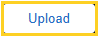
Drag and Drop to Add Attachments (continued)

Once the Upload is complete, select the Done button.

Click the Done button.

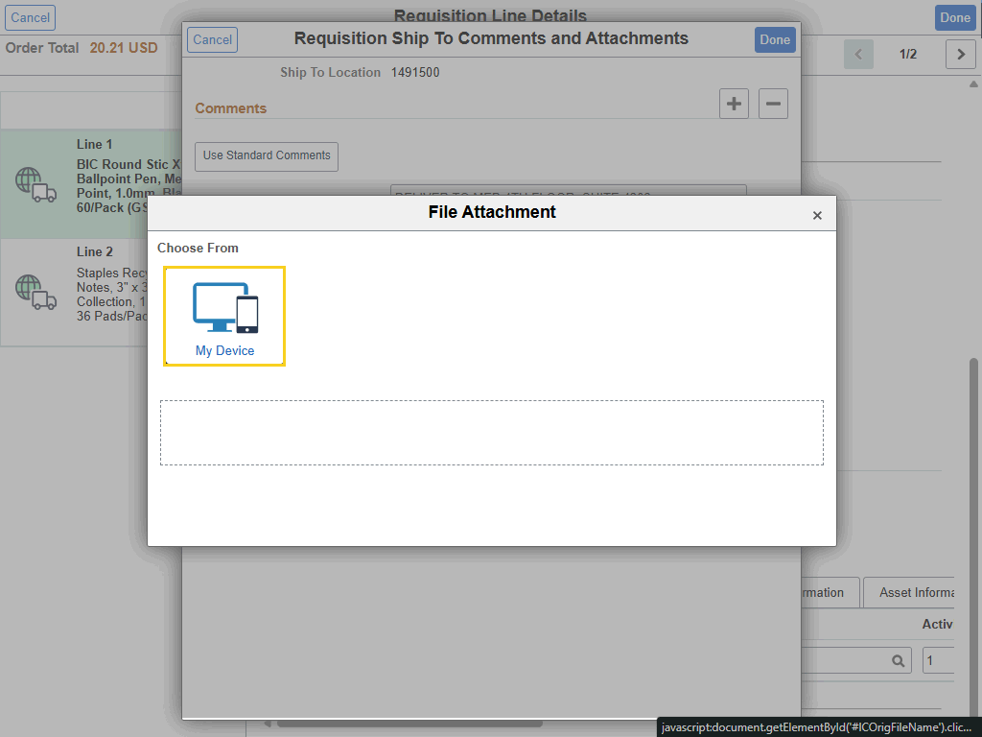

Step | Action
Alternative: Add Attachment using the My Device Button (continued)

Users can also select the My Device button to search for a specific file.

Click the My Device button.
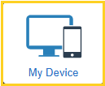
Alternative: Add Attachment using the My Device Button (continued)

NOTE: The folder and file selected in this example are used for training purposes only.

Double-click the Sample Docs for Manuals button.

Alternative: Add Attachment using the My Device Button (continued)

Click the ePro Attachment Example button.
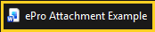
Alternative: Add Attachment using the My Device Button (continued)

Verify that the correct file has been selected before selecting the Open option.

Click the Open button.

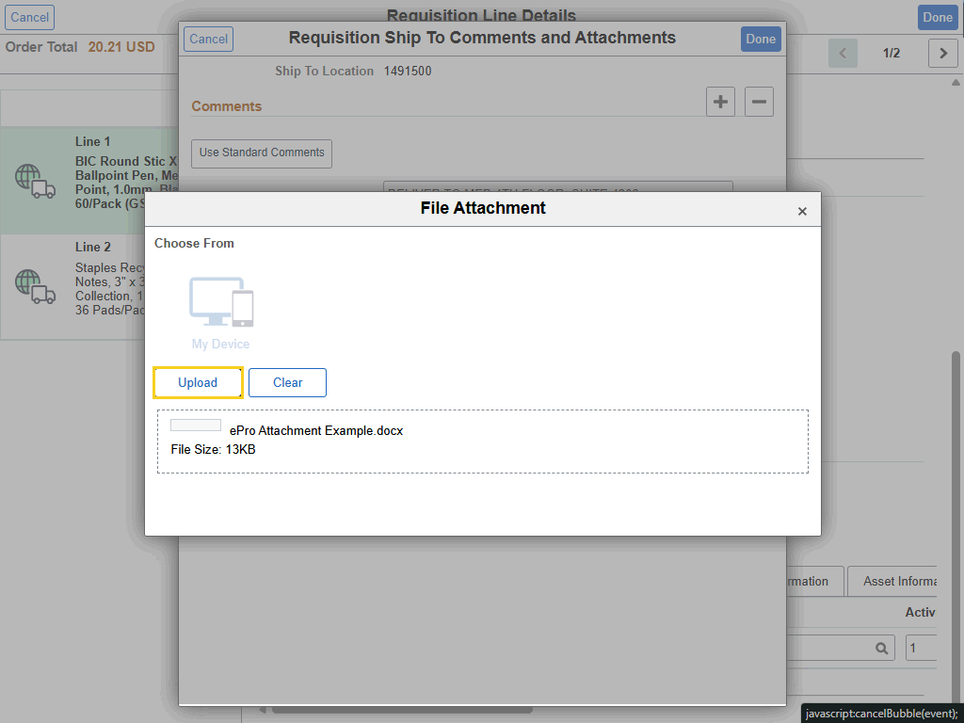

Step | Action
Alternative: Add Attachment using the My Device Button (continued)

The file name defaults into the bottom section of the File Attachment panel. Select the Upload button to complete uploading the file.

Click the Upload button.
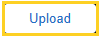
Alternative: Add Attachment using the My Device Button (continued)

The Word icon indicates the file is uploaded and you can complete attaching the file by selecting the Done button.

Click the Done button.
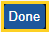
Alternative: Add Attachment using the My Device Button (continued)

The file is displayed in the Attachments section. The user can select if the file will be sent to the supplier, or one of the other selections, by clicking the Send to Supplier toggle button.

Click the Done button to exit the Requisition Ship To Comments and Attachments page.

This completes Checkout Page: Header, Justification and Line Comments, and Attachments.
End of Procedure.

Checkout Page: Distributions, Schedule and Line Details, and Save
Procedure

In this topic, you will learn how to use the Checkout Page: Distributions, Schedule and Line Details, and Save.

NOTE: Information presented in this topic is relevant to both Punchout and Special Request requisitions. In this topic the Punchout requisition is used as the example.
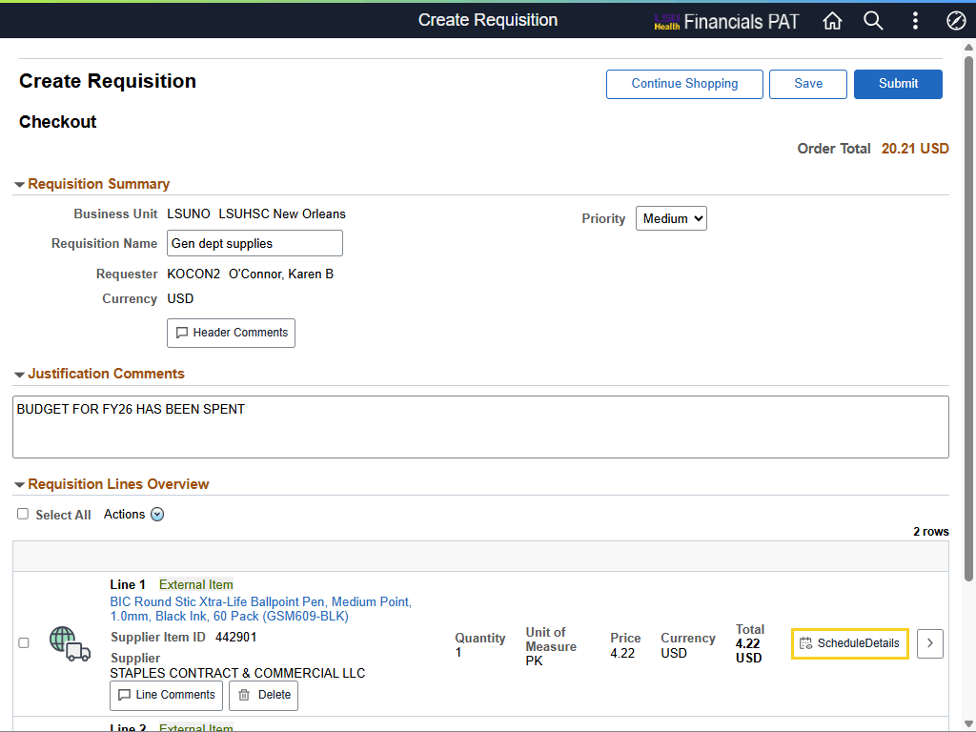

Step | Action
Click the Schedule Details button.
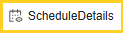
Line 1 and Left-Side Menu

The system defaults you to Line 1 - the first line item of the requisition, highlighted in green - in both tabs. In this exercise, there are two-line items that are displayed in the Left-Side Menu for ease of navigation.

The user can toggle between Line 1 and Line 2 item information simply by selecting the Line 2 option in the left-side menu.

Click the Left-Side Menu Line 2 button.
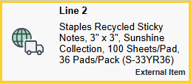
Left-Side Menu (continued)

Line 2 details are displayed.

Click the Left-Side Menu Line 1 button.
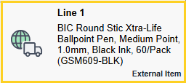
Schedule Details and Line Details Tabs

On the Requisition Line Details page there are two (2) tabs: one (1) tab for Schedule Details and one (1) tab for Line Details.

The Schedule Details tab consists of three (3) sections: Item Summary, Attributes, and Schedule 1. The Schedule 1 section allows the user to add or adjust the *Ship To, Attention To, Due Date, and Ship To Comments fields. Also included in Schedule 1 is the Distributions section. The user can add or adjust chartstring information in the Distributions section.

The Line Details tab contains two (2) sections: Item Summary and Attributes. The Item Summary section allows the user to confirm requisition checkout information for line-specific fields. Buyer information can be added or adjusted in this section as well. In the Attributes section, five (5) collapsed lines are displayed: Item Additional Information, Contract Information, Supplier Information, Manufacturer Information, and Sourcing Controls. More information will be provided later in this exercise for Line Details.
Schedule Details - Item Summary and Attributes

The Item Summary section which includes the Item Description, Supplier, Buyer Quantity, Price and Total Amount. Information in the Item Summary cannot be added or changed.

The Attributes section only displays that the item is an External Item.
Schedule Details - Schedule 1

The Schedule 1 section provides the *Ship To, Attention To, Due Date, and Ship To Comments options. Information for these Schedule 1 fields can be added or adjusted as needed on the tab.

NOTE: The Price Adjustments button is not used by LSUNO.
Schedule Details - Schedule 1 - Distributions

The Distributions section is used to specify how a requested item or service will be charged internally. It defines how departments, projects, and general ledger accounts will pay for the purchase. (Oracle Help Center)
Schedule Details - Schedule 1 - Distributions (continued)

The distribution method can be changed in the Distributions section for a specific line item. Funds are distributed either by Quantity or Amount. The distribution method is important when:
1. An item(s) is being charged to more than one account or department; or
2. An item(s) is a product or a service. Most blanket Purchase Orders are distributed by Amount.

Select the drop-down arrow for the *Distribute By field to change the distribution method.

NOTE: The Accounting Tag option will be discussed in another topic. See the "Using Accounting Tags" topic for additional information.
Schedule Details - Schedule 1 - Distributions (continued)

Chartfield and budget information can be added / updated in the Distributions section across several tabs. Below are the noteworthy fields and the tabs where they can be found:

• Chartfields1 Tab – Location, Quantity, Percent, GL Business Unit
• Chartfields2 Tab – Account, Fund, Department, Program Code, Class
• Chartfields3 Tab – PC Business Unit, Project, Activity
• Budget Information Tab – Budget status, Pre-encumbrance Balance
Line Details

The Line Details tab will now be discussed.

Click the Line Details tab.
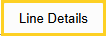
Line Details (continued)

In the Item Summary section, the Physical Nature and Buyer fields can be updated / added. The other fields in this section cannot be updated. However, the user can confirm the information provided.

NOTE: The Show Configuration button is not used by LSUNO.
Line Details (continued)

The Physical Nature field displays whether the requisition is for Goods or Services based on the type of requisition you created.
Line Details (continued)

The five (5) collapsed lines, in the Attributes section at the bottom page, represent the key components and functionalities within the Line Details tab. In the Item Additional Information section, the user can select if an item requires a RFQ (Request For Quote). In the Supplier Information section, the user can add / update supplier or item information.

Use the Expand All and Collapse All buttons to open and close all lines at the same time.
Line Details

Once all information has been updated / confirmed, select the Done button to return the Requisition Line Details page.

Click the Done button.
Punchout Requisitions (continued)

The user can Save the requisition, without submitting it, and come back to it later. Saving the requisition will generate a requisition id number.

See the Find, Submit, and Print a Saved Requisition topic for instructions on finding saved requisitions.

Click the Save button.
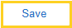
Punchout Requisitions (continued)

Click the Home button.

The completes Checkout Page: Distributions, Schedule and Line Details, and Save.
End of Procedure.

Find, Submit, and Print a Saved Requisition
Procedure

In this topic you will learn how to Find, Submit, and Print a Saved Requisition.

NOTE: Information related to this topic is relevant to both Punchout and Special Request requisitions.
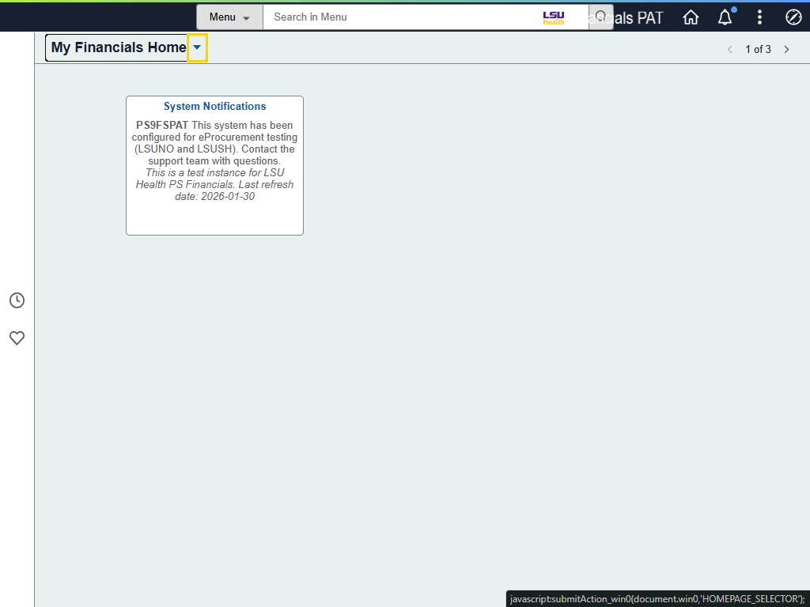

Step | Action
Navigation to Find a Requisition

Click the My Financials dropdown button to activate the menu.
Navigation to Find a Requisition (continued)

Click the LSU Health Financials menu.
Navigation to Find a Requisition (continued)

Click the eProcurement tile.

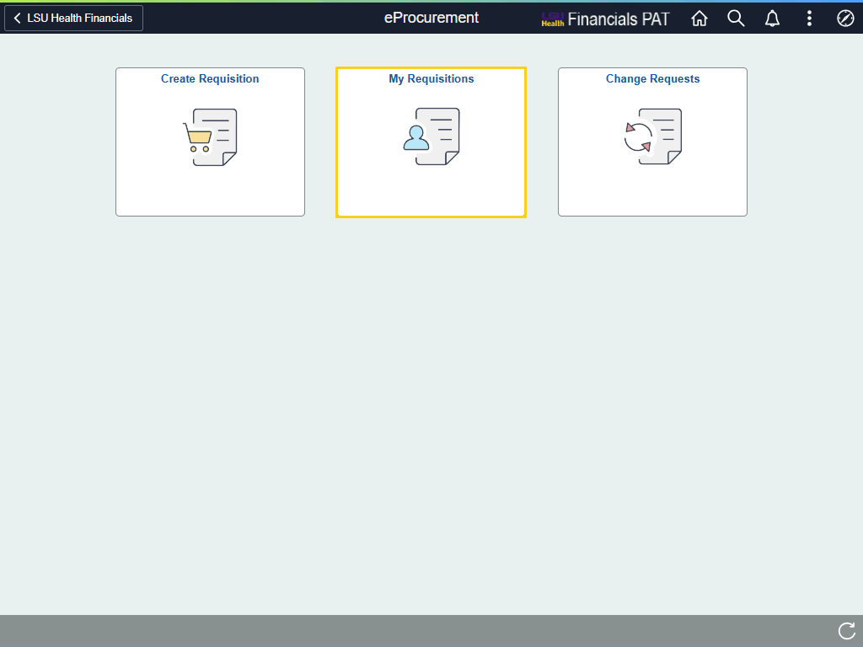

Step | Action
Navigation to Find a Requisition - My Requisitions

The user will select the My Requisitions tile to find his/her existing requisition.

Click the My Requisitions tile.
*****NOTICE*****

Punchout requisitions cannot be edited. Only Special Request requisitions can be edited in the system.

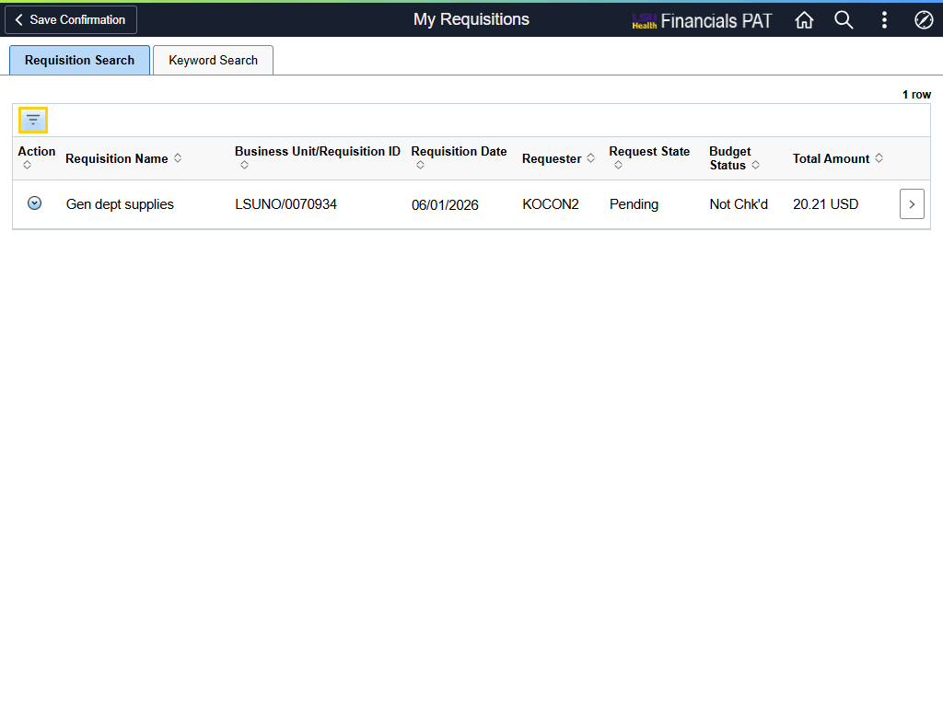

Step | Action
My Requisitions (continued)

By default, the My Requisitions page will display requisitions created by you on the current date (today). To filter for more or fewer requisitions, select the Filter button at the top-left of the Requisition Search tab.

Click the Filter button.
Filters

The Filters page is displayed.

Delete the date in the From Date field to view all your requisitions. Or enter a time span in the From Date and To Date to view requisitions from a specific date range.

NOTE: If you have access to edit requisitions for other people, delete the value in the Requester field.

Highlight the From Date and press [Delete] on your keyboard.
Filters (continued)

Click the Done button.

My Requisitions (continued)

Any requisition(s) you have created on the date specified on the Filters page will be displayed. If you leave the From Date blank, all requisitions will be displayed.

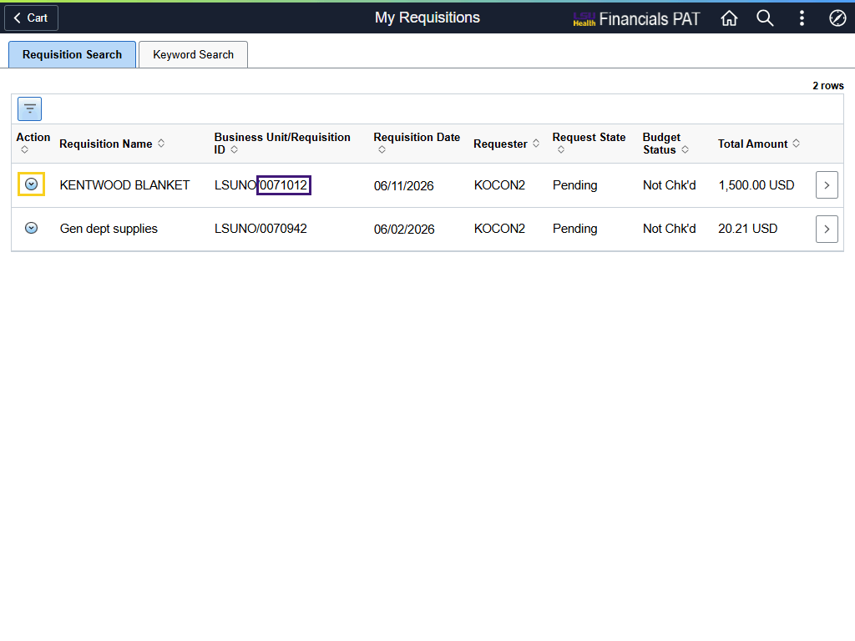

Step | Action
My Requisitions (continued)

Click the Related Actions button for requisition id 0071012.
My Requisitions (continued)

The Actions menu is displayed. Depending on the status the requisition is in, depends on which of these options the user can access.
My Requisitions (continued)

To add items or complete checkout, select the Edit option from the Actions list.

Click the Edit link.
Edit Requisition (continued)

The Edit Shopping Cart page is displayed. From this page, the user can update Requisition Name, Item Quantity, and Unit of Measure (UOM). If a change is made to any of these fields, the user must select the Update Cart button to save the change.

Edit Requisition (continued)

From the Edit Shopping Cart page, the user can also Delete the requisition. However, the user cannot Delete the requisition without first talking with Purchasing about the status of the requisition.
Edit Requisition (continued)

If additional items need to be added to the requisition, such as Freight or coffee service, the user will select the Continue Shopping button, then Special Requests from the left-side menu. A new page will display for you to add the new item.

In this example, the user will select Checkout.

Click the Checkout button.

Checkout

After selecting the Checkout button, notice the Preview Approvals link and Check Budget button are displayed. The user can select the Preview Approvals link to view the approvals required.

NOTE: If the user is not his/her own approver, the Check Budget cannot be performed until the requisition is approved.

If the user is his/her own approver, the system will auto-approve the requisition, and the user can Check Budget the requisition before navigating away from the page.
Checkout (continued)

The user can select the Schedule Details or the Line Details button to view and / or confirm shipping, chartstring, and line-item information.
Schedule Details

On the Schedule Details tab, Schedule 1 section, the user can make changes to the following fields: Ship To, Attention To, Due Date, Quantity, and / or ShipTo Comments.
Schedule Details (continued)

In the Schedule 1, Distributions section, the Distribute By and chartstring information can be changed.
Schedule Details (continued)

Click the Line Details tab.
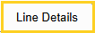
Line Details

On the Line Details tab, Item Summary section, the user can change the Physical Nature (e.g., Goods or Services), as well as the Buyer.

The user can also confirm line-item details such as Category, Price, Quantity and Total Amount.
Line Details (continued)

In the Attributes section, the user can turn on RFQ Required in Item Additional Information, and /or change Supplier data in the Supplier Information section.
Edit Requisition (continued)

If all default, chartstring, and item information have been added to the requisition, the user can Submit the requisition.

Click the Submit button.

Checkout Confirmation (continued)

Previously in the exercise, a quote was printed. The user can print the completed requisition by selecting the Print Preview button.

Click the Print Preview button.

Checkout Confirmation (continued)

The user can select whether s/he wishes to print the requisition distribution details (e.g., due date, supplier id, chartstring information, etc.) by selecting the "Yes" button.

Click the Yes button.

Print Requisition (continued)

The user can select the Ellipses (3 dots) in the upper right corner of the Requisition tab to print the requisition.

Click the Ellipses button.

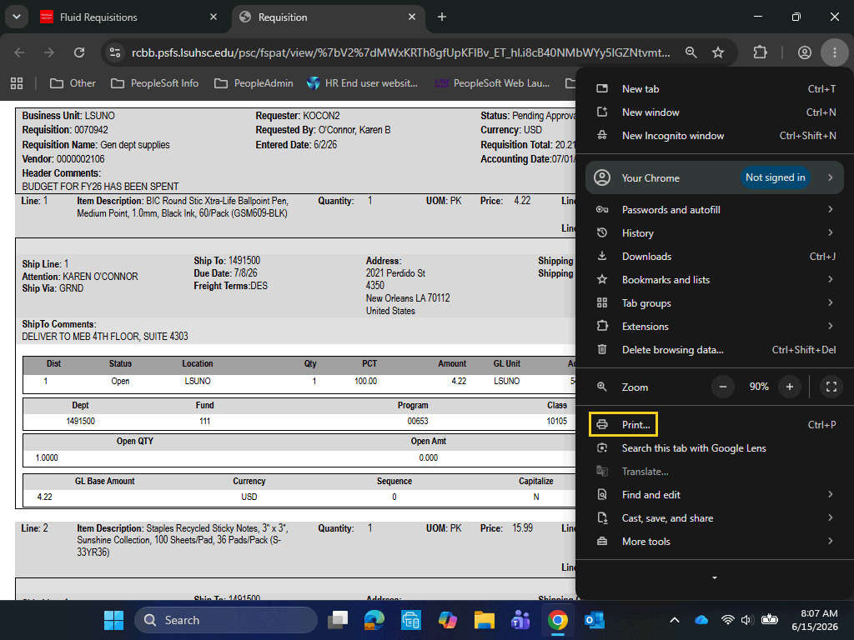

Step | Action
Print Requisition (continued)

Click the Print button.

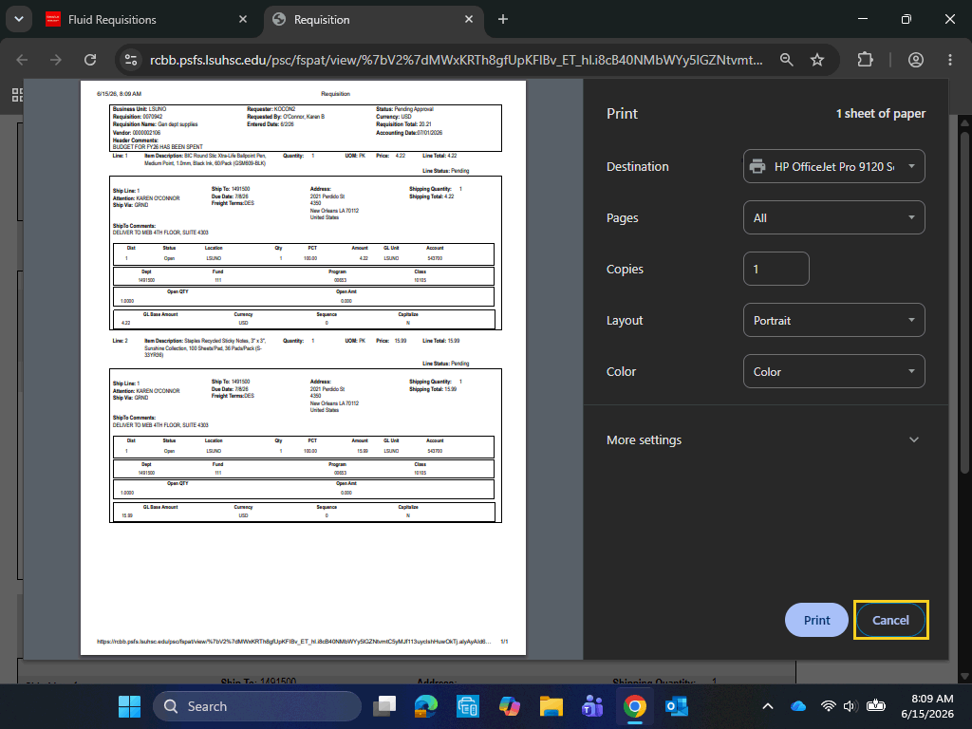

Step | Action
Print Requisition (continued)

The user will select his/her print parameters and select the Print button.

For training purposes only, click the Cancel button.


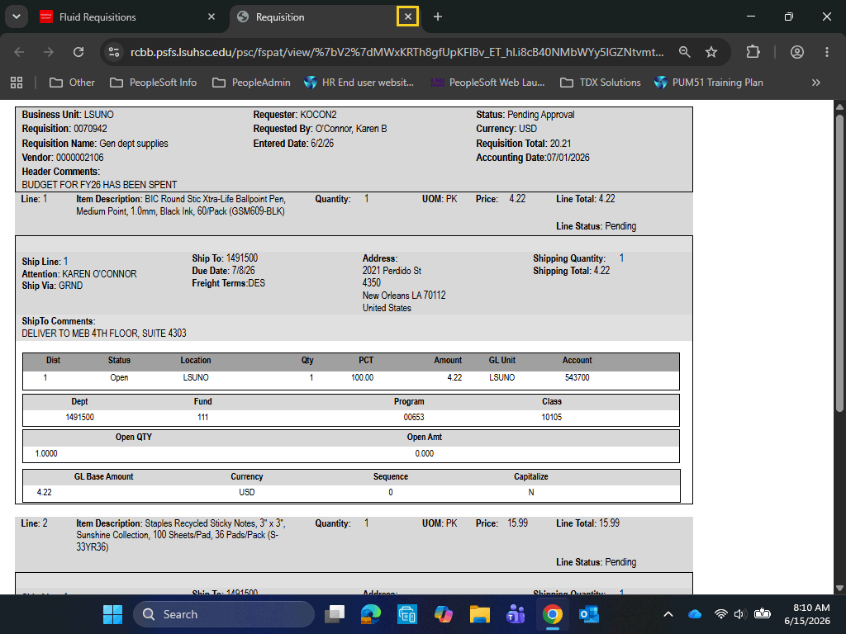

Step | Action
Print Requisition (continued)

Click the Close Requisition tab.
This completes Find, Submit, and Print a Saved Requisition.
End of Procedure.

View Requisition Details and Lifeline
Procedure

In this topic you will learn how to View Requisition Details and Lifeline.
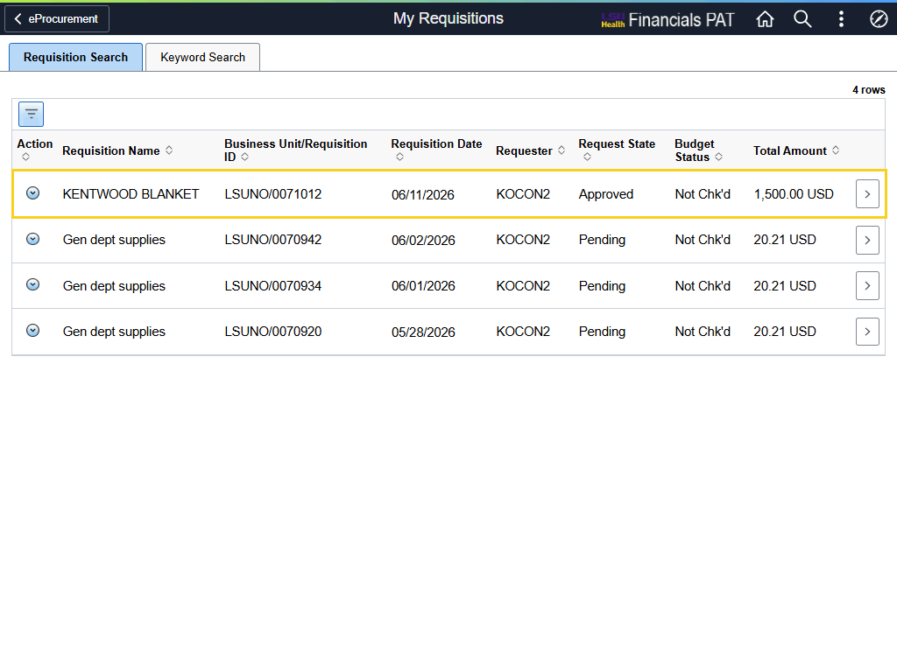

Step | Action
My Requisitions

The user can click anywhere on a requisition line to view the Details page for that line.

Click the KENTWOOD BLANKET button.
Details Page

The Details page allows the user to view and confirm information relevant to the requisition. The page is divided into three (3) sections: Requisition Summary, Requisition Lifeline, and Lines.
Details Page (continued)

Directly above the Requisition Summary section is the Cancel Requisition button. Selecting this button will cancel the entire requisition.

NOTE: A user must speak with Purchasing before canceling a requisition.
Requisition Summary (continued)

The Requisition Summary section contains information specific to the requisition such as Requisition Name, Requisition ID, Request State, Budget Check Status, Total Amount and Approval Justification. Also included in this section is the View Requisition Header Comments / Attachments button.

NOTE: If the requisition has a "Valid" Budget Status, then the requisition's Total Amount and the Remaining Pre-Encumbrance balance will be displayed below the Budget Check Status.

Click the View Requisition Header Comments / Attachments arrow.
Requisition Header Comments and Attachments

View Comment 1.

Click the Close button.

Requisition Lifeline (continued)

The Requisition Lifeline is a visual tracking tool used to identify where a purchasing request is in the procure-to-pay lifecycle. Active icons are colored and the titles are a blue hyperlink. In this example, the Requisition has been created and approved.
Requisition Lifeline (continued)

The user can select any colored icon to view relevant information. In this example, the user will select the Approvals icon.

Click the Requisitions button.

Requisition Lifeline (continued)

Header Comments have been previously discussed, so skip down to Line Comments.

Click the Line Comments button.
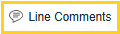
Requisition Line Comments and Attachments

View the Line Comments page.

Click the Close button.

Requisition Lifeline (continued)

Click the View Details button.
Requisition Line Details

The Schedule and Line Details tabs are displayed.

See the Checkout Page: Distributions, Schedule and Line Details, and Save topic for information regarding the Schedule and Line Details tabs.

Click the Close button.

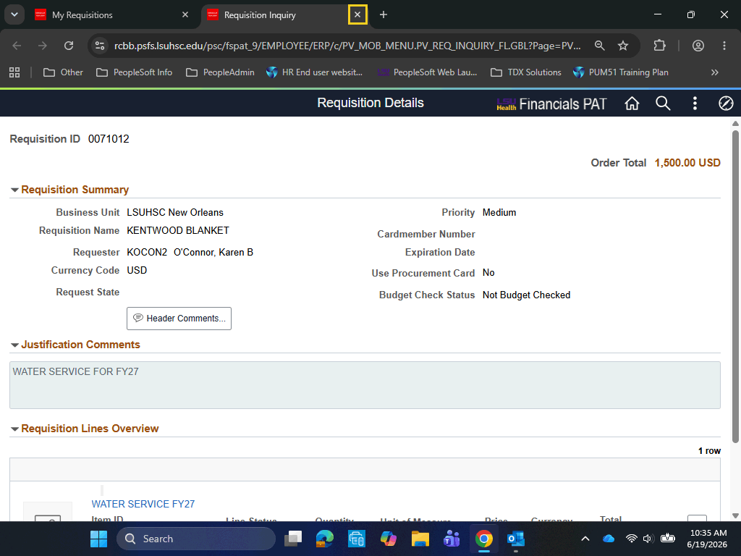

Step | Action
Requisition Inquiry

Click the Requisition Inquiry Close tab.
Details (continued)

The third section of the Details page is the Lines section. This section provides specific information about the line item(s) on the requisition.
Lines (continued)

The user can select the View Comments and Attachments button to view line comments and attachments. Line comments are specific to the line item.
Cancel Line

The Cancel Line button can be used to cancel a specific line on the requisition.

NOTE: A user must speak with Purchasing before canceling a line on the requisition.

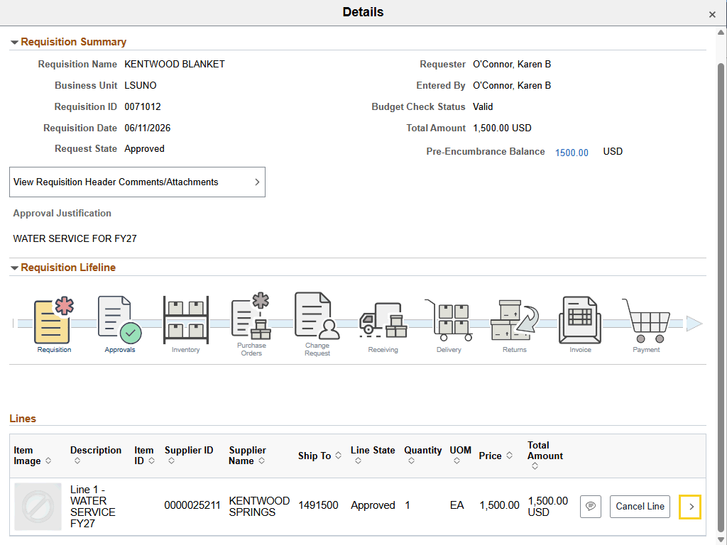

Step | Action
Lines (continued)

Click the Schedule Details button.

Schedule Details (continued)

The Line Details and Shipping Details are displayed on the Schedule Details page.

If the price has been adjusted, the user can select the Price Adjustment button to view the price change.
Schedule Details (continued)

Click the Distributions button.

Distribution Details

Chartfield and budget information can be viewed on the Distributions section across several tabs. Below are the noteworthy fields and the tabs where they can be found:

• Chartfields1 Tab – Location, Quantity, Percent, GL Business Unit
• Chartfields2 Tab – Account, Fund, Department, Program Code, Class
• Chartfields3 Tab – PC Business Unit, Project, Activity
• Budget Information Tab – Budget status, Pre-encumbrance Balance

Click the Distribution Details Close button.
Schedule Details (continued)

Click the Schedule Details Close button.
Details (continued)

Click the Details Close button.
This completes View Requisition Details and Lifeline.
End of Procedure.

Using the Requisition Actions Menu
Procedure

In this topic you will learn about Using the Requisition Actions Menu.
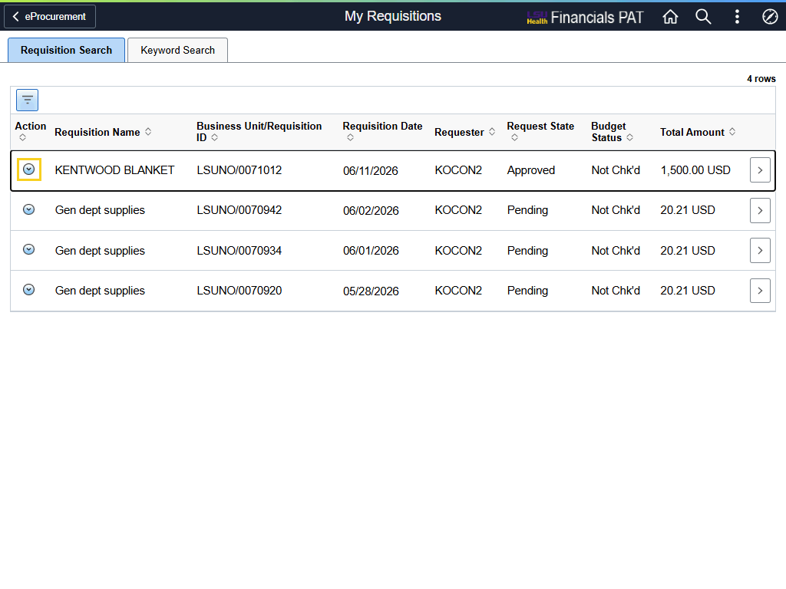

Step | Action
My Requisitions

Users can access the Actions menu on the My Requisitions page. Simply select the Related Actions button to view the menu.

NOTE: For training purposes only, selecting the Related Actions button will only be shown on this page. The user will need to select the Related Actions button each time s/he wishes to access the Actions menu.

Click the Related Actions button.
Actions Menu

The Actions menu is displayed. Users can access other options on the menu depending on the state of the requisition.
Actions Menu

The Details, View Approvals, and Inquiry options are discussed in the "View Requisition Details and Lifecycle" topic.

The Edit and View Print options are discussed in the "Find, Submit, and Save the Requisition" topic.

These five (5) options will not be discussed in this topic.
Actions Menu - Copy

Click the Copy link.
Actions Menu - Copy (continued)

Copying a requisition brings up the Edit Shopping Cart page where items can be removed from the cart. Selecting the Checkout button brings up the Checkout page, where comments and attachments can be added and line details / chartfields can be edited.

Click the < My Requisitions button.
Actions Menu - Cancel

Click the Cancel link.
Actions Menu - Cancel (continued)

Selecting Cancel will cancel the entire requisition. Depending on the filter parameters, the canceled requisition will still display on the My Requisitions page and there will be a new action to undo cancel.

NOTE: A user must speak with Purchasing before canceling a requisition.

Click the No button.

Actions Menu - Pre-Budget Check

To see if the requisition will pass budget check without committing to do so, select PreBudget Check.

Click the PreBudget Check link.
Actions Menu - Pre-Budget Check (continued)

A message is displayed informing you that the process will take a few minutes and asking if you wish to continue.

Click the Yes button.

Actions Menu - Pre-Budget Check (continued)

If successful, the budget status will update to Prov Valid, for provisionally valid, in the Budget Status column.
The completes Using the Requisition Actions Menu.
End of Procedure.

Budget Check a ePro Requisition
Procedure

In this topic you will learn how to Budget Check an ePro Requisition.

Step | Action
Budget Check an ePro Requisition

A requisition creates a pre-encumbrance in the PeopleSoft system. The Budget Check process is run to verify that funds are available in the budget to purchase the items on the requisition. A "Valid" budget check then creates a pre-encumbrance hold on the funds so that the funds cannot be spent on something else.

Prior to running the budget check, the requisition Status will be "Approved", and the Budget Status will be "Not Chk'd".

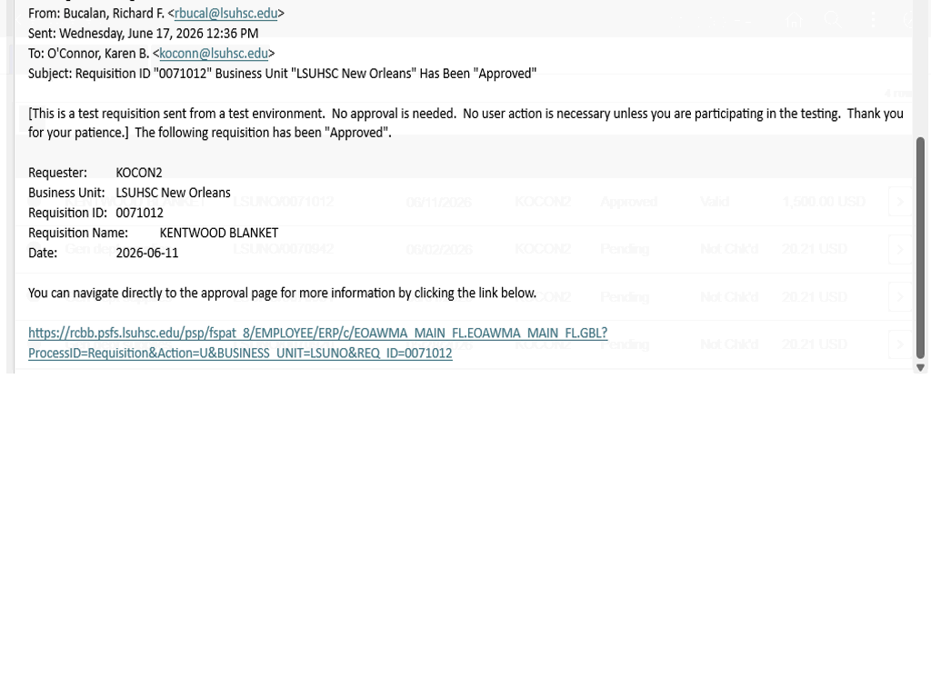

Step | Action
Budget Check an ePro Requisition

The Requester is responsible for Budget Checking the requisition. The Budget Check process cannot be completed until the requisition is approved. The Requester will receive an email, like the one pictured here, to inform him / her that the requisition has been approved. The Requester can navigate to eProcurement > My Requisitions > Related Actions to begin the Budget Check process.

NOTE: The link provided will take the user to the Requisition Approval page, not the Budget Check page.

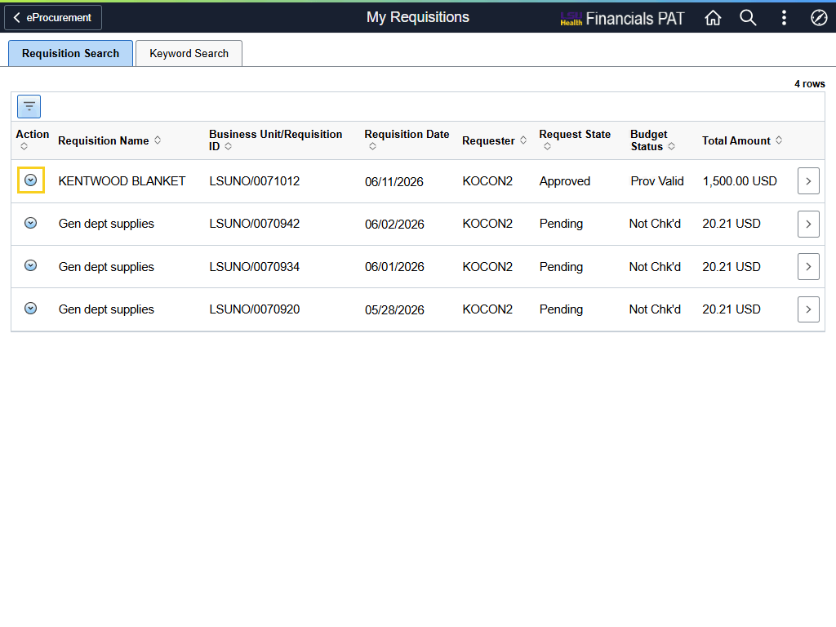

Step | Action
Budget Check an ePro Requisition (continued)

Click the Related Actions button for the appropriate requisition.

Budget Check an ePro Requisition (continued)

Selecting the Budget Check option will initiate the process.

Click the Budget Check link.
Budget Check an ePro Requisition (continued)

A message is displayed stating the Budget Check process may take several minutes to complete.

Click the Yes button.


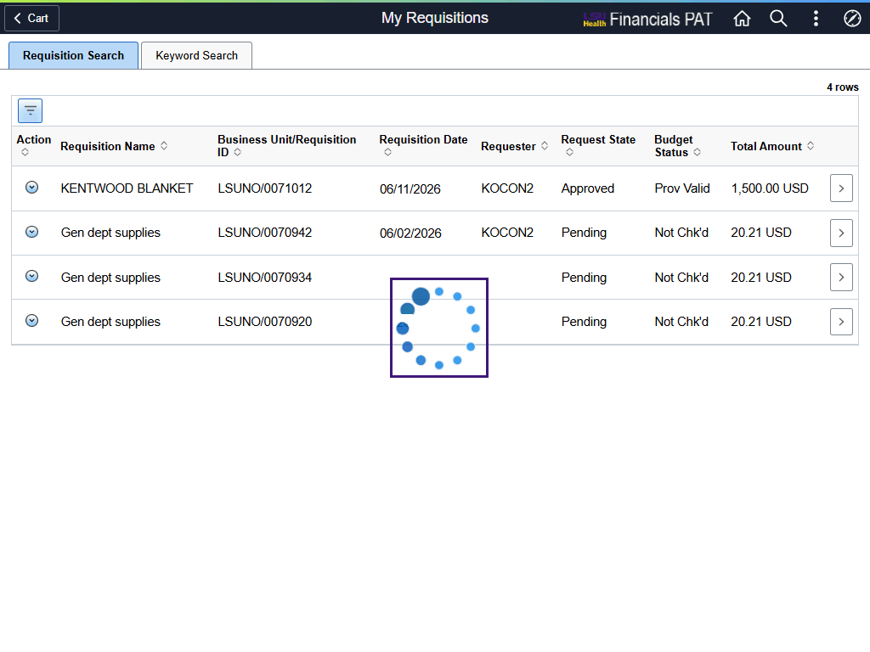

Step | Action
Budget Check an ePro Requisition (continued)

The dotted circle, shown here, indicates the budget check process is running.
Budget Check an ePro Requisition (continued)

When the budget check process completes, the new Budget Status will be displayed on the appropriate line.

NOTE: If you get a Budget Status other than Valid (e.g., Error or Warning), please contact your Buyer for assistance.
This completes Budget Check an ePro Requisition.
End of Procedure.

