

eProcurement
Requester Guide
LSUNO Only

Version Date: July 31, 2026

Table of Contents
eProcurement Requester Guide – LSUNO Only 1
Create a Requisition 1
Change a Chartstring using the Accounting Tag Link 1
Change a Chartstring by Adding Accounting Tag to Favorites 7
Update Requisition Lines using Mass Change Action 18
Update Requisition Lines using Mass Change Action and Accounting Tag 23
Addendum 36
Split a Distribution Line 36
Split the Distribution for a Single Requisition Line 36
Split the Distribution Line for Multiple Distribution Lines 40
Create a Requisition for Next Fiscal Year 53
Create a Requisition for Next Fiscal Year 53
Copy an Existing Requisition for Next Fiscal Year 64

eProcurement Requester Guide – LSUNO Only

Create a Requisition

Change a Chartstring using the Accounting Tag Link
Procedure

In this topic you will learn how to Change a Chartstring using the Accounting Tag Link.

Step | Action
 | NOTE: The steps discussed in this topic may be used to change a chartstring on Punchout and / or Special Request requisitions.

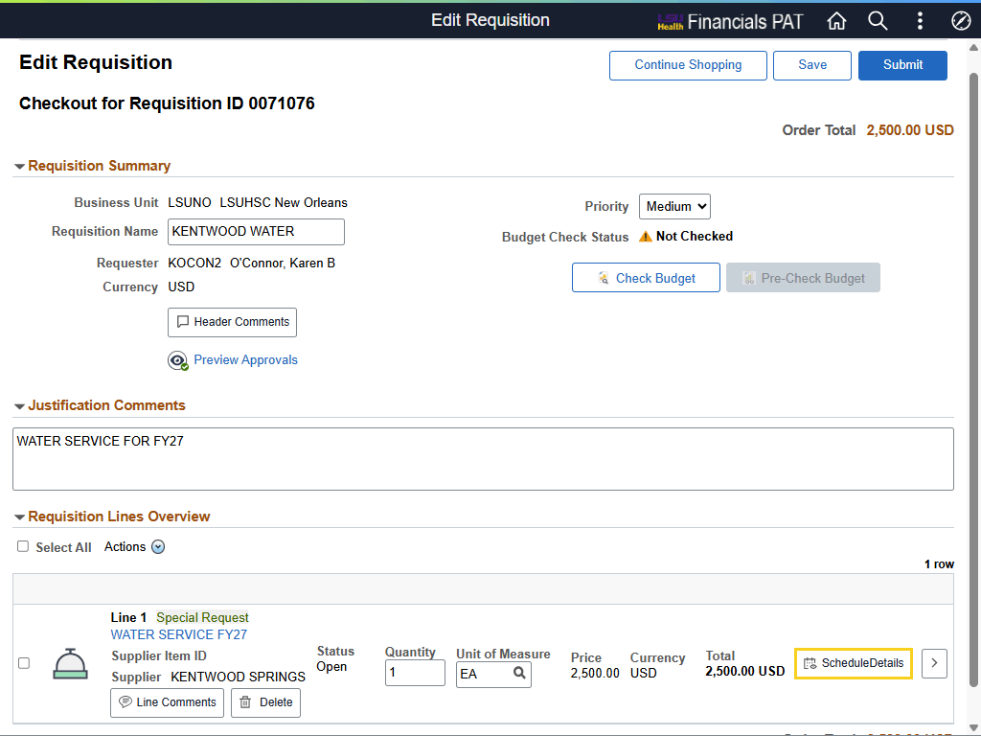

Step | Action
Edit Requisition - Schedule Details

In this exercise, you will change the requisition chartstring using an Accounting Tag. Select Schedule Details to access the accounting tag link.

Click the Schedule Details button.

Edit Requisition - Schedule Details (continued)

Click the Close Navigation Control Panel button.
Edit Requisition - Schedule Details (continued)

Click the Down button of the scrollbar.
Distributions

You can review the current chartstring information by selecting the Chartfields2 tab.

Click the Chartfields2 tab.
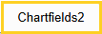
Distributions (continued)

Review the Fund Code, Program Code, and Class Field information.
Distributions (continued)

Click the Chartfield1 tab.
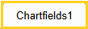
Change Chartstring using Accounting Tag

The Accounting Tag link is located either directly under or to the right of the *Distribute By field (depends on whether left-side menu is open or closed). A new pop-up window will be displayed after opening the link.

Click the Accounting Tag link.
Change Chartstring using Accounting Tag (continued)

Two (2) interacting elements - Manage Favorites and Add button - are displayed on the Accounting Tag panel.

For this exercise, only the Add button will be utilized to change the chartstring on the requisition.

Click the Add button.
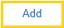
Change Chartstring using Accounting Tag (continued)

A listing of all accounting tags is displayed. Select the Filter button to search for the new accounting tag.

Click the Filter button.

Change Chartstring using Accounting Tag (continued)

To begin your search, set the List field to "All" if it does not default.

The user can enter the accounting tag number directly into the Accounting Tag field if it is known. If it is not known, select the Look up Accounting Tag (magnifying glass) to search for it. Users can also search by entering text into the Description field.

In this example, the text "FAMILY" will be entered in the Description field to search for an accounting tag.

Enter the desired information into the Description field. Enter "FAMILY".
Change Chartstring using Accounting Tag (continued)

Click the Done button.
Change Chartstring using Accounting Tag (continued)

A list of accounting tags containing the word "FAMILY" in the Description appears. Select the checkbox to the left of the appropriate accounting tag.

Click the Select Checkbox option.
Change Chartstring using Accounting Tag (continued)

Make sure the appropriate accounting tag is checked before selecting the Done button.

Click the Done button.


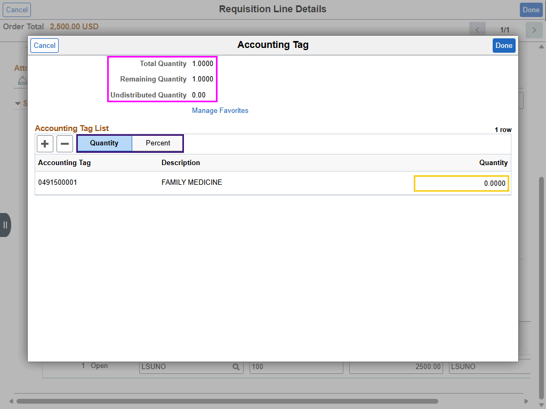

Step | Action
Change Chartstring using Accounting Tag (continued)

This panel allows the user to set the Quantity or Percentage to be allocated to the accounting tag. For single-distribution accounting tags, allocate the entire quantity or percentage (100%).

NOTE: The number entered in the Quantity field must match the Total Quantity. In this example the Total Quantity is "1", so the user will enter "1" in the Quantity field.

Enter the desired information into the field. Enter "1".
Change Chartstring using Accounting Tag (continued)

Click the Done button.

Change Chartstring using Accounting Tag (continued)

The system will automatically copy the new chartstring into the Chartfield tabs on the Schedule Details panel. Select Chartfields2 tab to view updated chartstring information.

Click the Chartfields2 tab.
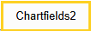
Change Chartstring using Accounting Tag (continued)

After reviewing the new chartstring information, select the Done button to return to the Checkout page.

Click the Done button.

this complete Change a Chartstring using the Accounting Tag Link.
End of Procedure.

Change a Chartstring by Adding Accounting Tag to Favorites
Procedure

In this topic, you will learn how to Change Chartstring by Adding Accounting Tag to Favorites.

Step | Action
 | NOTE: The steps discussed in this topic may be used to change a chartstring in Punchout and / or Special Request requisitions.

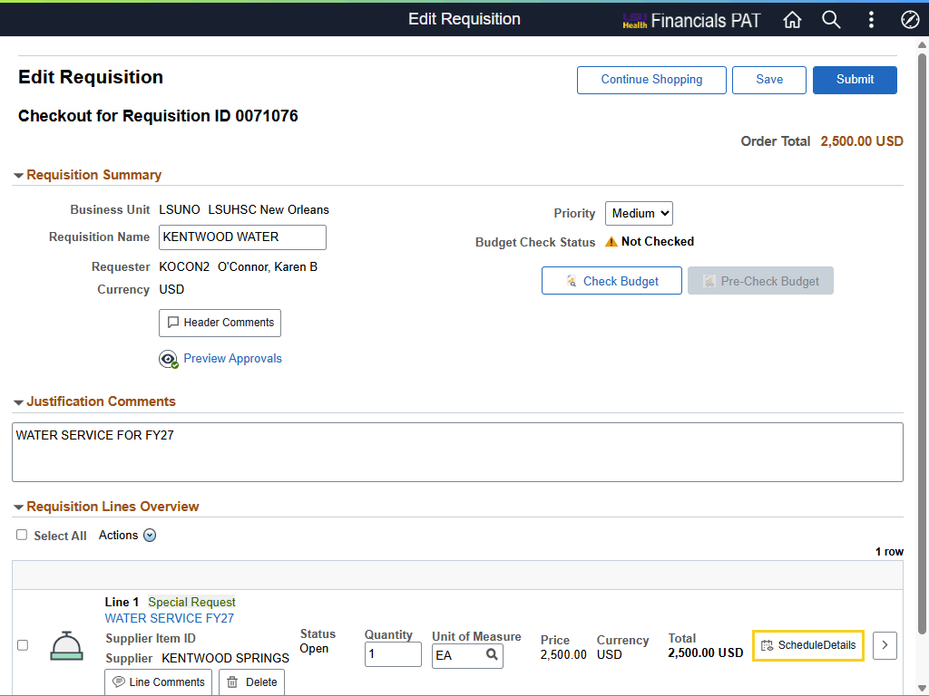

Step | Action
Edit Requisition - Schedule Details

You can change the chartstring on a requisition using the Accounting Tag link on the line-item Schedule Details page.

Click the Schedule Details button.

Edit Requisition - Schedule Details

Scroll down to the Schedule 1 Distributions section.

Click the Down button of the scrollbar.
Edit Requisition - Schedule Details

Click the Close Navigation Control Panel button.
Distributions

You can review the current chartstring information by selecting the Chartfields2 tab.

Click the Chartfields2 tab.
Distributions (continued)

Review the Fund Code, Program Code, and Class Field information.
Distributions (continued)

Click the Chartfield1 tab.
Add Accounting Tag to Favorites

The Accounting Tag link is located either directly under or to the right of the *Distribute By field (depends on whether left-side menu is open or closed). A new pop-up window will be displayed after opening the link.

Click the Accounting Tag link.
Add Accounting Tag to Favorites (continued)

Two (2) interacting elements - Manage Favorites and Add button - will be shown. You will select the Manage Favorites link first to find and add favorite accounting tags.

Click the Manage Favorites link.
Add Accounting Tag to Favorites (continued)

The Filter icon must be selected to find an accounting tag. Selecting the Filter icon will open a new window.

Click the Filter button.


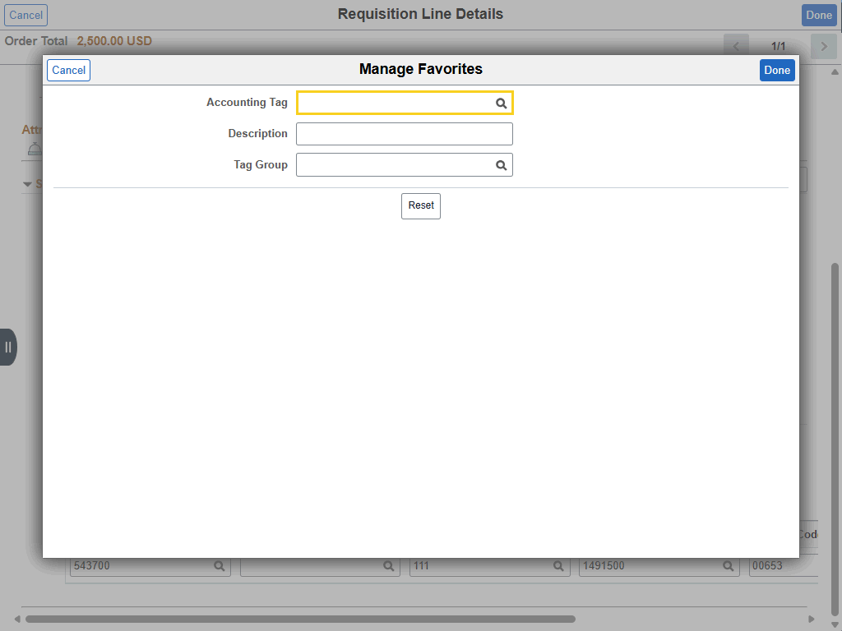

Step | Action
Add Accounting Tag to Favorites (continued)

You can enter the accounting tag number directly into the Accounting Tag field, or you can search for it using the Look up Accounting Tag (magnifying glass) feature.

In this example, you will enter accounting tag "0491500001" directly into the field.

Enter the desired information into the Accounting Tag field. Enter "0491500001".

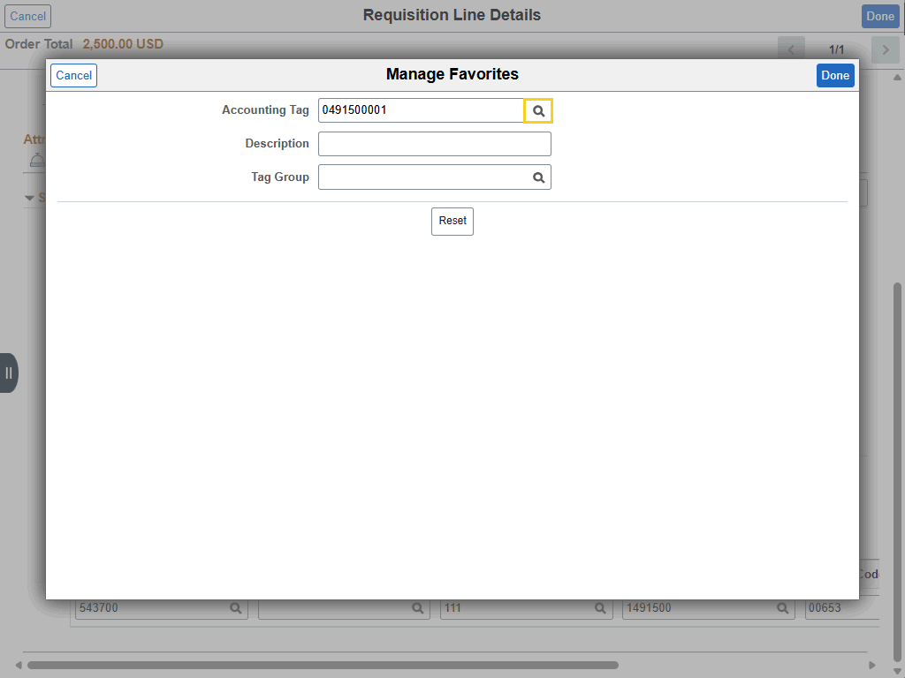

Step | Action
Add Accounting Tag to Favorites (continued)

Use the Look up Accounting Tag feature to verify the number you entered is correct.

Click the Look up Accounting Tag button.
Add Accounting Tag to Favorites (continued)

Click anywhere on the Accounting Tag line to select it.
Add Accounting Tag to Favorites (continued)

Selecting the Done button will add the accounting tag as a Favorite. However, adding it as a Favorite does not select it for use in the requisition as yet.

Click the Done button.
Add Accounting Tag to Favorites (continued)

You must select the checkbox to the left of the Accounting Tag number to Save the accounting tag as a Favorite.

NOTE: The Accounting Tag will not Save if the checkbox is not checked.

Click the Favorites Checkbox option.
Add Accounting Tag to Favorites (continued)

Click the Save button.
Add Accounting Tag to Favorites (continued)

To add the Accounting Tag to the requisition, select the Add button.

Click the Add button.
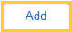

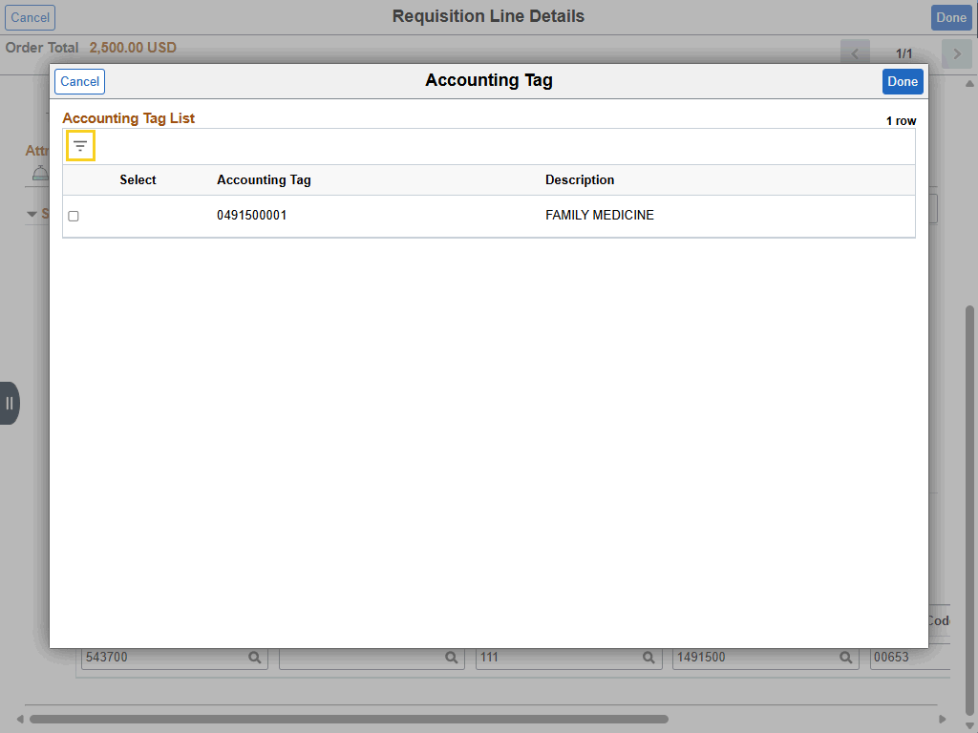

Step | Action
Add Accounting Tag to Favorites (continued)

Click the Filter button.


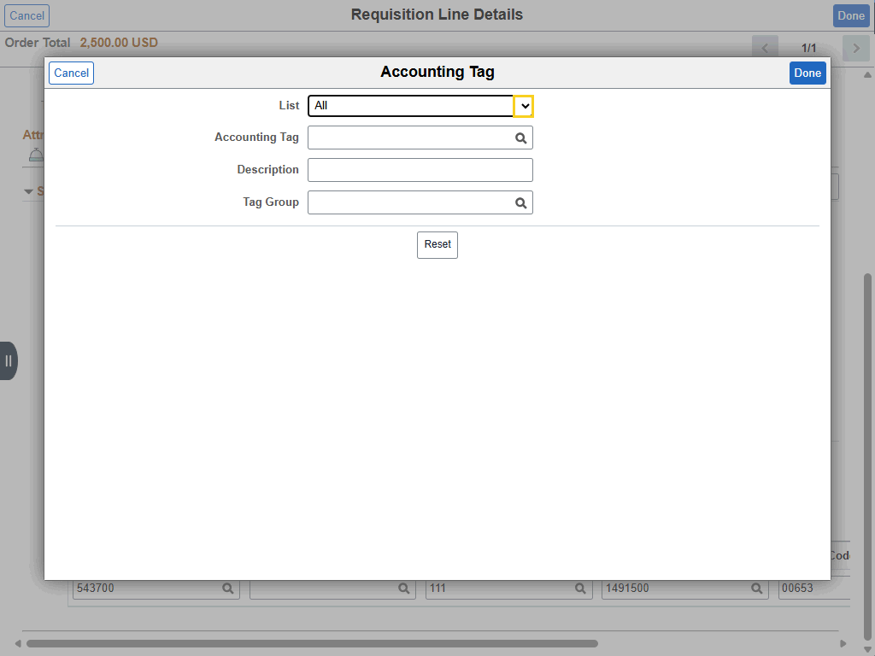

Step | Action
Add Accounting Tag to Favorites (continued)

An Accounting Tag can be searched individually, or a Favorite Accounting Tag can be selected by choosing the "Favorite" option from the drop-down list.

Click the button to the right of the List field.

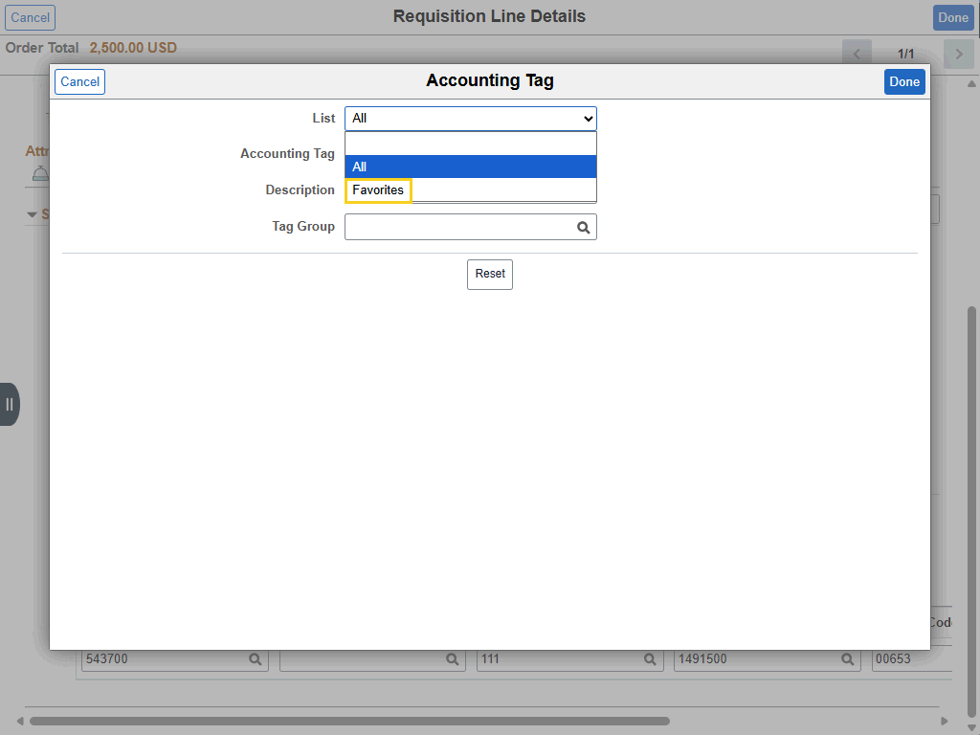

Step | Action
Add Accounting Tag to Favorites (continued)

Click the Favorites list item.

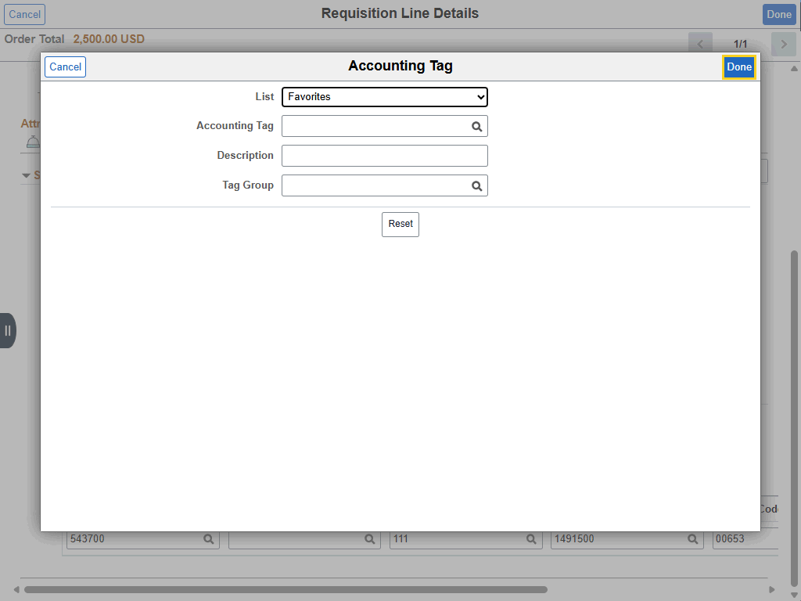

Step | Action
Add Accounting Tag to Favorites (continued)

Click the Done button.

Add Accounting Tag to Favorites (continued)

A list of all saved favorite accounting tags is displayed.

Click the Select Checkbox option.
Add Accounting Tag to Favorites (continued)

Click the Done button.


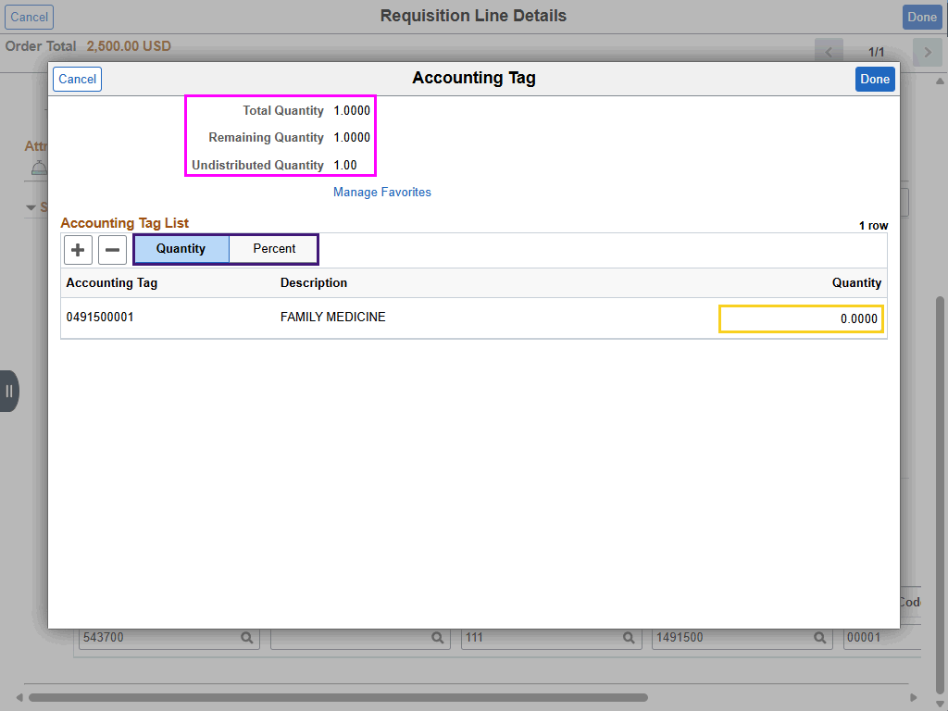

Step | Action
Add Accounting Tag to Favorites (continued)

This panel allows the user to set the Quantity or Percentage to be allocated to the accounting tag. For single-distribution accounting tags, allocate the entire quantity or percentage (100%).

NOTE: The number entered in the Quantity field must match the Total Quantity. In this example the Total Quantity is "1", so the user will enter "1" in the Quantity field.

Enter the desired information into the Quantity field. Enter "1".

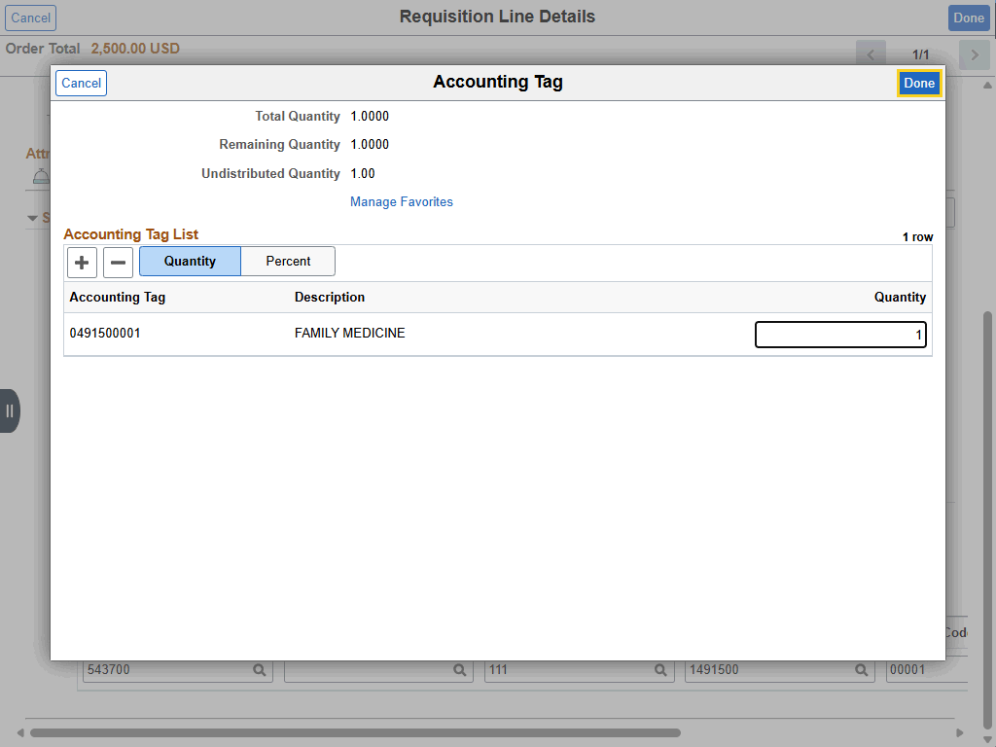

Step | Action
Add Accounting Tag to Favorites (continued)

Click the Done button.
Schedule Details (continued)

The system will automatically copy the new chartstring into the Chartfield tabs on the Schedule Details panel. Select Chartfields2 tab to view updated chartstring information.

Click the Chartfields2 tab.
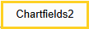
Schedule Details (continued)

Review new chartstring information. Select Done to return to the Checkout page.

Click the Done button.

This completes Change Chartstring by Adding Accounting Tag to Favorites.
End of Procedure.

Update Requisition Lines using Mass Change Action
Procedure

In this topic you will learn how to Update Requisition Lines using Mass Change Action.

Step | Action
Using Mass Change Action

Requisition lines can be updated on an individual line basis using all the pages and features previously discussed in this manual. However, to make changes to multiple requisition lines and their distributions (i.e., account, department, fund, program, class, and project id) at one time, the Mass Change action is required.

NOTE: Changes to the entire requisition must be made with either the Mass Change action or done on individual requisition lines.

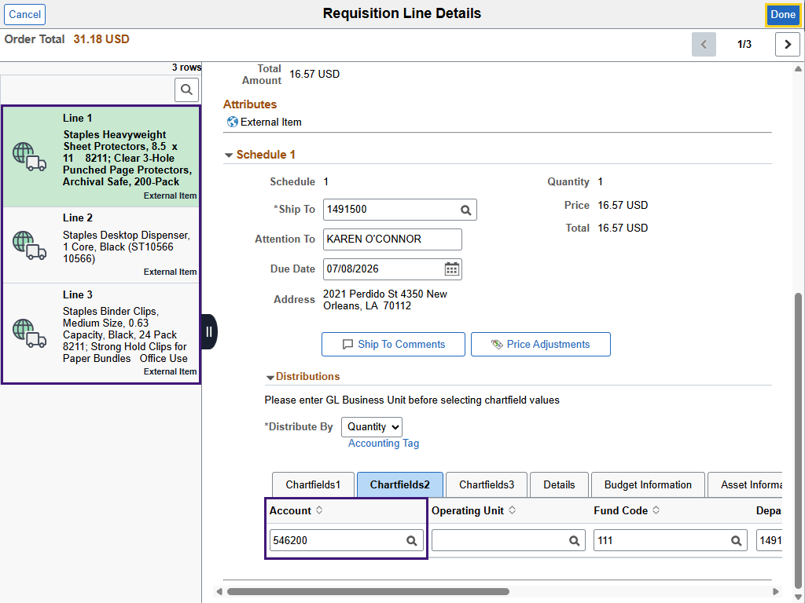

Step | Action
Using Mass Change Action - Scenario

In this example, the left-side menu shows the items selected for this requisition. Upon reviewing the Line 1 Schedule Details, it is discovered the Account number used is incorrect. The current Account number, 546200, is for Non-Automotive Equip Supplies. The cart shows office supply items, so the Account number 546700 should be used.

Click the Done button.

Using Mass Change Action (continued)

In this example, you will use the Mass Change Action to change the Account on all line items at once from 546200 to 546700.

Click the Select All option.
Using Mass Change Action (continued)

Open the Actions menu to access the Mass Change link.

Click the button to the right of the Actions field.
Using Mass Change Action (continued)

Click the Mass Change link.
Using Mass Change Action (continued)

No chartfield values will be displayed at first on the Mass Change page. The Load Values From Defaults button must be selected to view chartfield information.

Click the Load Values From Defaults button.
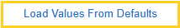
Using Mass Change Action (continued)

Chartfield information, including Account number, is displayed. The Account field is not grayed out, so you are able to adjust it.

Enter the desired information into the Account field. Enter "546700".
Apply Distribution Changes for Mass Change Action

After entering updated chartfield value(s), select which type of distribution change is required in the *Apply Distribution Changes menu. There are three (3) types of Distribution changes. Each will be discussed individually.

Click the button to the right of the *Apply Distribution Changes field.
Apply Distribution Changes for Mass Change Action (continued)

1. All Distribution Lines is the default for this scenario. Use this option if only one (1) distribution should be applied to all line distributions. This includes if a requisition line contains multiple distributions. In this option, only the chartfield(s) that have been updated will be changed in the existing distributions.

For example, if only the department is changed, only the department on the requisition line distributions will be changed. All other existing values in the requisition line distributions will remain the same.
Apply Distribution Changes for Mass Change Action (continued)

2. Matching Distribution Lines - Use this option if you want to update existing line distributions with a new one and delete unwanted lines.

For example, if a req line distribution contains two (2) lines and the mass change updates only one (1) line, "req line 1 / distribution 1" will be updated and "req line 1 / distribution 2" will be deleted.

NOTE: LSUNO will not use this option.
Apply Distribution Changes for Mass Change Action (continued)

3. Replace Distribution Lines - Use this option if a new distribution split has been applied to existing lines. This is the default choice when using an accounting tag.

• Existing distributions will be completely replaced, regardless of the number of distribution lines for the line item.
• If requisition line 1 has only one (1) distribution line and the mass change contains two distribution lines, requisition line 1’s distribution will then have two distribution lines after mass change.
• If only one (1) chartfield was entered (i.e., department) and all other chartfields were left blank, then the requisition line distribution will be changed to have only the department chartfield value, and all others will be empty.
Using Mass Change Action (continued)

Click the All Distribution Lines list item.

Using Mass Change Action (continued)

Click the Done button.
Using Mass Change Action (continued)

A message is displayed stating the system will modify field changes to existing requisition line items / schedules. Select OK.

Scroll the OK button with the mouse wheel.
Using Mass Change Action (continued)

Verify that the Account change has been made to all lines. You can view the Account on the Schedule Details page. Select the Line 1 Schedule Details button.

Click the Schedule Details button.

Using Mass Change Action (continued)

Scroll the Down scrollbar with the mouse wheel.
Using Mass Change Action (continued)

Click the Chartfields2 tab.
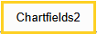
Using Mass Change Action (continued)

The Account was successfully changed on Line 1.

Click the Line 2 button.
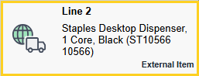
Using Mass Change Action (continued)

The Account was successfully changed on Line 2.

Click the Line 3 button.
Using Mass Change Action (continued)

The Account was successfully changed on Line 3.

Click the Done button.

This completes Update Requisition Lines using Mass Change Action.
End of Procedure.

Update Requisition Lines using Mass Change Action and Accounting Tag
Procedure

In this topic, you will learn how to Update Requisition Lines using Mass Change Action and Accounting Tag.

Step | Action
Using an Accounting Tag in Mass Change

An Accounting Tag can be used to update requisition line distributions in Mass Change.

***WARNING*** - The values of the Accounting Tag will replace whatever is on the requisition line distribution. If the selected Accounting Tag has only one (1) distribution but your existing requisition line has two (2) distribution lines, then the two (2) distributions will be replaced by the one (1) distribution found in the accounting tag.

Only an accounting tag with multiple distributions can update requisition lines with multiple distributions. In general, it is not recommended to use an accounting tag when updating requisition lines with multiple distributions.

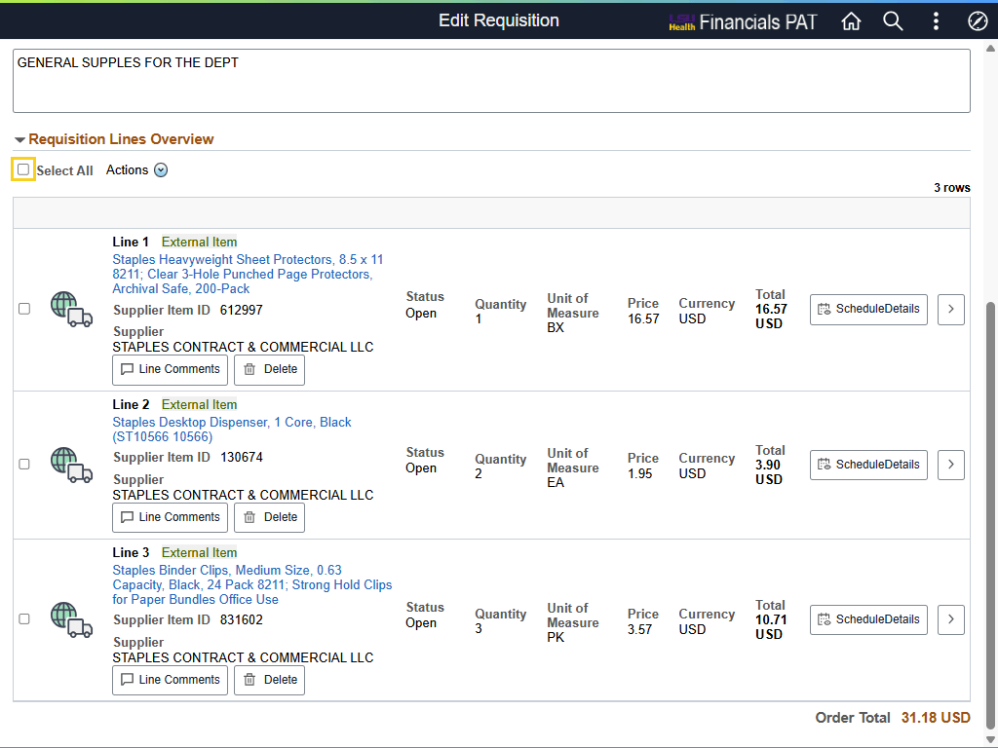

Step | Action
Using Mass Change Action (continued)

In this example, you will use the Mass Change Action to change the chartstring for all line items at once using Accounting Tag: 0491500001.

Click the Select All option.
Using Mass Change Action (continued)

Open the Actions menu to access the Mass Change link.

Click the Actions button.
 | Click the Mass Change link.
 | Click the button to the right of the *Apply Distribution Changes field.
Apply Distribution Changes for Mass Change Action (continued)

1. All Distribution Lines is the default for this scenario. Use this option if only one (1) distribution should be applied to all line distributions. This includes if a requisition line contains multiple distributions. In this option, only the chartfield(s) that have been updated will be changed in the existing distributions.

For example, if only the department is changed, only the department on the requisition line distributions will be changed. All other existing values in the requisition line distributions will remain the same.
Apply Distribution Changes for Mass Change Action (continued)

2. Matching Distribution Lines - Use this option if you want to update existing line distributions with a new one and delete unwanted lines.

For example, if a req line distribution contains two (2) lines and the mass change updates only one (1) line, "req line 1 / distribution 1" will be updated and "req line 1 / distribution 2" will be deleted.

NOTE: LSUNO will not use this option.
Apply Distribution Changes for Mass Change Action (continued)

3. Replace Distribution Lines - Use this option if a new distribution split has been applied to existing lines. This is the default choice when using an accounting tag.

• Existing distributions will be completely replaced, regardless of the number of distribution lines for the line item.
• If requisition line 1 has only one (1) distribution line and the mass change contains two distribution lines, requisition line 1’s distribution will then have two distribution lines after mass change.
• If only one (1) chartfield was entered (i.e., department) and all other chartfields were left blank, then the requisition line distribution will be changed to have only the department chartfield value, and all others will be empty.

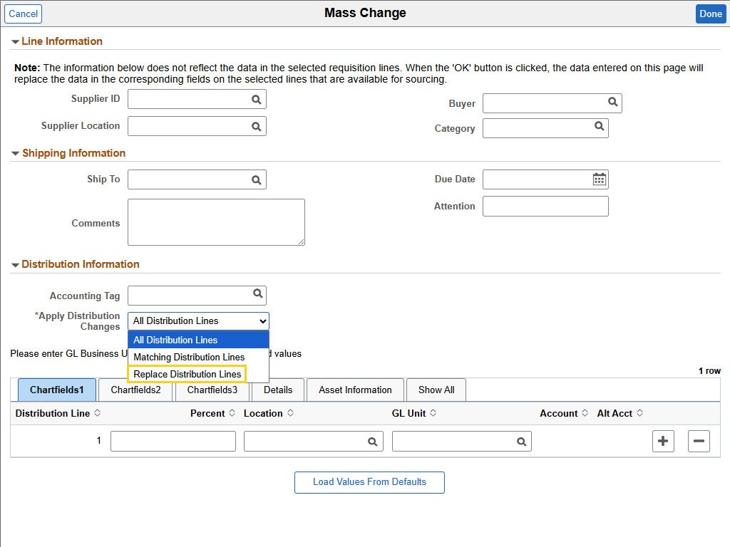

Step | Action
Apply Distribution Changes for Mass Change Action (continued)

Click the Replace Distribution Lines list item.

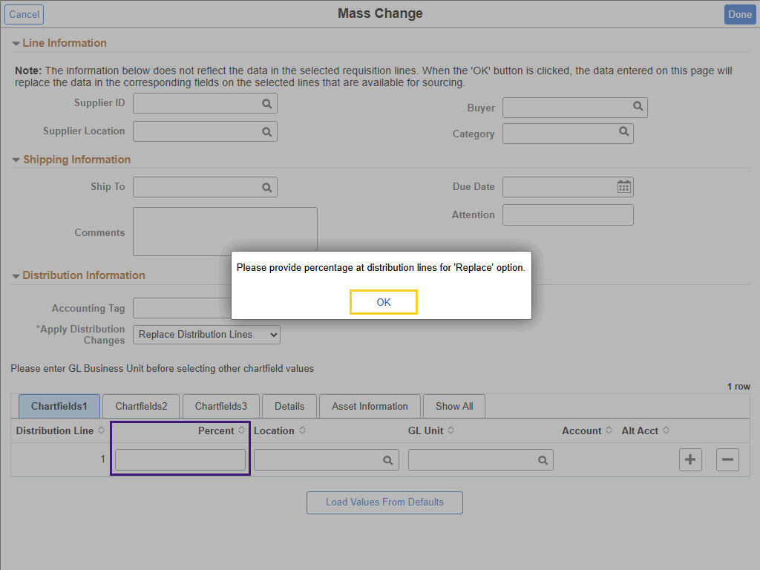

Step | Action
Apply Distribution Changes for Mass Change Action (continued)

A message is displayed asking you to enter the percentage for 'Replace' option in the distribution line.

Click the OK button.


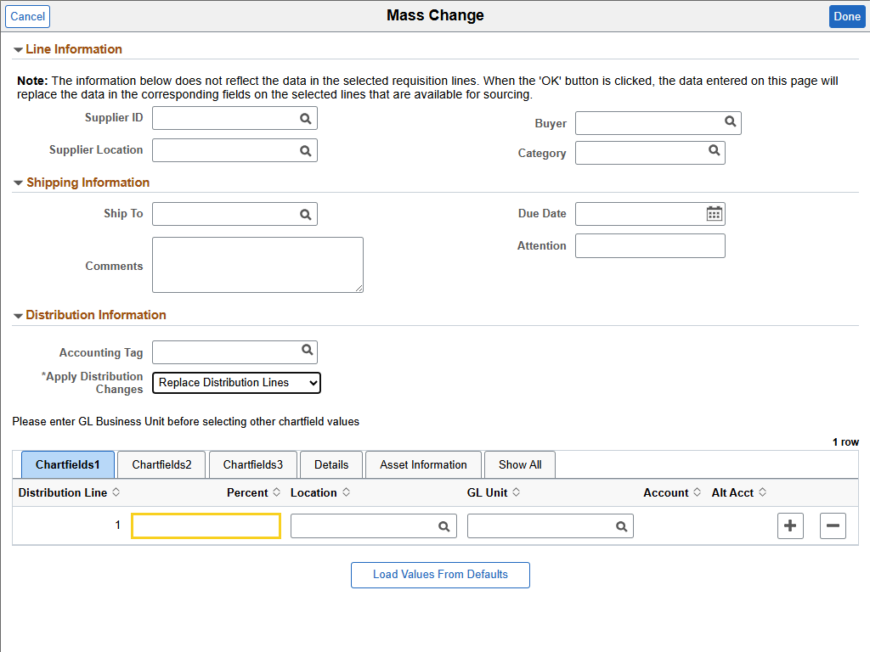

Step | Action
Apply Distribution Changes for Mass Change Action (continued)

Enter the desired information into the Percent field. Enter "100".

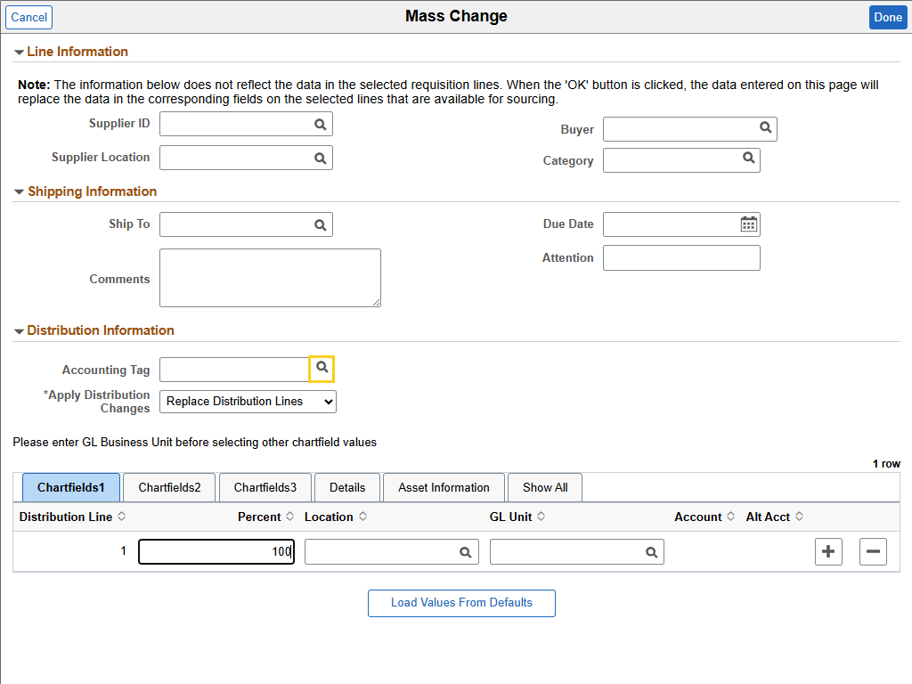

Step | Action
Add Accounting Tag

You will search for the Accounting Tag to use to default chartfield information into the Distribution fields.

Click the Lookup Accounting Tag button.
Add Accounting Tag (continued)

Click the Search Criteria arrow.

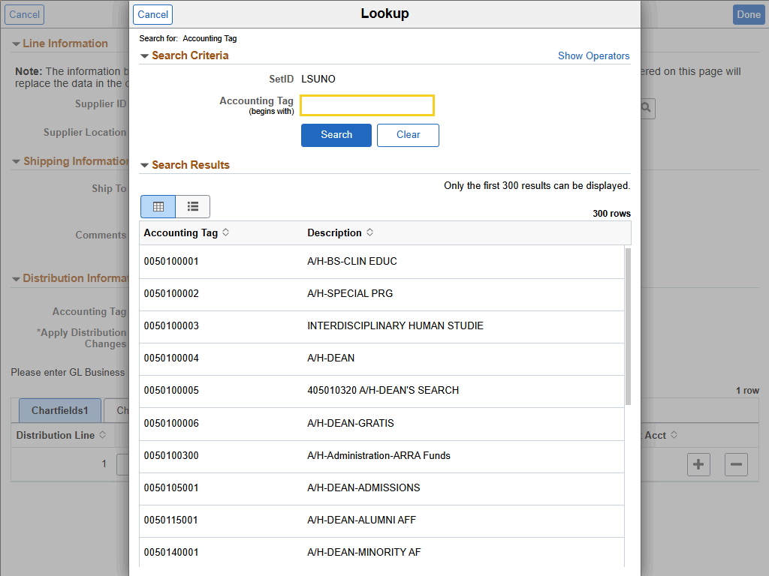

Step | Action
Add Accounting Tag (continued)

Enter the desired information into the Accounting Tag (beings with) field. Enter "04915".

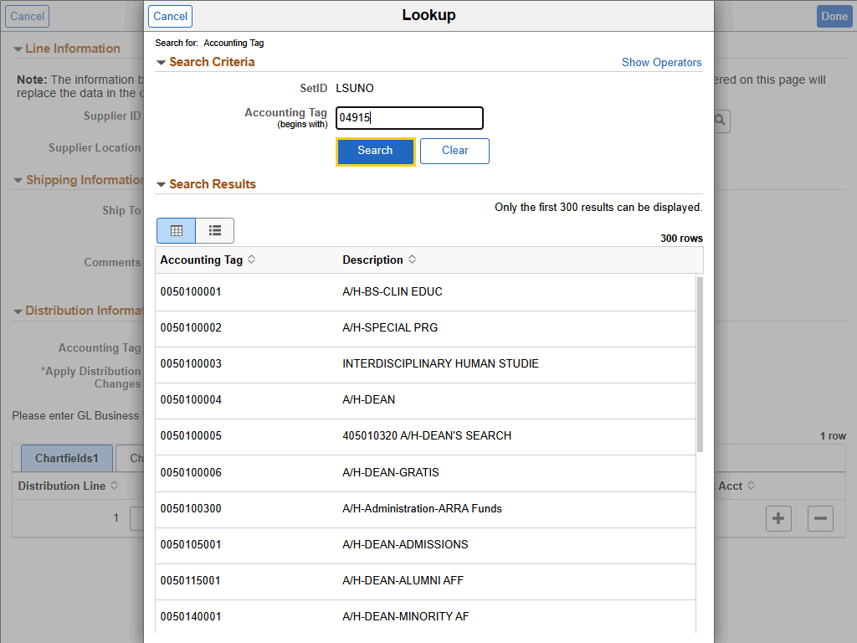

Step | Action
Add Accounting Tag (continued)

Click the Search button.

Add Accounting Tag (continued)

Click the 0491500001 - FAMILY MEDICINE button.
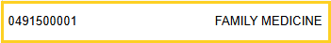

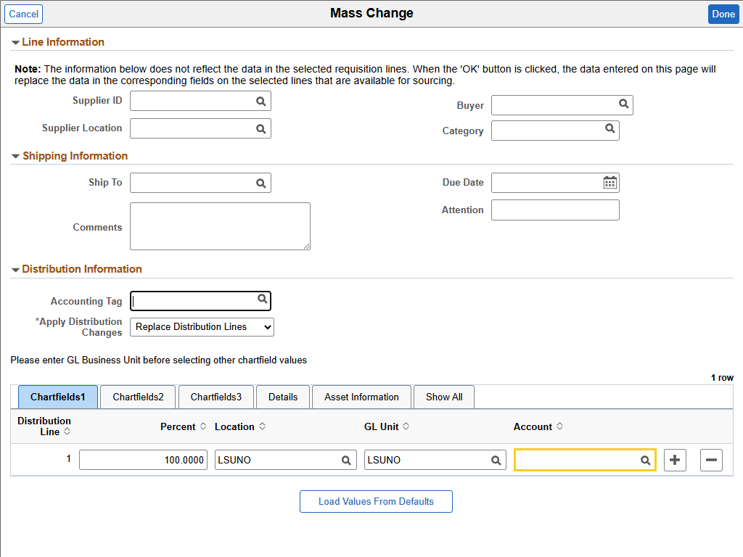

Step | Action
Add Accounting Tag (continued)

The Account is not included in the Accounting Tag chartstring information. In this example, use the Office Supplies Account number.

Enter the desired information into the Account field. Enter "546700".

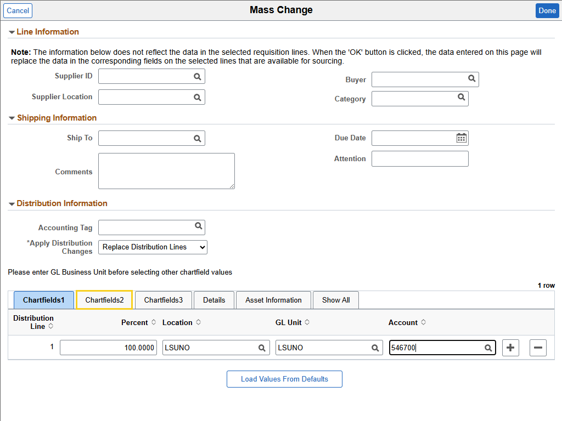

Step | Action
Add Accounting Tag (continued)

Verify on the Chartfields2 tab that the correct chartstring information has defaulted.

Click the Chartfields2 tab.
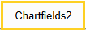
Add Accounting Tag (continued)

If chartfield information is correct, select the Done button.

Click the Done button.
Add Accounting Tag (continued)

A message is displayed asking if you want to retrofit (default) the field changes (chartstring information) to all existing requisition lines.

Click the OK button.

Verify Each Line Item Contains New Accounting Tag Information

You can verify that the Accounting Tag chartfield information has correctly defaulted to each line item using Schedule Details.

Click the Schedule Details button.

Verify Each Line Item Contains New Accounting Tag Information (continued)

New charstring information can be viewed on the Chartfields2 tab.

Click the Chartfields2 tab.
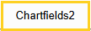
Verify Each Line Item Contains New Accounting Tag Information (continued)

View Account and Fund.
Verify Each Line Item Contains New Accounting Tag Information (continued)

View Department, Program Code, and Class Field.

Click the Line 2 button.
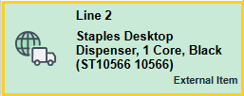
Verify Each Line Item Contains New Accounting Tag Information (continued)

View Account and Fund.
Verify Each Line Item Contains New Accounting Tag Information (continued)

View Department, Program Code, and Class Field.

Click the Line 3 button.
Verify Each Line Item Contains New Accounting Tag Information (continued)

View Account and Fund.
Verify Each Line Item Contains New Accounting Tag Information (continued)

View Department, Program Code, and Class Field.

Click the Done button.

Save the Requisition

Click the Save button.

This completes Update Requisition Lines using Mass Change Action and Accounting Tag.
End of Procedure.

Addendum

Split a Distribution Line

Split the Distribution for a Single Requisition Line
Procedure

In this topic, you will learn how to Split the Distribution for a Single Requisition Line.

Step | Action
Split a Distribution Line

Users can split a distribution line on the Schedule Details page and / or using the Mass Change option. If the requisition has three (3) or less line items, the distribution will be split on the Schedule Details page. If the requisition has more than three (3) line items, or the distribution is being split three (3) or more ways, the distribution will be split using the Mass Change option.

In this exercise, the requisition has three (3) line items, but you will only be splitting the distribution line two (2) ways. Thus, the user will split the distribution line on the Schedule Details page.

NOTE: Accounting Tags will not be used with multiple distributions unless it is known that the accounting tag itself contains multiple distributions.

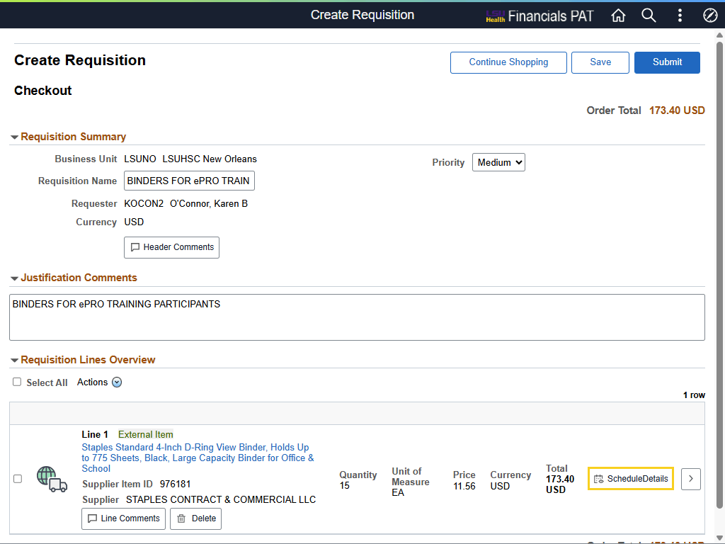

Step | Action
Split the Distribution for a Single Requisition Line

Click the Schedule Details button.

Split the Distribution for a Single Requisition Line (continued)

Click the Close Navigation Panel Control button.
Split the Distribution for a Single Requisition Line (continued)

You add a second line to split the distribution.

Click the Right button of the scrollbar.
Split the Distribution for a Single Requisition Line (continued)

In the Distributions section of the Schedule Details page, select the add a new row (+) button.

Click the Add a new row at row 1 button.

Split the Distribution for a Single Requisition Line (continued)

In this example, the *Distribute By is set to Quantity because goods have been ordered. Notice the Quantity field is active on both lines, thus allowing the user to adjust the Quantity for each line.

Also notice that the Percent field is active for Line 2, but not for Line 1. Even if the user were to change the *Distribute By to Amount, the Line 1 Percent field will not activate. In this example, this precludes the user from being able to adjust the distribution based on Percent.
Split the Distribution for a Single Requisition Line (continued)

In this example, the Quantity will be nine (9) and six (6), respectively, for Line 1 and 2.

Enter the desired information into the Line 2 - Quantity field. Enter "6".
Split the Distribution for a Single Requisition Line (continued)

Enter the desired information into the Line 1 - Quantity field. Enter "9".
Split the Distribution for a Single Requisition Line (continued)

The user must adjust one or more fields on Chartfields2 & 3 tabs to differentiate line 2 from line 1.

Click the Chartfields2 tab.
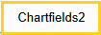
Split the Distribution for a Single Requisition Line (continued)

In this example, the user will change the Program Code for line 2 from 53000 to 53002.

Enter the desired information into the Program Code field. Enter "53002".
Split the Distribution for a Single Requisition Line (continued)

After all adjustments have been made to the requisition, select the Done button at the top right of the page.

Click the Done button.
Split the Distribution for a Single Requisition Line (continued)

If the requisition is complete, select the Submit button.

Click the Submit button.

This completes Split the Distribution for a Single Requisition Line.
End of Procedure.

Split the Distribution Line for Multiple Distribution Lines
Procedure

In this topic you will learn how to Split the Distribution for Multiple Lines Using Mass Change.

Step | Action
Split a Distribution Line on Multiple Distribution Lines

Users can split a distribution line on the Schedule Details page and / or using the Mass Change option. If the requisition has three (3) or less line items, the distribution will be split on the Schedule Details page. If the requisition has more than three (3) line items, or the distribution is being split three (3) or more ways, the distribution will be split using the Mass Change option.

In this exercise, the requisition has four (4) line items but will only be splitting the distribution line two (2) ways. Thus, the user will split the distribution line on the Mass Change page.

NOTE: Accounting Tags will not be used with multiple distributions unless it is known that the accounting tag itself contains multiple distributions.

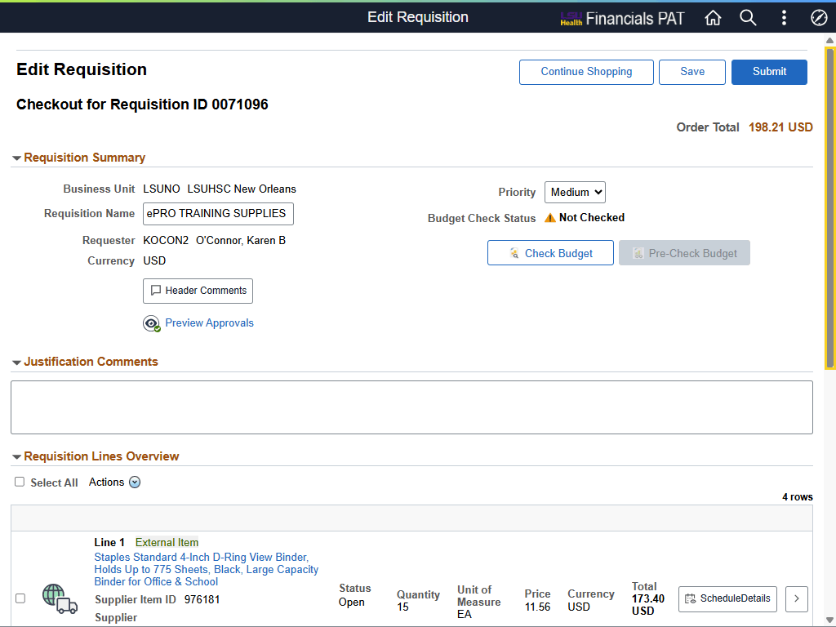

Step | Action
Split a Distribution Line for Multiple Distribution Lines (continued)

Press the left mouse button over the scrollbar and drag the mouse to the desired location.
Split a Distribution Line for Multiple Distribution Lines (continued)

All line items must be selected to split the distribution for multiple line items.

Click the Select All button.
Split a Distribution Line for Multiple Distribution Lines (continued)

The Mass Change option is located on the Actions menu.

Click the Actions dropdown button to activate the menu.
Split a Distribution Line for Multiple Distribution Lines (continued)

Click the Mass Change link.
Split a Distribution Line for Multiple Distribution Lines (continued)

Select the Load Values From Defaults options so that the values initially entered in Requisition Defaults page are displayed.

Click the Load Values From Defaults button.

Split a Distribution Line for Multiple Distribution Lines (continued)

Next, add the new distribution line.

Click the Add anew row at row 1 button.

Split a Distribution Line for Multiple Distribution Lines (continued)

***IMPORTANT***
After adding a new distribution line, set the *Apply Distribution Changes option to Replace Distribution Lines.

Click the button to the right of the *Apply Distribution Changes field.

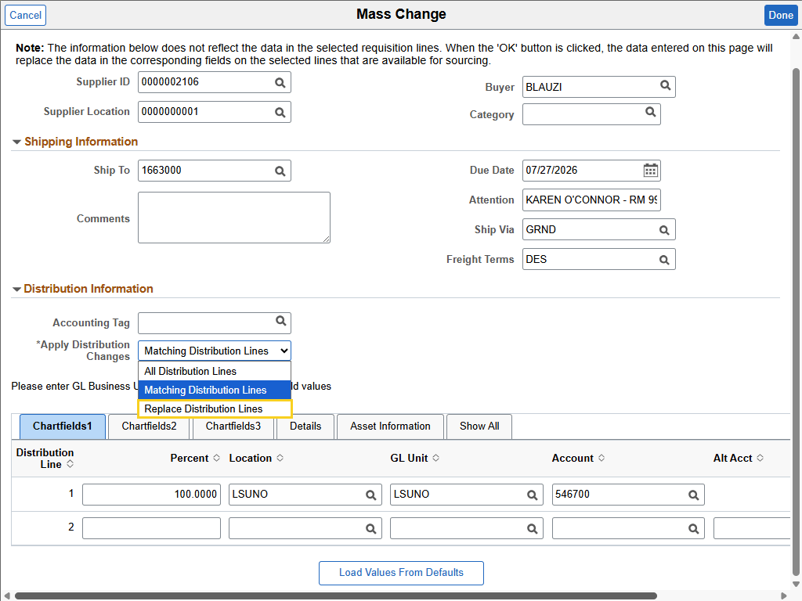

Step | Action
Split a Distribution Line for Multiple Distribution Lines (continued)

Click the Replace Distribution Lines list item.

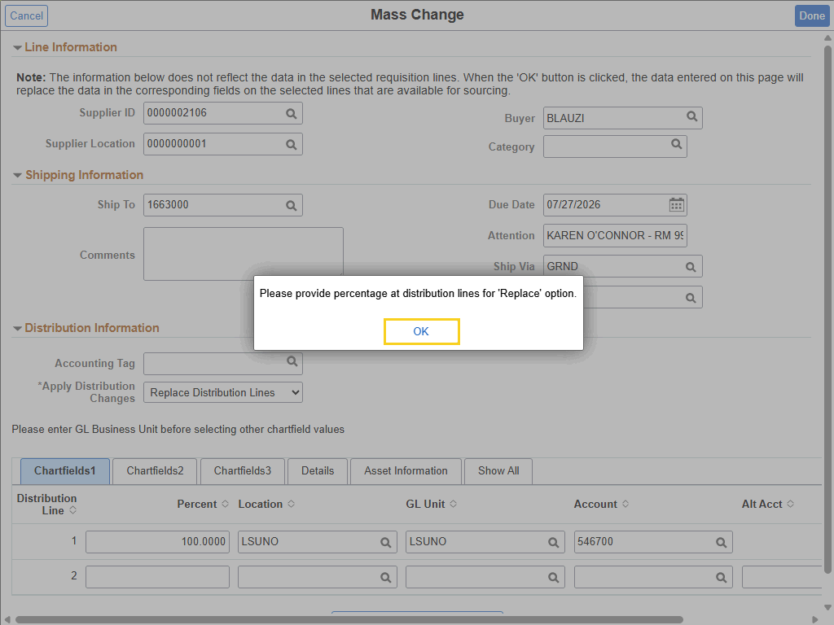

Step | Action
Split a Distribution Line for Multiple Distribution Lines (continued)

You are prompted to provide a percentage for the distribution lines. In this example, Line 1's percentage will be 75 and Line 2's will be 25. The Percentage distribution must equal 100%.

Click the OK button.


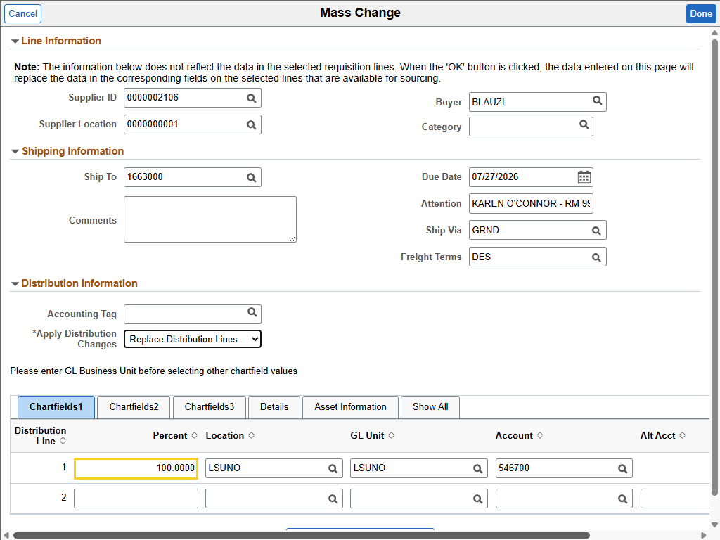

Step | Action
Split a Distribution Line for Multiple Distribution Lines (continued)

Enter the desired information into the Line 1 Percent field. Enter "75".
Split a Distribution Line for Multiple Distribution Lines (continued)

Enter the desired information into the Line 2 Percent field. Enter "25".
Split a Distribution Line for Multiple Distribution Lines (continued)

NOTE: You must complete all requisition line information for Line 2 across Chartfields1, 2, and 3 tabs.

Enter Chartfields1 tab information:
• Location = LSUNO
• GL Unit = LSUNO
• Account = 546700

NOTE: Accounting Tags cannot be used to populate fields.
Split a Distribution Line for Multiple Distribution Lines (continued)

NOTE: The values entered in the Location, GL Unit, and Account fields are used for training purposes only. You will enter values appropriate for your requisition in the Production database.

Enter the desired information into the Location field. Enter "LSUNO".
Split a Distribution Line for Multiple Distribution Lines (continued)

Enter the desired information into the GL Unit field. Enter "LSUNO".

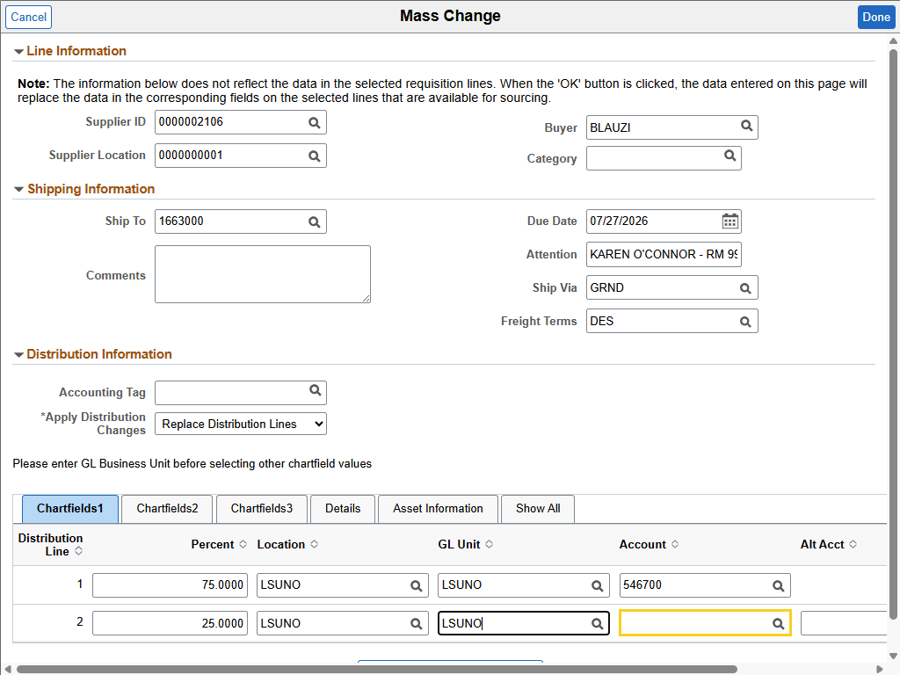

Step | Action
Split a Distribution Line for Multiple Distribution Lines (continued)

Enter the desired information into the Account field. Enter "546700".
Split a Distribution Line for Multiple Distribution Lines (continued)

Click the Chartfields2 tab.
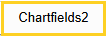
Split a Distribution Line for Multiple Distribution Lines (continued)

NOTE: Accounting Tags cannot be used to populate chartstring fields.

Enter Chartfields2 tab information:
• Fund Code = 111
• Dept = 1663001
• Program = 53000
• Class = 10105

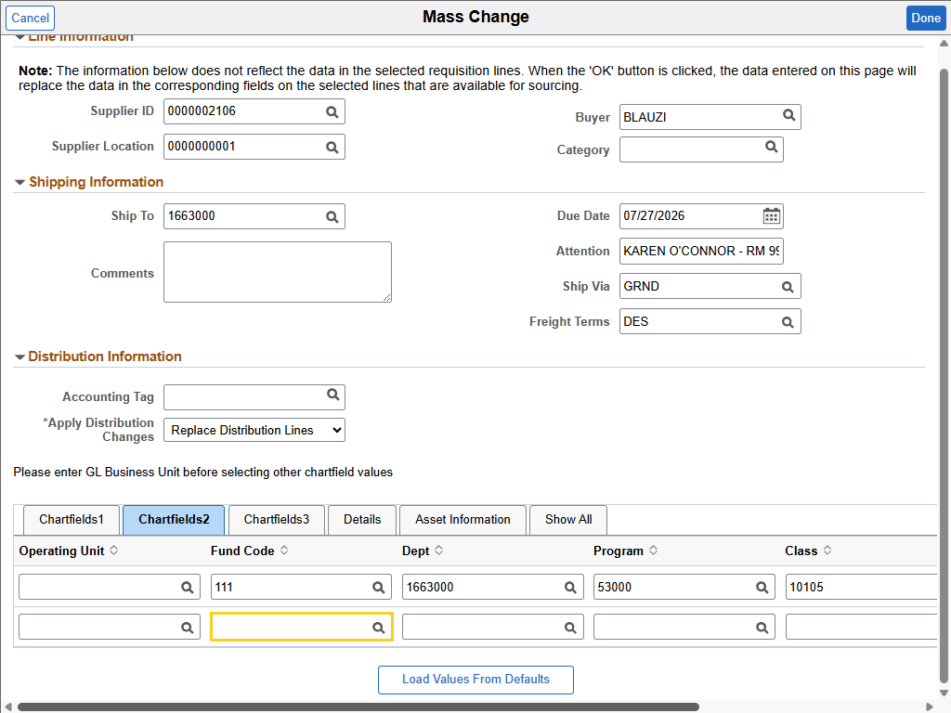

Step | Action
Split a Distribution Line for Multiple Distribution Lines (continued)

NOTE: The values entered in the Fund, Dept, Program, and Class fields are used for training purposes only. You will enter values appropriate for your requisition in the Production database.

Enter the desired information into the Fund Code field. Enter "111".
Split a Distribution Line for Multiple Distribution Lines (continued)

Enter the desired information into the Dept field. Enter "1663100".
Split a Distribution Line for Multiple Distribution Lines (continued)

Enter the desired information into the Program field. Enter "53000".
Split a Distribution Line for Multiple Distribution Lines (continued)

Enter the desired information into the Class field. Enter "10105".

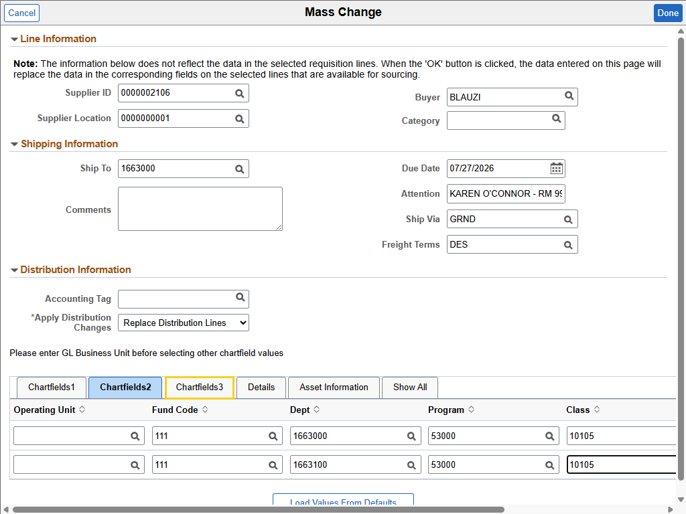

Step | Action
Split a Distribution Line for Multiple Distribution Lines (continued)

Click the Chartfields3 tab.
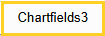
Split a Distribution Line for Multiple Distribution Lines (continued)

NOTE: Accounting Tags cannot be used to populate chartstring fields.

Enter Chartfields3 tab information:
• PS Business Unit = LSUNO

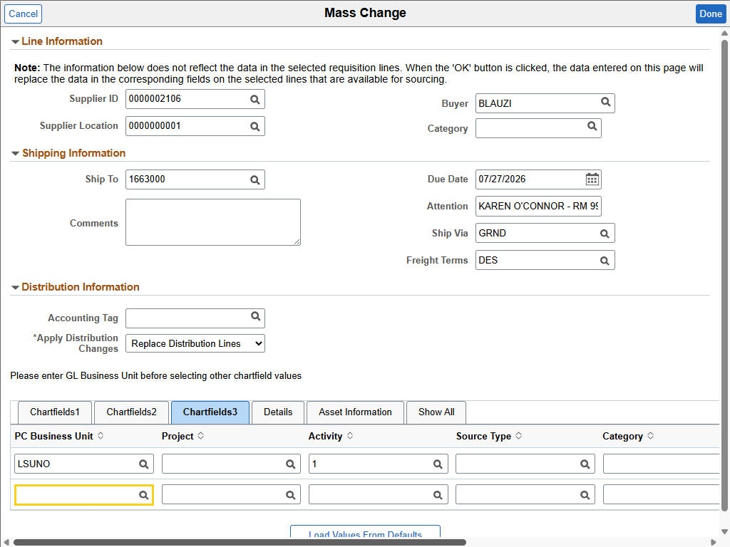

Step | Action
Split a Distribution Line for Multiple Distribution Lines (continued)

NOTE: The value entered in the PS Business Unit field is used for training purposes only. You will enter values appropriate for your requisition in the Production database.

Enter the desired information into the PC Business Unit field. Enter "LSUNO".

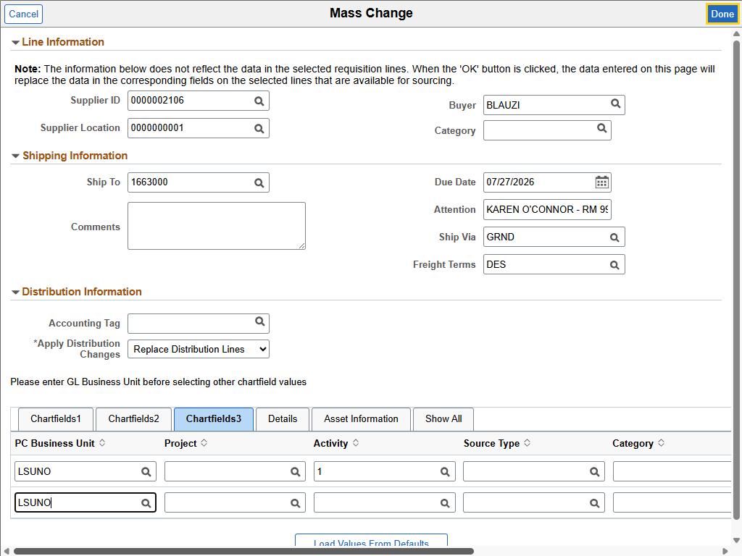

Step | Action
Split a Distribution Line for Multiple Distribution Lines (continued)

Once all values have been entered, select the Done at the top-right corner of the Mass Change page.

Click the Done button.
Split a Distribution Line for Multiple Distribution Lines (continued)

A message is displayed asking if you wish to retrofit (replace) field values on existing lines with the new distribution.

Click the OK button.

Split a Distribution Line for Multiple Distribution Lines (continued)

Click the Schedule Details button.

Split a Distribution Line for Multiple Distribution Lines (continued)

The *Distribute By is set to Quantity. However, you used a percentage for your distribution. Quantities must be entered in whole numbers, so Line 1 cannot have 11.25 binders. You will need to change your *Distribute By to Amount if using a percentage for physical items. You will need to change the *Distribute By on each line item.

Click the button to the right of the *Distribute By field.
Split a Distribution Line for Multiple Distribution Lines (continued)

Click the Amount list item.
Split a Distribution Line for Multiple Distribution Lines (continued)

The Quantity field has changed to Merchandise Amount and displays the cost to be charged to each department for Line 1 items.

Click the Line 2 button.
Split a Distribution Line for Multiple Distribution Lines (continued)

Click the button to the right of the *Distribute By field.
Split a Distribution Line for Multiple Distribution Lines (continued)

Click the Amount list item.
Split a Distribution Line for Multiple Distribution Lines (continued)

Click the Line 3 button.
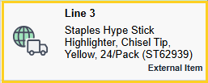
Split a Distribution Line for Multiple Distribution Lines (continued)
Click the button to the right of the *Distribute By field.
Split a Distribution Line for Multiple Distribution Lines (continued)

Click the Amount list item.
Split a Distribution Line for Multiple Distribution Lines (continued)

Click the Line 4 button.
Split a Distribution Line for Multiple Distribution Lines (continued)
Click the button to the right of the *Distribute By field.
Split a Distribution Line for Multiple Distribution Lines (continued)

Click the Amount list item.
Split a Distribution Line for Multiple Distribution Lines (continued)

Once all line items have been updated, select the Done button at the top-right corner of the page.

Click the Done button.
Split the Distribution Line for Multiple Distribution Lines (continued)

You can either Save or Submit the requisition.
This completes Split the Distribution for Multiple Distribution Lines.
End of Procedure.

Create a Requisition for Next Fiscal Year

Create a Requisition for Next Fiscal Year
Procedure

In this topic you will learn how to Create a Requisition for Next Fiscal Year.

Step | Action
Create a Requisition for the Next Fiscal Year

When creating a requisition for the next fiscal year, it is required to set the Accounting (Acctg) Date to July 1 to ensure that the requisition is charged in the correct period.

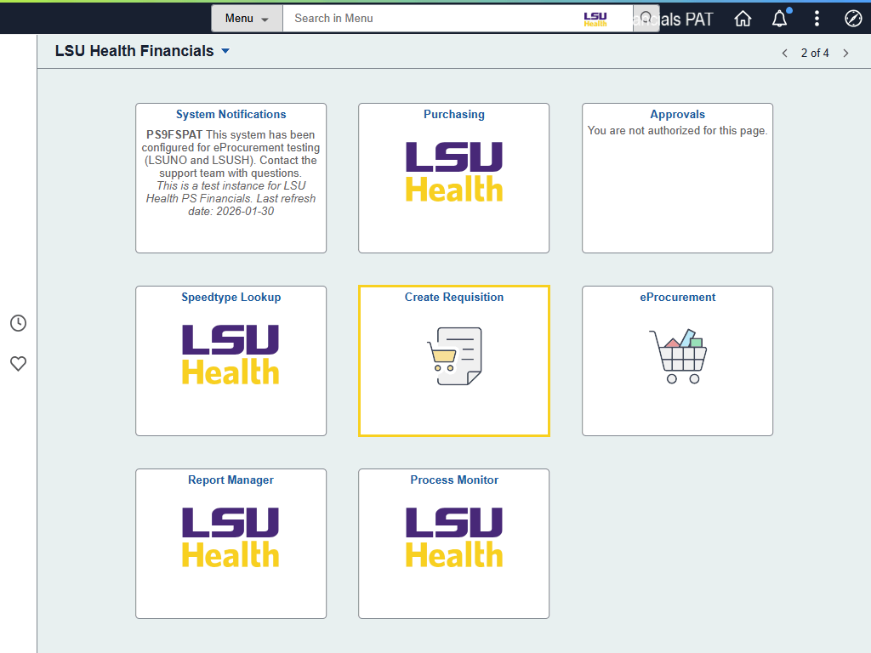

Step | Action
Create a Requisition for the Next Fiscal Year (continued)

Click the Create Requisition tile.

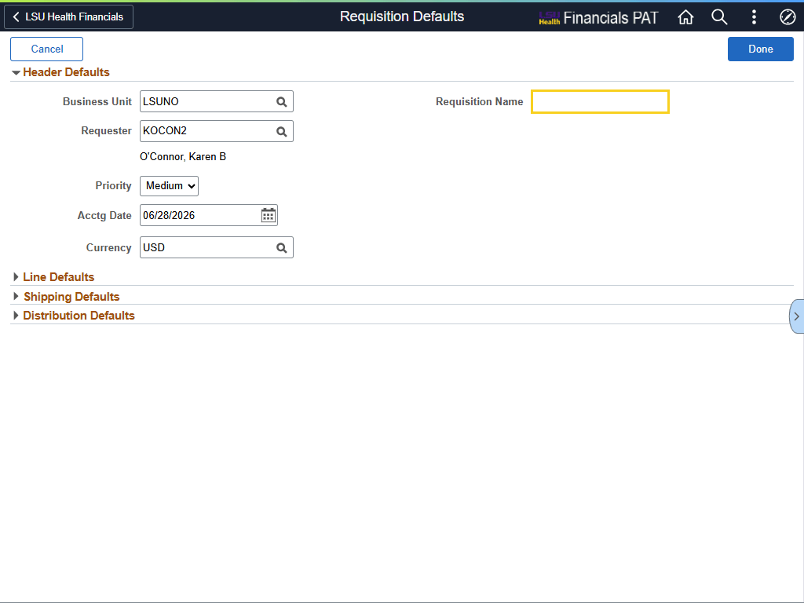

Step | Action
Create a Requisition for the Next Fiscal Year (continued)

Enter the desired information into the Requisition Name field. Enter "COFFEE SERVICE".

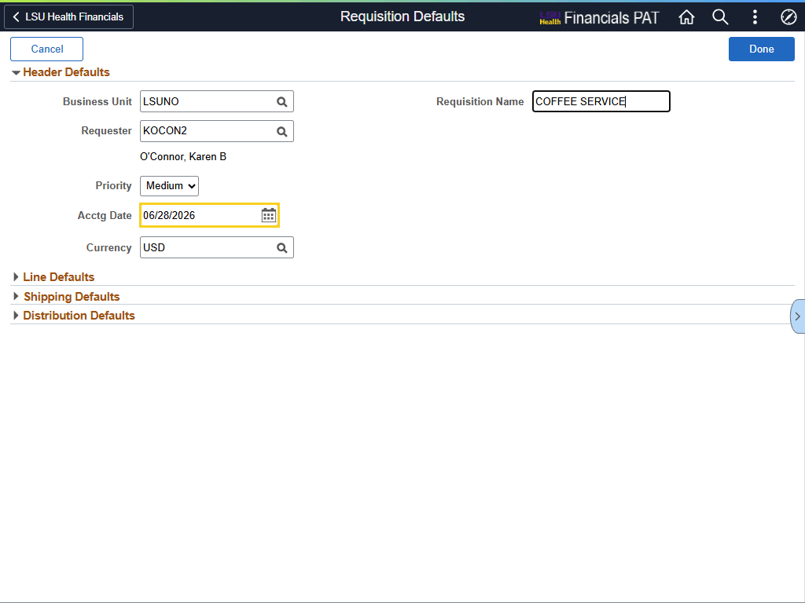

Step | Action
Create a Requisition for the Next Fiscal Year (continued)

In the Requisition Defaults page, change the Acctg Date to 07/01 of the next fiscal year. For example, for Fiscal Year 2027, the date 07/01/2026 is entered.

NOTE: Changing the Acctg Date to an older than today's date is not allowed.

Enter the desired information into the Acctg Date field. Enter "070126".
Create a Requisition for the Next Fiscal Year (continued)

NOTE: You must enter Requisition Defaults before entering line-item information.

Click the Line Defaults arrow.
Create a Requisition for the Next Fiscal Year (continued)

Click the Lookup Supplier ID button.
Create a Requisition for the Next Fiscal Year (continued)

Click the Search Criteria arrow.

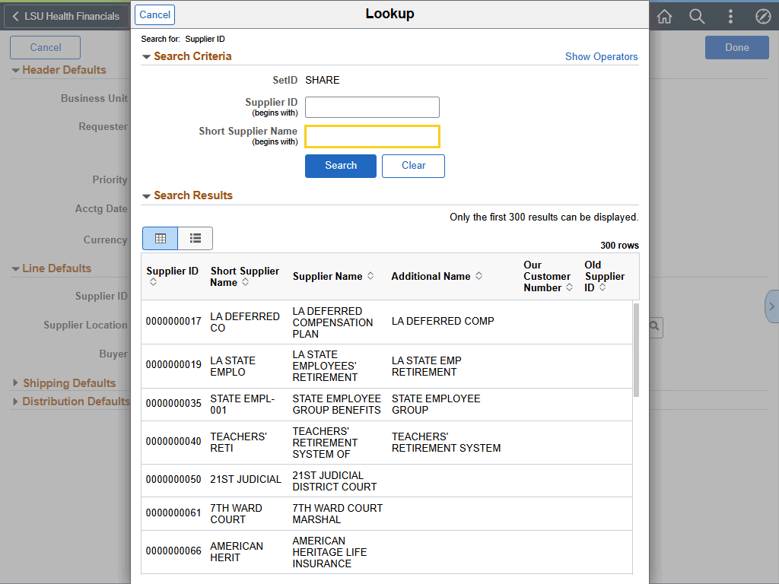

Step | Action
Create a Requisition for the Next Fiscal Year (continued)

Enter the desired information into the Short Supplier Name field. Enter "COMMUNITY".

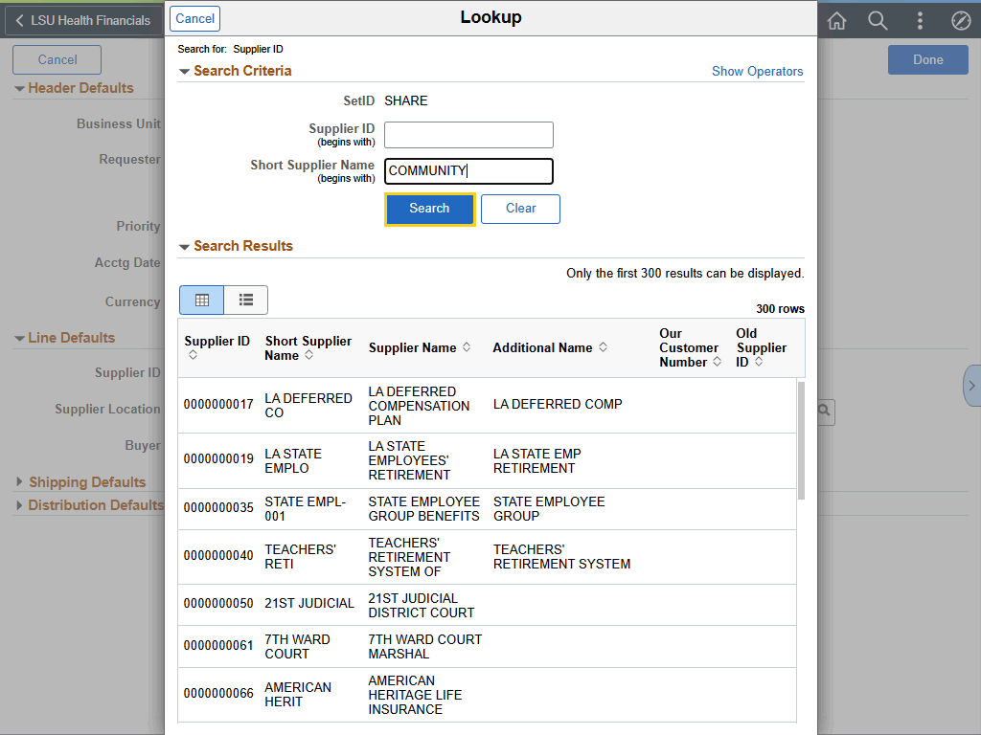

Step | Action
Create a Requisition for the Next Fiscal Year (continued)

Click the Search button.

Create a Requisition for the Next Fiscal Year (continued)

Click the 0000002791 - COMMUNITY COFFEE LLC button.
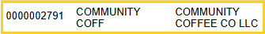
Create a Requisition for the Next Fiscal Year (continued)

Click the Line Defaults arrow.
Create a Requisition for the Next Fiscal Year (continued)

Enter the desired information into the Buyer field. Enter "DHOLME2".
Create a Requisition for the Next Fiscal Year (continued)

Click the Line Defaults arrow.
Create a Requisition for the Next Fiscal Year (continued)

Click the Shipping Defaults arrow.
Create a Requisition for the Next Fiscal Year (continued)

Enter the desired information into the Ship To field. Enter "1491500".

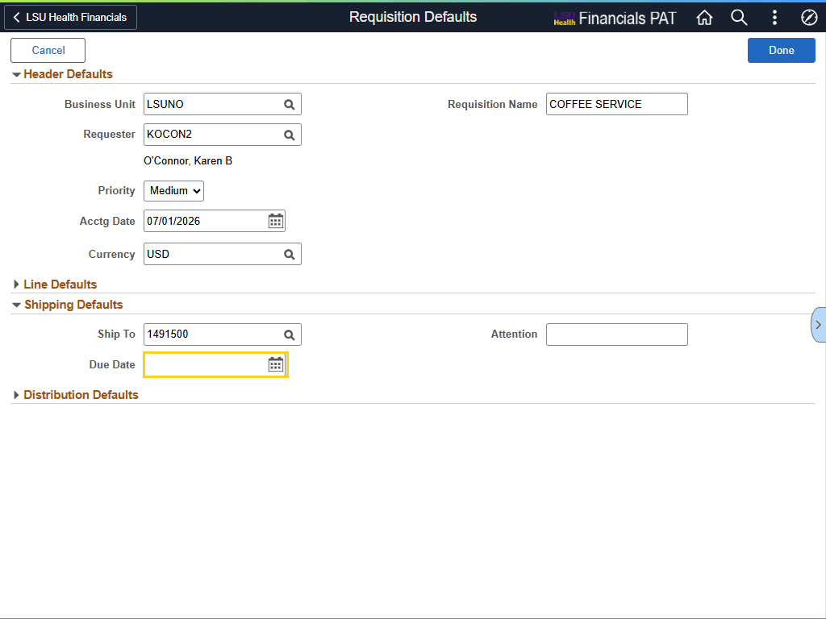

Step | Action
Create a Requisition for the Next Fiscal Year (continued)

The Due Date will be the last day of the new fiscal year. For example, for Fiscal Year 2027, the date will be 06/30/2027.

Enter the desired information into the Due Date field. Enter "063027".

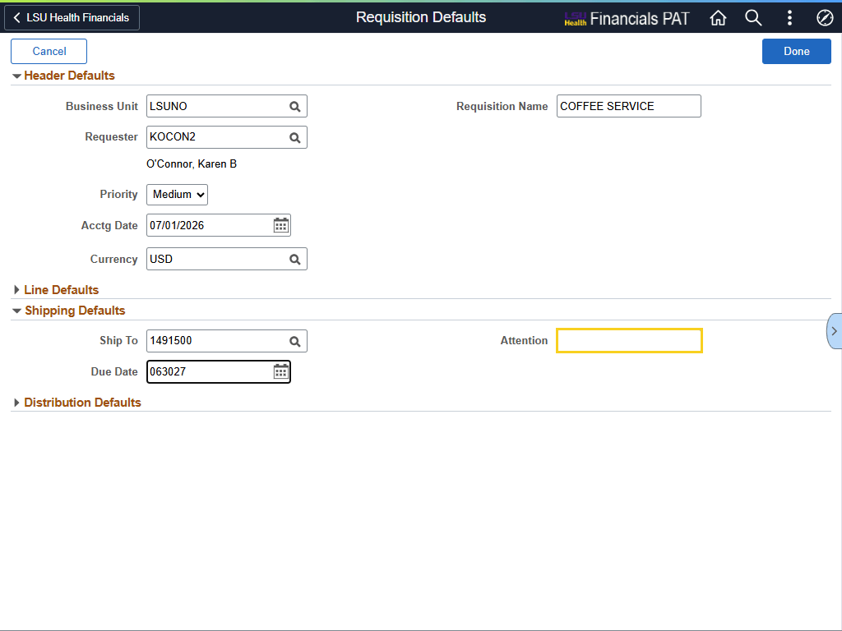

Step | Action
Create a Requisition for the Next Fiscal Year (continued)

NOTE: The name for the Attention field is used for training purposes only. Enter your department person who will receive the items.

Enter the desired information into the Attention field. Enter "KAREN O'CONNOR".
Create a Requisition for the Next Fiscal Year (continued)

A message is displayed stating the Due Date is more than 30 days in the future.

Click the OK button.

Create a Requisition for the Next Fiscal Year (continued)

Click the Shipping Defaults arrow.
Create a Requisition for the Next Fiscal Year (continued)

Click the Distribution Defaults arrow.

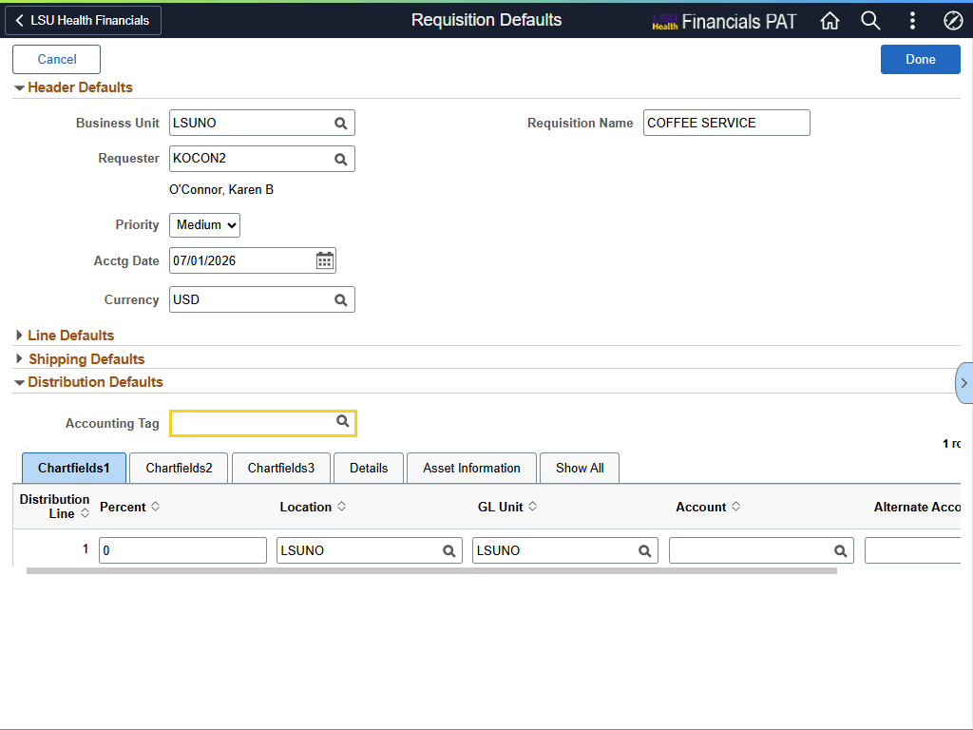

Step | Action
Create a Requisition for the Next Fiscal Year (continued)

NOTE: The Accounting Tag used in this example is for training purposes only. When in Production, use an appropriate Accounting Tag for your department.

Enter the desired information into the Accounting Tag field. Enter "0491500001".
Create a Requisition for the Next Fiscal Year (continued)

Press [Tab] to populate chartstring information into the tabs.

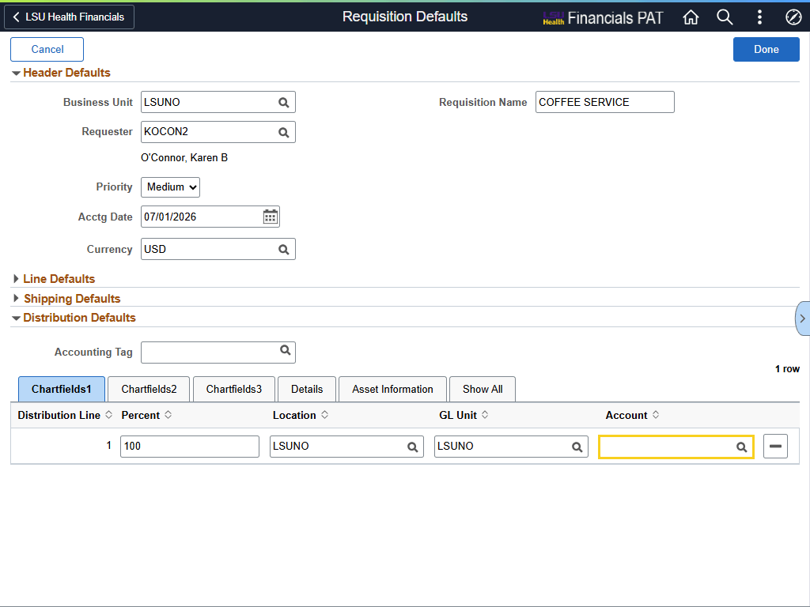

Step | Action
Create a Requisition for the Next Fiscal Year (continued)

Enter the desired information into the Account field. Enter "543700".
Create a Requisition for the Next Fiscal Year (continued)

Click the Done button.

Create a Requisition for the Next Fiscal Year (continued)

If you are past the initial Requisitions Defaults page, the page can be accessed again by selecting the Gear icon at the top-right corner of Create Requisition page.

Click the Gear button.
Create a Requisition for the Next Fiscal Year (continued)

Click the Defaults link.
Create a Requisition for the Next Fiscal Year (continued)

You are returned to the Defaults page. Verify the Acctg Date is 07/01/XX, and the Due Date, on the Shipping Defaults panel, is 06/30/XX.

Click the Done button.
Create a Requisition for the Next Fiscal Year (continued)

You can now continue with your requisition by selecting either Special Requests or a Punchout supplier.
This completes Create a Requisition for Next Fiscal Year.
End of Procedure.

Copy an Existing Requisition for Next Fiscal Year
Procedure

In this topic, you will learn how to Copy an Existing Requisition for Next Fiscal Year.
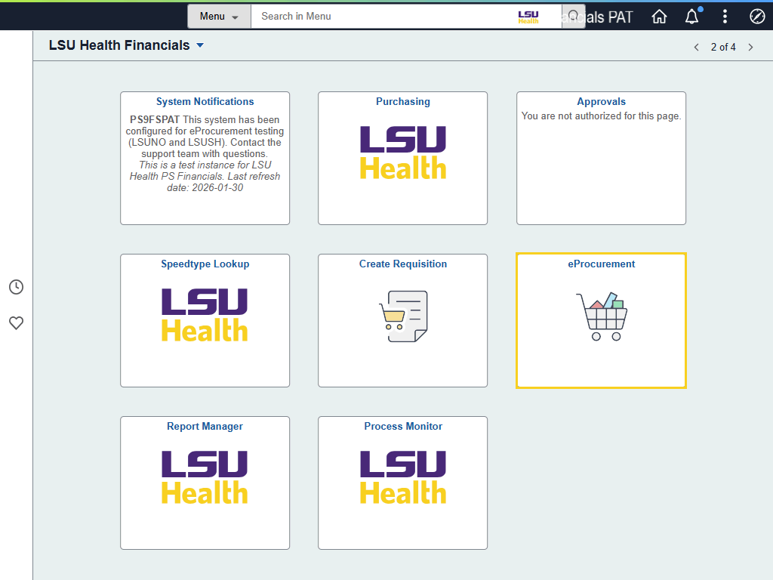

Step | Action
Copy a Requisition for Next Fiscal Year

eProcurement and non-ePro requisitions can be copied for the next fiscal year.

Click the eProcurement tile.
Copy a Requisition for Next Fiscal Year (continued)

Click the My Requisitions tile.

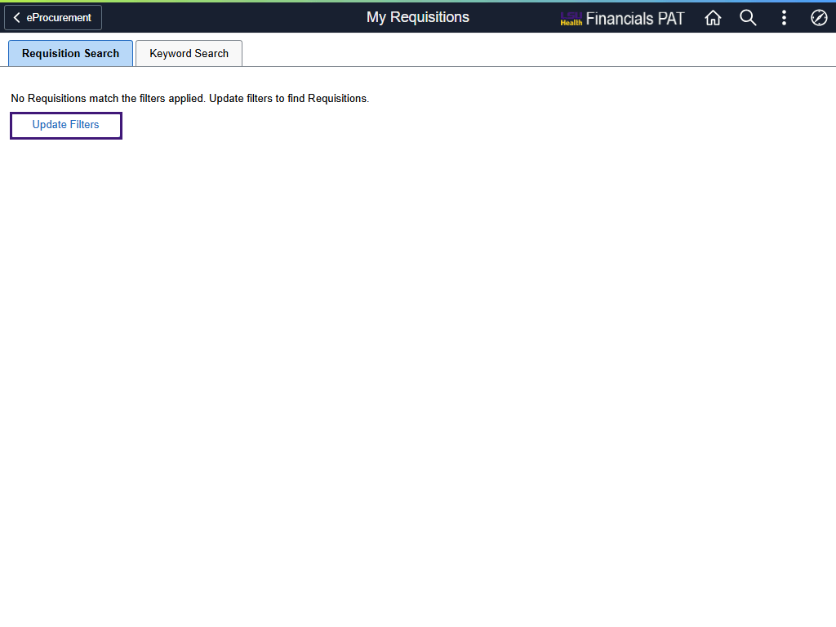

Step | Action
Copy a Requisition for Next Fiscal Year (continued)

The filter button acts as a search option to find requisitions using specific criteria such as Business Unit, Requisition ID, From and To Date, and Requester. The filter button will display differently on the page if My Requisitions displays current date requisitions or not.

This example shows what the filter button looks like with no requisitions displayed.

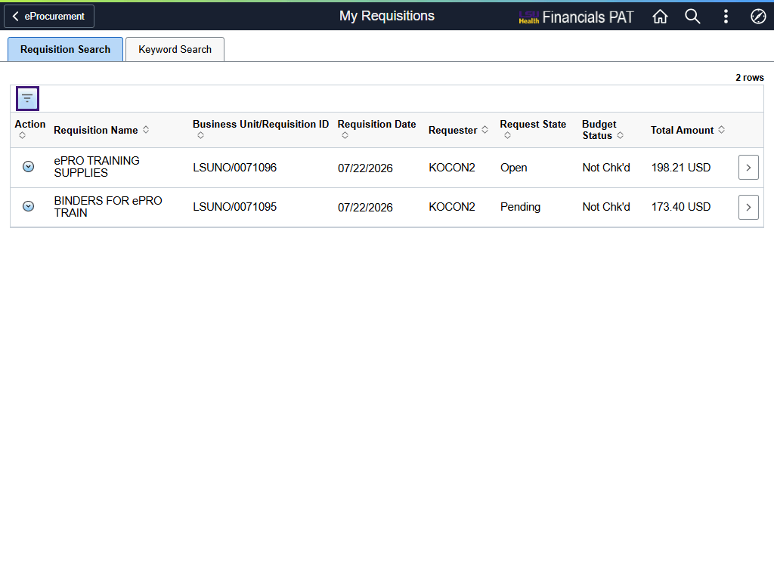

Step | Action
Copy a Requisition for Next Fiscal Year (continued)

This example shows what the filter button will look like when current date requisitions are displayed on My Requisitions.

The filter options are the same regardless of which option is used.

Copy a Requisition for Next Fiscal Year (continued)

The Update Filters option will be used to search for a requisition.

Click the Update Filters button.


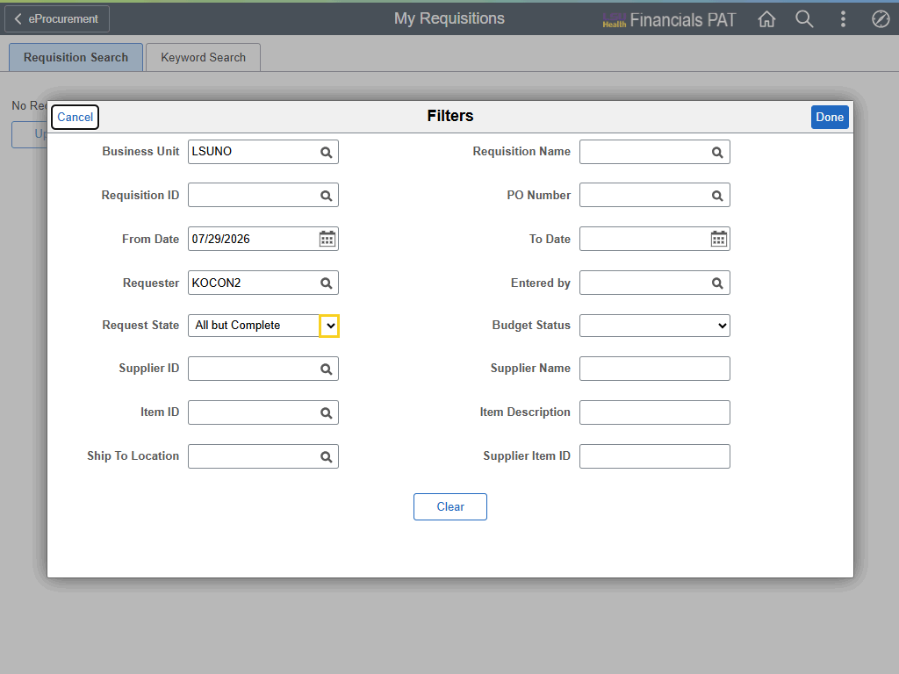

Step | Action
Copy a Requisition for Next Fiscal Year (continued)

You will use Business Unit and Requisition ID as your main filter options. You can also use From and To Date, as well as Requester. It is not recommended to use any of the other options.

In this example, you will select the blank option for Requester state, delete Requester, and delete From Date. You will enter the Requisition ID as 0071095.

Click the button to the right of the Request State field.
Copy a Requisition for Next Fiscal Year (continued)

Click the Blank list item.
Copy a Requisition for Next Fiscal Year (continued)

Highlight the Requester ID and press [Delete].
Copy a Requisition for Next Fiscal Year (continued)

Highlight the From Date and press [Delete].
Copy a Requisition for Next Fiscal Year (continued)

Enter the desired information into the Requisition ID field. Enter "0071095".

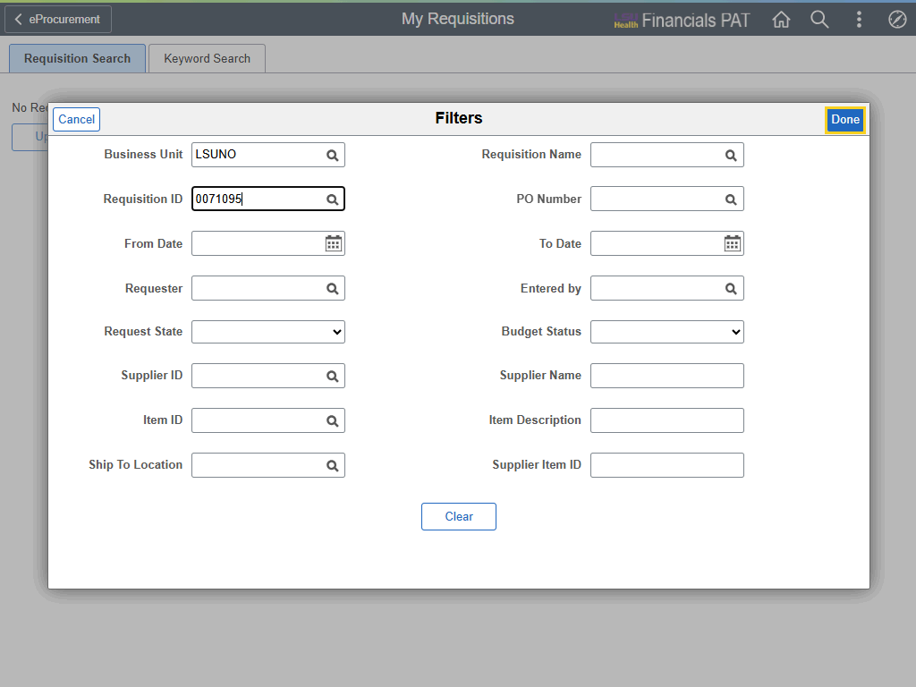

Step | Action
Copy a Requisition for Next Fiscal Year (continued)

Click the Done button.

Copy a Requisition for Next Fiscal Year (continued)

The requisition information is displayed. Use the Actions menu to select the Copy link.

Click the Actions button.
Copy a Requisition for Next Fiscal Year (continued)

Selecting the Copy option will copy the requisition and bring up the Edit Shopping Cart screen.

Click the Copy link.
Copy a Requisition for Next Fiscal Year (continued)

To update the accounting date, select Continue Shopping.

Click the Continue Shopping button.

Copy a Requisition for Next Fiscal Year (continued)

The main page for Create Requisition is displayed, along with the item from the copied requisition in a cart on the right-hand side. Select the Gear icon and then Defaults to bring up the Requisition Defaults page.

Click the Gear button.
Copy a Requisition for Next Fiscal Year (continued)

Click the Defaults link.

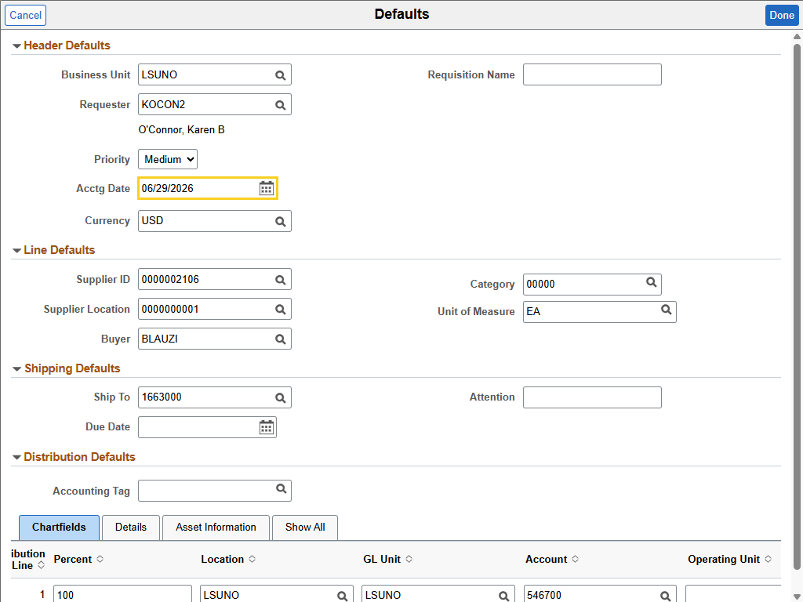

Step | Action
Copy a Requisition for Next Fiscal Year (continued)

Change the Acctg Date to the new fiscal year. For example, for Fiscal Year 2027, the date will be 07/01/2026.

Enter the desired information into the Acctg Date field. Enter "070126".
Copy a Requisition for Next Fiscal Year (continued)

Due Date is a required field, so you must enter the appropriate date. Requisition Name and Attention are highly recommended fields, so consider entering information into those fields as well. Verify the chartstring data.

Enter the desired information into the Due Date field. Enter "070826".

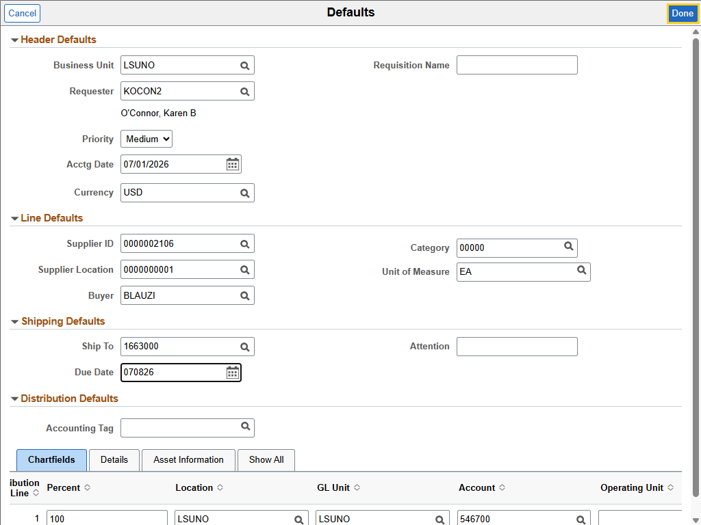

Step | Action
Copy a Requisition for Next Fiscal Year (continued)

Click the Done button.
Copy a Requisition for Next Fiscal Year (continued)

Click the Checkout button.

Copy a Requisition for Next Fiscal Year (continued)

Review your requisition and then select the Submit button when ready.

Click the Submit button.

Copy a Requisition for Next Fiscal Year (continued)

Your Checkout Confirmation page is displayed.

The Print Preview option is shown at the top-right of the page. Select the View Approval Chain to view who needs to approve the requisition. If you are your own Approver, you may select the Check Budget button to budget check your requisition. On the lower left side, Next Steps are displayed. The user can select any or all these options as needed.
This completes Copy an Existing Requisition for Next Fiscal Year.
End of Procedure.

